WISHLIST for RARE PEARLS COWETA YOUTH NEWS REPORTER PROGRAM

- https://www.amazon.com/dp/B0BQLMHQS4?
- Movo Tablet Vlogging Kit for iPad - iPad Vlogging Kit with Tablet Holder, Full Size Tripod, Microphone, LED Light, Cold Shoe Extension - YouTube Starter Kit with iPad Tripod Mount for Video Recording https://a.co/d/1twUlLv

- https://www.amazon.com/dp/B0DGPSQRZZ?
- 2 Pack LED Video Light with 63'' Tripod Stand, Kmasic 2500-8500K Dimmable Photography Lighting Kit,15W Soft Studio Lighting for Video Recording/Filming/Game Streaming/YouTube/Podcast, USB Charger

- https://www.amazon.com/dp/B0CH2NGCFP?
- sktome Podcast Equipment Bundle for 2, V8s Voice Changer with BM-800 Podcast Microphone Bundle - Studio Condenser Microphone Perfect for Podcasting, Recording, Singing, Streaming and Gaming

- https://www.amazon.com/dp/B0DJ2MRN3N?
- Android Tablet, 10.1 Inch Android 14 Tablet with 1280x800 IPS HD Touch Screen, Dual Camera, 64GB Storage 1TB Expansion, 8 in 1 Tablets Kit with Keyboard, Protective Case, Mouse, Stylus, BT 5.0, WiFi 6

- a camera for photography,
- podium
- projector
- studio setup (backdrop) below - RP Step and fetch to be secured from Damon Peebles (photosbydamonpeebles.com)
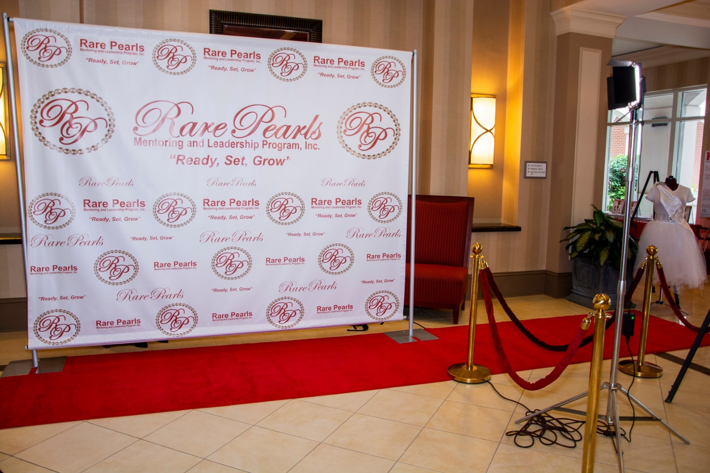

- HOTSPOT for wifi when we need it,
- Katie needs a refurbished computer, or external hard drive , photo printer,
- Large Screen for Projection
- Storage unit fee of $46.00 a month

RESPECTFULLY SUBMITTED:

