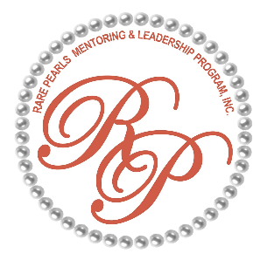

PARENT UPDATES & REMINDERS (5/25)

- Girls should bring their white binder and pencil to every meeting. Cell phones will be kept by the hospitality volunteers during our meetings. If you need to reach your child please call director: Ms. Cheryl on 845-549-9057
- June 14 is the Tea Party/Awards Ceremony Luncheon - please provide info on school and extra-curricular activities awards earned. Tea Party attire suggested: Sundresses, Slacks, Blouses, sandals, sun hats, gloves, No jeans, T- shirts or shorts. Pictures will be taken.
Also: The girls will be given an Invitation, We will be doing a lesson on RSVP and Thank you notes. The girls will Need to Call to RSVP to assigned Leader listed on invitation by RSVP date for the Tea Party/Etiquette Training in June.
- RP T-shirts and pearls should always be worn at meetings (unless special events). White t-shirt is allowed if a RP t-shirt is not available. New grey T-shirts and caps orders will begin in June - $20.00 for the set. Please wait for the t-shirt order form before any money is sent in.
- Most communications will now be delivered through our new intranet site: https://cowetaparents.com. use this site to see all information on upcoming events, trips, Fundraisers, forms, applications, scholarships, apparel, youth binder documents etc. It is a new site, with updates and adjustments being regularly made. Make sure to check into this site regularly. Due to the amount of parents on the roster, Special text, email and phone reminders will be rare.
- If you want to be on any committee or team, check your text message for the sign-up genius account Shan created for us. Help is needed with the Community Fun day and Holiday Festive event.
- if anyone can help with making copies, please let us know
- if any parent is a customer of “Constellation” energy company, your help is needed applying for a grant. Deadline is May 15th. Please check with your HR department for any local community grant they offer. As an active employee you will be able to apply for a grant for us!
- ATTENDANCE - Please try to be timely and responsive to requests, it helps us plan for our meetings, events. We invest a lot of time, money and resources into the meetings, If your girls are not able to attend please inform us as soon as possible so we can plan accordingly, you need to contact Mrs. Jackie McCollough - your parent Liaison (678 923-2430), or Sherita 678-522-4993
- There will be a Survey next month, we need feedback from you to see how we are doing, We are asking for 100% participation.
Thanking you in advance, Yours in Service
Sherita…..Cheryl…..Ercelene

