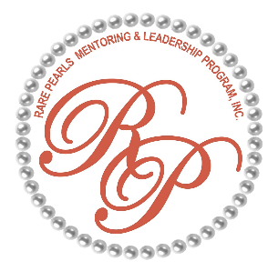
February 8, 2025 - 10:00
PARENT MEETING
Welcome/call to order

NEW DIRECTOR INTRODUCTIONS
REMINDER: Update applications for allergies, medical & contacts
UP COMING EVENTS:
- TOMORROW – FEBRUARY 9 - MLK WALK – IF RAIN MORE THAN 50% WE CANCEL
  - WHO’S PARTICIPATING (youth without parent need permission slip)
  - Details – 1:30 meetup time, 55 Savannah Street, 3:00 parade
- February 16 - *AWARD SERVICE – RADCLIFF PRESYERTIAN (flyer/)
- February 22 - * Ms. Debbie – Guest Speaker (flyer)
*Youth church attire is black skirt or pants, white blouse, pearls
- March 8th - Mentee Meeting focus – Period Party (Permission slip required) , Career Dressup

- March 15th - 5TH ANNIVERSARY CELEBRATION (flyer)
Date: MARCH 15TH, 2025 – Saturday SEMI-FORMAL
Place: LEROY JOHNSON CENTER
6646 HWY 16E, SENOIA GA
Time: 5:00 -10:00 PRICE: $50 pp
ADULTS ONLY
DINNER SERVICE AT: 5:15

NEED: 1. AUCTION ITEMS, 2. GIFT CARDS, 3. SHEET CAKE
Payment methods – like the sneaker ball setup: GUEST PAY THE SELLER OF THE TICKET, receive ticket, THEN THE RP SELLER LEADER WILL FORWARD FUNDS TO ORGANIZATION
CASHAPP = $rpcoweta, Zelle: cowetararepearls@yahoo.com EVENTBRITE

