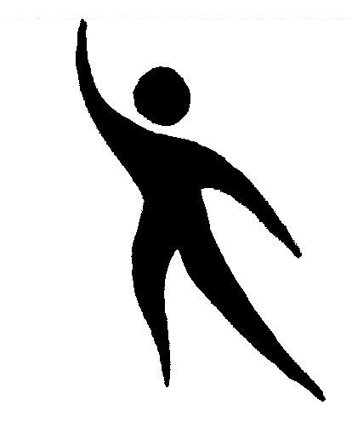
Qualicum
PHYSIOTHERAPY
CLINIC
Pahl Physiotherapist Corp.
#1 - 140 West 1st Ave, Qualicum Beach, BC V9K 2R5
Phone: (250) 752-3212 Fax: (250) 752-3275
Email: qbphysio@shaw.ca
Cory Pahl, B.M.R., PT
Ezra Canfield, B. Sc., Kin., MScPT
Connor Malbon, MSc PT, MSc Kin

IMS (NEEDLING) CONSENT FORM

Acupuncture and Intramuscular Stimulation use fine flexible needles. These needles are solid; therefore, no drug is injected. IMS needling releases shortened muscle bands caused by abnormal functioning of the nervous system.

Like any medical procedure, there are possible complications. While these complications are rare in occurrence, they are real and must be considered prior to giving consent to acupuncture and IMS procedures.

Any time a needle is used; there is a risk of infection. Qualicum Physiotherapy Clinic uses new disposable sterile needles and infection is rare. A needle may be placed inadvertently in an artery, nerve or vein. If an artery or vein is punctured with the needle, a hematoma (bruise) will develop. If a nerve is punctured, it may cause paresthesia (a prickling sensation) which may continue for days.

When a needle is placed close to the chest wall, there is a rare possibility of pneumothorax (air in the chest cavity). Fortunately, all these complications are not fatal and are readily reversible.

IMS may cause an increase in pain, only for 1 to 2 days in most cases. Following this an improvement in the overall pain state should occur. The increased pain is related to overactive shortened muscle bands that have not been released.

Acupuncture rarely causes an increase in pain.

Are you using blood thinners? YES / NO
Do you have a blood clotting problem? YES / NO
Have you ever had a blood transfusion? YES / NO
Have you ever had Jaundice? YES / NO
Do your Currently have Hepatitis? ………….……...YES / NO - If yes please circle A, B or C
Have you had a positive HIV test? YES / NO
Are you allergic to latex? YES / NO
Are you allergic to Metal?..................................YES / NO

I have read the above and agree that I understand the risks involved in Acupuncture and IMS therapy. I consent to Acupuncture and IMS treatment at Qualicum Physiotherapy Clinic.

Signed: ________________________________ Date: ______________________

Print name: _____________________________

