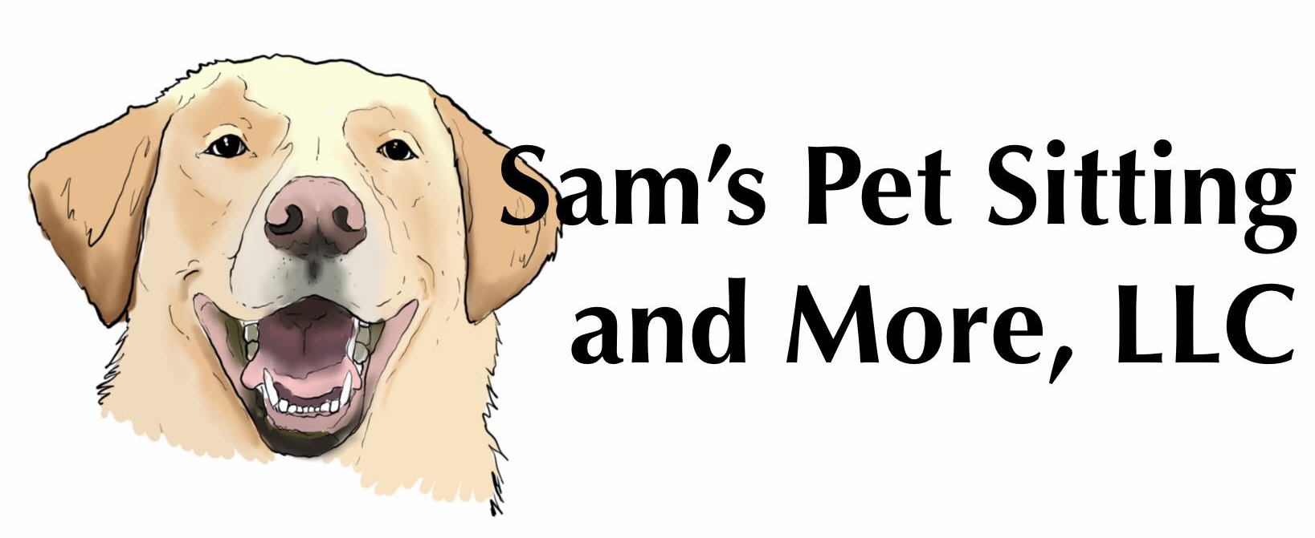

262-930-2985

[samspetsittingandmorellc@gmail.com](mailto:samspetsittingandmorellc@gmail.com)

**Owner Information**

*Owners Name*: ________________ Additional *Owner*: ________________

*Address*: ________________________ *City*: ______ *St:* ____ *Zip*: ______

*Cell Phone*: ______________ *Additional Owner Cell*: ________________

*Email:* _______________________ *Additional Owner Email*: ____________

**Emergency Contact**

*Name:* ___________________ *Phone:* _______________________

*Veterinarian*: ___________________ *Phone Number*: _________________

**Pet Information**

*Pet Name*: ______________ Breed: ______________ *Birthdate*: _____

Does your pet have any medical conditions/concerns? (List medications below) Yes/No

_______________________________________________________

Does your pet have allergies? (seasonal/food?) Yes/ No

_______________________________________________________

How often do you feed your pet? Amount? Special instructions?

_______________________________________________________

Where does your pet Sleep? Where does Pet stay when you are gone?

_________________ ________________________

Food aggressive? Yes or No Toy Aggressive? Yes or No

Dog friendly? Yes or No Treats? Yes or No

Is there any other information we should know?

_____________________________________________________

**Rules and Regulations:**

**If in our judgment, your pet(s) requires immediate medical care we will attempt to reach you and/or your emergency contact, however we will also take your dog to a veterinarian or animal hospital to avoid any unnecessary suffering. You agree to be solely responsible for the payment of all medical bills for your dog and you release Sams Pet Sitting and More LLC, its employees of from any and all responsibility for claims, damages, debts, etc., arising out of or related to any such medical care, including, but not limited to, transportation to/from the veterinary clinic and choice of veterinary and animal hospital.**

**Your dog must be healthy and current on vaccinations. Documents must be provided before service. Any pets not boarding will be required to be current with Rabies as required by State law. Any pets boarding in my home will be required to be current with Rabies as well as Distemper-parvo. Bordetella vaccine is recommended.**

**You understand that there are risks with in-home boarding with multiple dogs including but not limited to dog fights, dog bites to humans or other dogs and the transmission of disease. Additionally, any medical expenses will be your responsibility, and you release Sams Pet Sitting and More LLC of any liability and charges.**

**We accept Cash, Check or Venmo. 50% deposit at reservation for any in-home vacation stays and boarding. Remainder of in-home/boarding due on the first day of service. Payment for daily Visit due at time of service.**

**Boarding cancellations with 2 or more days advance will receive a full deposit refund. Any time less refund will not be given.**

**Cancellations for daily service require 48 hr. notice or 50% service due before the next service will be scheduled.**

**There are no pick-ups for boarding on Easter, Christmas Eve or Christmas Day.**

**Boarding Drop off and pick up times must be scheduled. No drop offs or pick-ups after 6pm. Any scheduled pick-ups after 6pm will require preapproval and additional convenience fee of $20.**

**Sams Pet Sitting and More LLC reserves the right to cancel any reservations if there are other people coming into home to do any services.**

**By submitting this form:**

**A) INITIAL ______ You indicate your agreement with all the terms listed above.**

**B) INITIAL ______ You release, indemnify, and agree to hold Sams Pet Sitting LLC harmless from any and all manner of damages, claims, losses, liabilities, costs or expenses, causes of actions or suits, whatsoever in law or equity, (including, without limitation, attorney’s fees and related costs) arising out of or related to the services provided by Sams Pet Sitting And More LLC, except those that may arise from the sole gross negligence or intentional and willful misconduct of Sams Pet Sitting and More LLC, including, without limitation, (a) any inaccuracy in any statement made by yourself or information provided by you to Sams Pet Sitting and More LLC (b) your dog(s), including but not limited to, the destruction of property, dog bites, injury and transmission of disease, and (c) any action by yourself which is in breach of the terms and conditions of this agreement.**

**C) INITIAL ______ This agreement covers the current relationship between Sams Pet Sitting and More LLC and yourself. Each time you bring your pet to Sams Pet Sitting and More LLC, you affirm the terms of this Agreement, and the truthfulness and accuracy of all statements you have made in this Agreement.**

**D) INITIAL ______ This document applies to all pets on your account with Sams Pet Sitting and More LLC**

**E) INITIAL_____ This document releases the use of Photos taken by Sams Pet Sitting and More LLC to us for any marketing.**

**PRINTED NAME_________________________SIGNATURE_____________________ DATE__________**