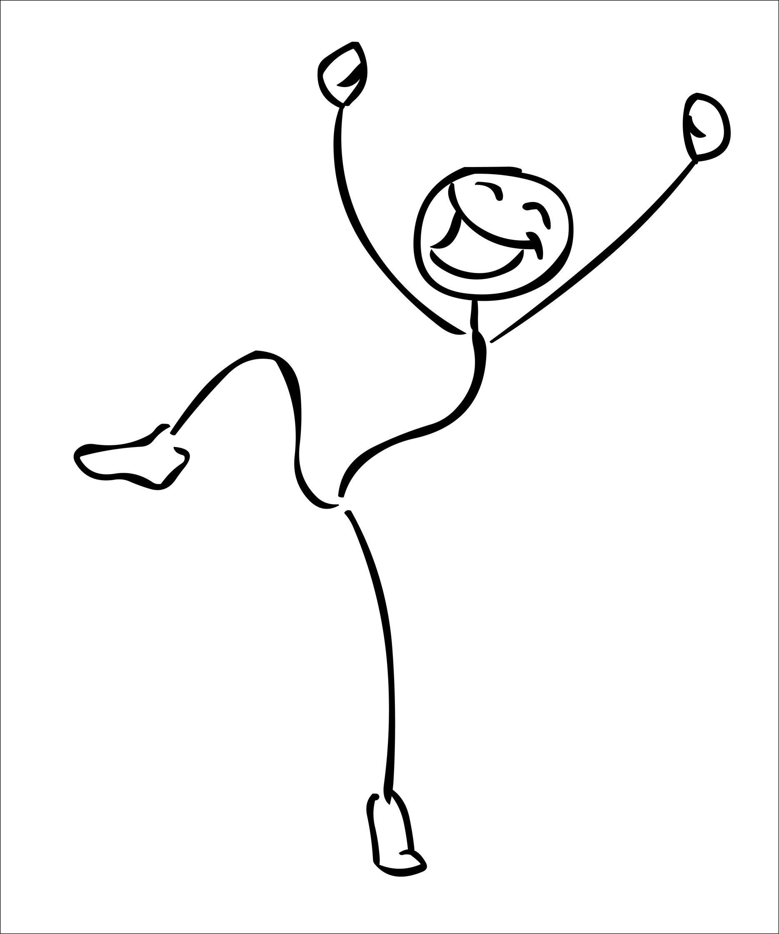
Y N
⃝ ⃝ Do you have any sore teeth?
⃝ ⃝ Is your appliance broken?
⃝ ⃝ Does your bite feel uneven?
⃝ ⃝ Does your appliance feel loose?
⃝ ⃝ Is your jaw joint sore or making noise?
⃝ ⃝ Does your face or head feel sore?
⃝ ⃝ Does your neck hurt?
⃝ ⃝ Does anywhere in your body feel sore? Where? (Please draw on diagram above)_____________________
⃝ ⃝ Are you snoring?
⃝ ⃝ Has it been difficult to do your PLAY exercises lately?
⃝ ⃝ Have you been wearing your appliances as directed?

I have noticed improvements in my…

⃝ Athletic ability
⃝ Sleeping
⃝ Growth
⃝ Breathing
⃝ Ability to stay calm and focused
⃝ Posture
⃝ Uncontrollable movements
⃝ Speech

+ -
⃝ ⃝ Right leg strength reflex test
⃝ ⃝ Left leg strength reflex test
⃝ ⃝ Right two finger test
⃝ ⃝ Left two finger test
⃝ ⃝ Home care
⃝ ⃝ ____________________________________

Comments:_________________________________________________________________________________________________________________________________________________________________________________________________________________________________________________________________________________________________________________________________________________________________________________

