

Puppy Questionnaire

First and Last Name of person Inquiring about puppy:
______________________________________________________________________________
Email Address:__________________________________________________________________
Phone:________________________________________________________________________
Address:___________________________________________________________________________________________________________________________________________________________________________________________________________________________________
Preferred method of Contact:_____________________________________________________
Please provide your current Veterinarians information:
Clinic Name:___________________________________________________________________
Doctor Name:__________________________________________________________________
Phone:________________________________________________________________________
Address:___________________________________________________________________________________________________________________________________________________________________________________________________________________________________
What is your living situation? Where will the puppy be spending most of it’s time?_______________________________________________________________________________________________________________________________________________________
Do you live in an apartment, condo, townhome, or house? ____________________________________________________________________________________________________________________________________________________________
What is your yard situation? How to you plan on potty training?__________________________________________________________________________________________________________________________________________________________________________________________________________________________________
Will you be crate training your puppy?____________________________________________________________________________________________________________________________________________________________________________________________________________________________________
Why the Chihuahua breed?____________________________________________________________________________________________________________________________________________________________________________________________________________________________________
Have you ever owned a chihuahua before?___________________________________________________________________________________________________________________________________________________________________________________________________________________________________
Please briefly describe your plans for the puppy:____________________________________________________________________________________________________________________________________________________________________________________________________________________________________
Please describe the life your puppy will have:_____________________________________________________________________________________________________________________________________________________________________________________________________________________________________
How many hours per day do you plan on leaving the puppy alone?____________________________________________________________________________________________________________________________________________________________________________________________________________________________________
Where will the puppy be when left alone?______________________________________________________________________________________________________________________________________________________
Do you have children?____________________________________________________________________________________________________________________________________________________
Do you have other dogs? If so, please describe.____________________________________________________________________________________________________________________________________________________
If you are a breeder or looking for a show prospect, and are looking for full registration, please provide your website and/or Facebook page._______________________________________________________________________________________________________________________________________________________
How did you hear about Colie’s Chihuahuas?_________________________________________________________________________________________________________________________________________________
Anything else you would life for us to know?______________________________________________________________________________________________________________________________________________________
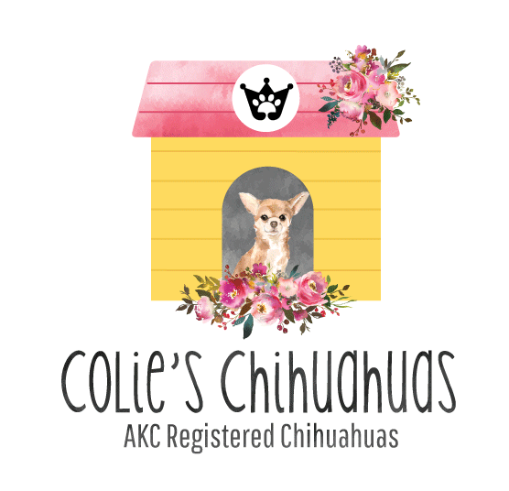
EMAIL: NICOLE@COLIESCHIHUAHUAS.LOVE
WEBSITE: WWW.COLIESCHIHUAHUAS.LOVE
SOCIAL MEDIA: @COLIESCHIHUAHUAS

