Affirmation Communication
Building Self Esteem Improving both listening
And Trust skills and building creating
non-violent solutions
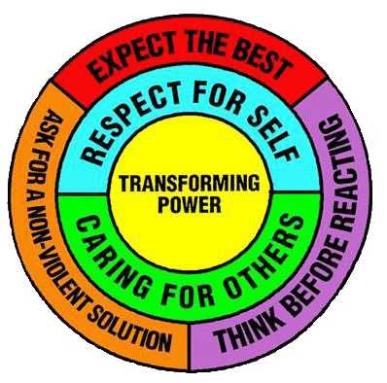
Cooperation Creative Conflict Resolution
Developing attitudes Getting in touch with our inner
That AVOID CONFLICT POWER TO RESOLVE VIOLENCE

