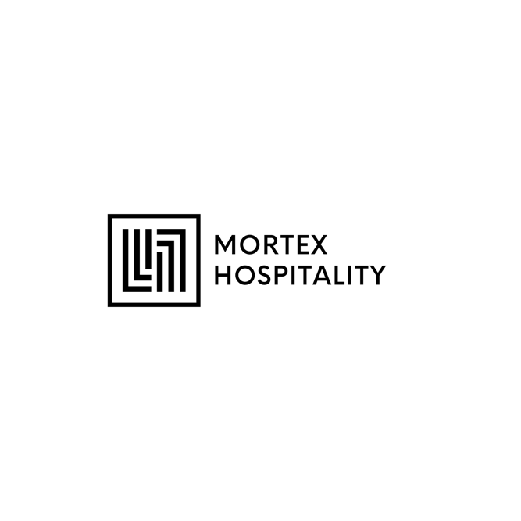

MANAGER TRAINING MANUAL

- DAY ONE

Welcome to our team! We are delighted to have you join our restaurant and become a part of our professional family. As you embark on this exciting journey, we want to take a moment to share our expectations and guidelines for maintaining a uniform standard of professionalism. By adhering to these principles, we can create a positive and efficient work environment that ensures outstanding service for our valued guests.

Dress Code: Always arrive at work in proper uniform, neat and well-groomed. Your appearance should reflect the high standards we hold for our establishment. Remember, you are an ambassador of our restaurant, and your attire should be clean, pressed, and in good condition.

Punctuality: Time management is essential in our industry. Arriving on time for your shift demonstrates respect for your colleagues, our guests, and the restaurant itself. Aim to be punctual and ready to start your duties at the scheduled time. If unforeseen circumstances arise, inform your supervisor promptly.
Communication: Effective communication is the key to success in any team. Be courteous and respectful when interacting with your colleagues, managers, and guests. Listen actively, speak clearly, and always strive to provide accurate information.
Customer Service: Our guests are the heart of our business. Treat each customer with the utmost respect and go the extra mile to ensure their satisfaction. Be attentive, anticipate their needs, and maintain a friendly and professional demeanor at all times.
Teamwork: Collaboration is fundamental to our success. Work together with your fellow employees, lending a helping hand when needed. Remember that every role is crucial, and by supporting each other, we create a cohesive and efficient work environment.
Adaptability: The restaurant industry is dynamic and fast-paced. Be flexible and adaptable to changing circumstances. Embrace challenges with a positive attitude and willingness to learn. Strive for continuous improvement and embrace constructive feedback.
Confidentiality: Respect the privacy of our guests and colleagues. Confidentiality is of utmost importance in maintaining trust and professionalism. Refrain from discussing sensitive information about guests or sharing internal matters outside the workplace.
Personal Conduct: Maintain a professional demeanor both inside and outside the workplace. Your actions reflect not only on yourself but also on our restaurant. Display good judgment, integrity, and ethical behavior at all times.
Safety and Cleanliness: Prioritize safety and hygiene in all aspects of your work. Adhere to all health and safety protocols, maintaining a clean and organized workspace. Report any hazards or concerns promptly to ensure the well-being of everyone in the establishment.
Professional Development: We believe in fostering growth and development. Take advantage of training opportunities and strive to expand your knowledge and skills. Be proactive in seeking feedback and demonstrating a commitment to personal and professional growth.

Remember, you are an essential part of our restaurant's success. By embodying these principles of uniform professionalism, you contribute to creating a positive and memorable dining experience for our guests. We are thrilled to have you on board and look forward to achieving great things together.

Welcome to our restaurant! As a MANAGER, you play a crucial role in providing excellent service and creating memorable dining experiences for our guests. This training manual is designed to equip you with the knowledge and skills necessary to excel in your position. Please read and familiarize yourself with the following guidelines:

Restaurant Overview
Familiarize yourself with the restaurant's concept, and mission.
Understand the layout of the restaurant, including seating areas, bar, kitchen, and restrooms.
Learn about the various menus, including food and beverage offerings, specials, and allergen information.

Service Standards
Understand the restaurant's service philosophy and the importance of exceptional customer service.
Learn about the steps of service, from greeting guests to taking their orders, serving the food, and providing the check.
Practice active listening, anticipating guest needs, and addressing any concerns promptly and courteously.
Develop a thorough understanding of the menu, including ingredients, preparation methods, and potential modifications.

Product Knowledge
- Familiarize yourself with all menu items, including appetizers, entrees, desserts, and beverages. MENU TRAINING!!!
- Understand the ingredients, cooking techniques, and presentation of each dish.
- Be knowledgeable about wine and beverage offerings, including pairing suggestions and non-alcoholic options.
- Stay updated on daily specials, promotions, and seasonal menu changes.

POS System and Order Taking
Learn how to operate the Point of Sale (POS) system efficiently.
- Practice taking orders accurately and entering them into the system promptly. (Multiple wrong orderings will ultimately lead to re-training or lead to termination). Restaurant supplies are expensive!!
- Understand the modifiers and customization options available for each dish.
- Familiarize yourself with the payment process, including splitting checks and handling different payment methods.

Tableside Etiquette and Service Techniques
- Master the art of professional tableside etiquette, including proper greetings, introductions, and farewells. “Hello Sir, Mam”, “Thank you”, “My Pleasure” Etc.
- Learn how to set and clear tables efficiently while maintaining a clean and organized appearance.
- Practice proper serving techniques, such as tray handling, plate carrying, and wine service. Help each other, teamwork is very important!!
- Understand the appropriate timing for serving and clearing dishes throughout the dining experience. Time Management!!

Upselling and recommending
- Develop the skill of upselling by suggesting additional menu items, specials, or upgrades.
- Learn how to make personalized recommendations based on guests' preferences and dietary restrictions.
- Understand the importance of suggestive selling and enhancing the overall dining experience.

Handling Guest Complaints and Difficult Situations
- Learn how to handle guest complaints or issues professionally and with empathy.
- Understand the escalation process.
- Practice active problem-solving and finding appropriate resolutions to ensure guest satisfaction.

Health and Safety
- Familiarize yourself with food safety regulations, proper hygiene practices, and health department guidelines. TABC/MANAGER FOOD HANDLER REQUIRED!!!
- Understand emergency procedures, including fire safety, first aid, and evacuation protocols.
- Follow proper sanitation practices and maintain a clean and safe work environment.

Teamwork and Communication
- Foster a spirit of teamwork by effectively communicating with other servers, and management.
- Collaborate with colleagues to ensure smooth operations and seamless service.
- Support your fellow team members during busy periods and assist with any tasks as needed. Help each other, teamwork is very important!!

Ongoing Training and Development

- Embrace continuous learning by attending training sessions, and tastings.
- Seek feedback from managers and colleagues to identify areas for improvement.
- Stay updated on industry trends, new menu items, and emerging service techniques.

Remember, as a MANAGER, you are an ambassador for our restaurant. Your professionalism, product knowledge, and exceptional service will leave a lasting impression on our guests. By following this training manual and consistently striving for excellence, you will contribute to the success of our establishment.

Best of luck in your new role, and we look forward to working with you!

