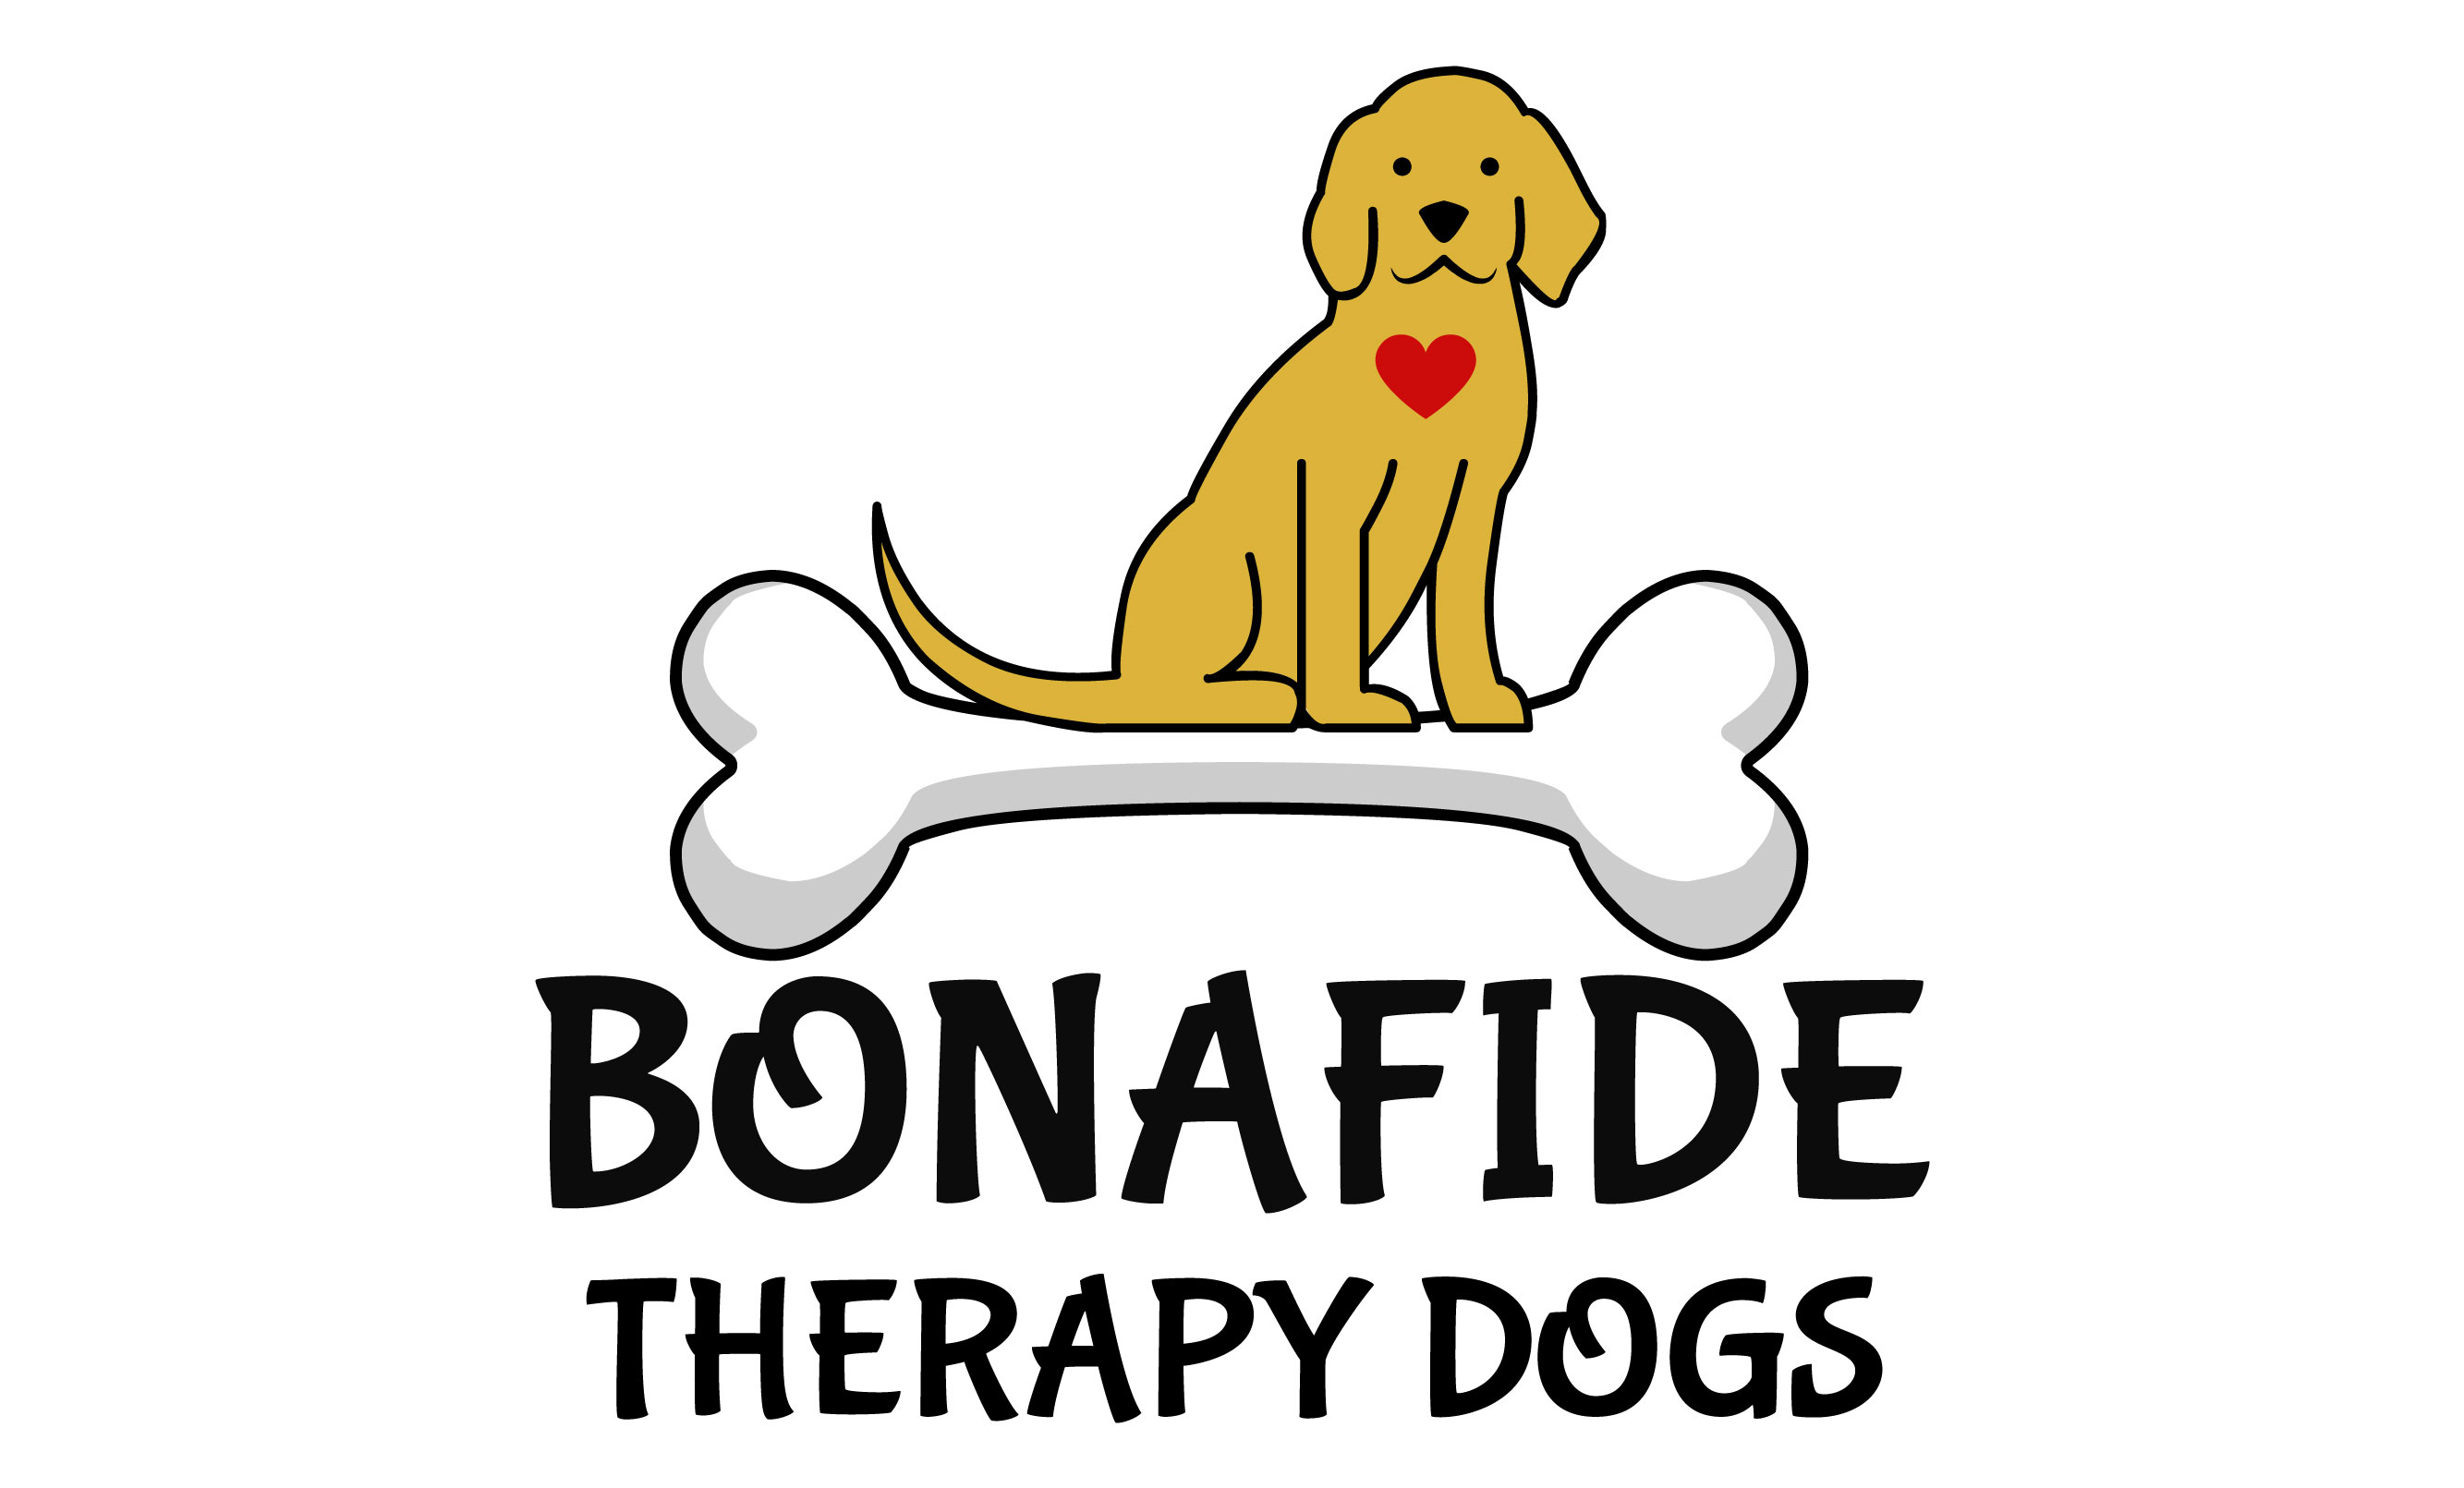
2022 BONAFIDE THERAPY DOGS, INC. MEDIA RELEASE FORM
MEDIA CONSENT FORM AND RELEASE FOR MYSELF AND/OR MINOR CHILDREN
I am [the parent/guardian of] print full name (of child) (“My Child”).
I hereby grant Bonafide Therapy Dogs, Incorporated (“BTD”) and their officers, board members, agents, representatives and associates the absolute right and permission to use photographic portraits, pictures, digital images or videotapes of Me/My Child/My Dog, or in which I/My Child/My Dog may be included in whole or part, or reproductions thereof in color or otherwise for any lawful purpose whatsoever, including but not limited to use in any BTD publication, materials or on the BTD websites, without payment or any other consideration. I hereby waive any right that I may have to inspect and/or approve the finished product or the copy that may be used in connection therewith, wherein My (My Child’s/My Dog’s) likeness appears, or the use to which it may be applied. I hereby release, discharge, and agree to indemnify and hold harmless the BTD, and their officers, board members, agents, representatives and associates from all claims, demands, and causes of action that I or My Child have or may have by reason of this authorization or use of My (My Child’s/My Dog’s) photographic portraits, pictures, digital images or videotapes, including any liability by virtue of any blurring, distortion, alteration, optical illusion, or use in composite form, whether intentional or otherwise, that may occur or be produced in the taking of said images or videotapes, or in processing tending towards the completion of the finished product, including publication on the internet, in brochures, or any other advertisements or promotional materials. I represent that I am at least eighteen (18) years of age and am fully legally competent to sign this Release.
No photos or videos can be taken by students, or members of Bonafide Therapy Dogs, Inc., No photos can be sold, or given to another person without the permission of BTD.
ALL PHOTOS ARE THE PROPERTY OF BONAFIDE THERAPY DOGS, INC. ANY, AND ALL PERMISSON MUST BE GRANTED IN WRITING BY BTD FOR USE. WHERE GRANTED, ALL PHOTOS MUST BE TAGGED ON ALL SOCIAL MEDIA OUTLETS WITH EITHER @BONAFIDETHERAPYDOGS OR #BONAFIDETHERAPYDOGS.
THIS IS A RELEASE OF LEGAL RIGHTS. READ IT CAREFULLY AND BE CERTAIN YOU UNDERSTAND IT BEFORE SIGNING (Both parents, if possible) PLEASE CHECK ONE OF THE BOXES BELOW AND SIGN YOUR NAME(S)
□ CONSENT: We/I hereby certify that We/I are/am (the parent(s) or guardian(s) of the above named child and) do hereby give our/my consent without reservation to the foregoing on behalf of Me/My Child.
□ NON--‐‐CONSENT: We/I hereby certify that We/I are/am (the parent(s) or guardian(s) of the above-named child and) do not hereby give our/my consent without reservation to the foregoing on behalf of

Signature: __________________________________________________________ Date: __________________ (FOR NON-MINOR)
Mother/Father/ Guardian’s Signature ______________________________________________________Date: _____________________
Mother/Father/ Guardian’s Printed Name: ______________________________________________________ Phone #_____________________

