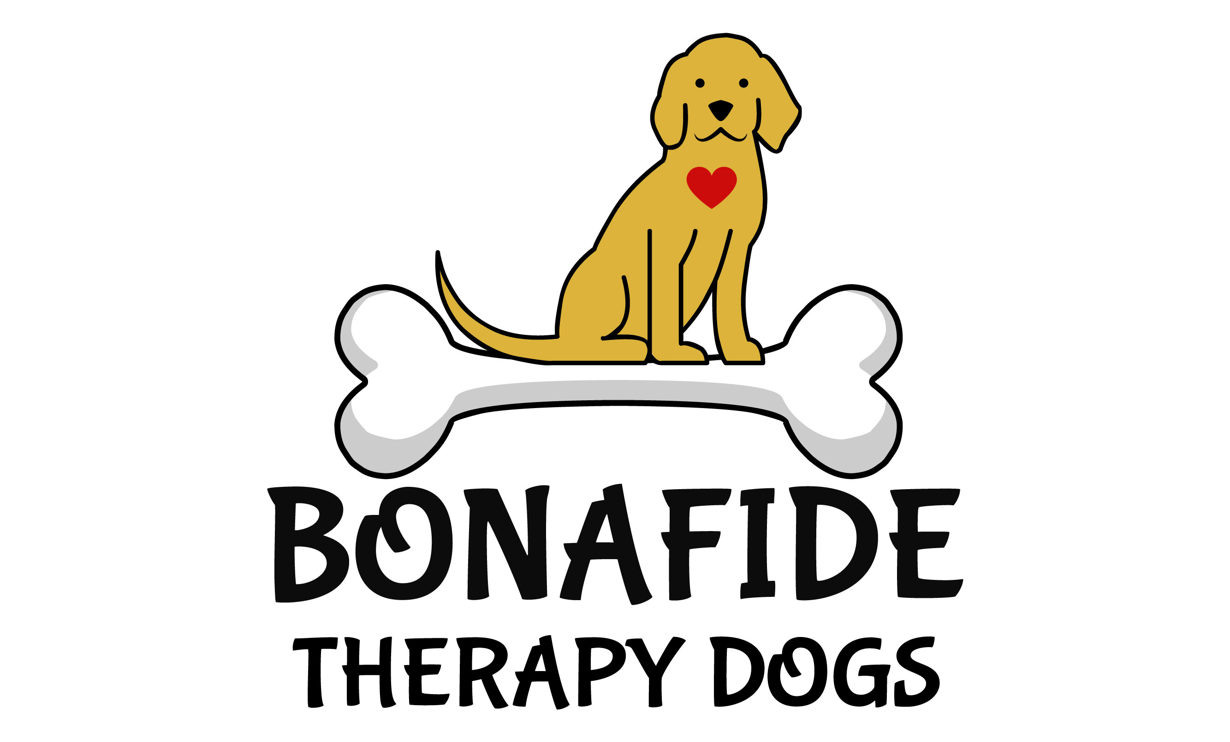
2023 BONAFIDE THERAPY DOGS, INC. MEDIA RELEASE / ALLERGY CONSENT
MEDIA CONSENT / ALLERGY CONSENT FORM, AND RELEASE FOR MYSELF AND/OR MINOR CHILDREN
I am:
[the parent/guardian of]
print full name (of child) (“My Child”).
I hereby grant Bonafide Therapy Dogs, Incorporated (“BTD”) and their officers, board members, agents, representatives and associates the absolute right and permission to use photographic portraits, pictures, digital images or videotapes of Me/My Child/My Dog, or in which I/My Child/My Dog may be included in whole or part, or reproductions thereof in color or otherwise for any lawful purpose whatsoever, including but not limited to use in any BTD publication, materials or on the BTD websites, without payment or any other consideration. I hereby waive any right that I may have to inspect and/or approve the finished product or the copy that may be used in connection therewith, wherein My (My Child’s/My Dog’s) likeness appears, or the use to which it may be applied. I hereby release, discharge, and agree to indemnify and hold harmless the BTD, and their officers, board members, agents, representatives and associates from all claims, demands, and causes of action that I or My Child have or may have by reason of this authorization or use of My (My Child’s/My Dog’s) photographic portraits, pictures, digital images or videotapes, including any liability by virtue of any blurring, distortion, alteration, optical illusion, or use in composite form, whether intentional or otherwise, that may occur or be produced in the taking of said images or videotapes, or in processing tending towards the completion of the finished product, including publication on the internet, in brochures, or any other advertisements or promotional materials. I represent that I am at least eighteen (18) years of age and am fully legally competent to sign this Release.
THIS IS A RELEASE OF LEGAL RIGHTS. READ IT CAREFULLY AND BE CERTAIN YOU UNDERSTAND IT BEFORE SIGNING (Both parents, if possible) PLEASE CHECK ONE OF THE BOXES BELOW AND SIGN YOUR NAME(S)
□ CONSENT: We/I hereby certify that We/I are/am (the parent(s) or guardian(s) of the above-named child and) do hereby give our/my consent without reservation to the foregoing on behalf of Me/My Child.
□ NON--‐‐CONSENT: We/I hereby certify that We/I are/am (the parent(s) or guardian(s) of the above named child and) do not hereby give our/my consent without reservation to the foregoing on behalf of
Bonafide Therapy Dogs, Inc. is not held responsible for any allergies that may arise from a child or an adult having touched/ petted a dog during any visit.
(Mother/Guardian’s Signature) Date ______________________________________________________ _____________________
(Mother/Guardian’s Printed Name) Primary Phone Number ______________________________________________________ _____________________ (Father/Guardian’s Signature) Date ______________________________________________________ ________________

