Registered Charity 1180371

Member of UK Men’s Shed Association

Chippenham Shed

Not just about making and mending

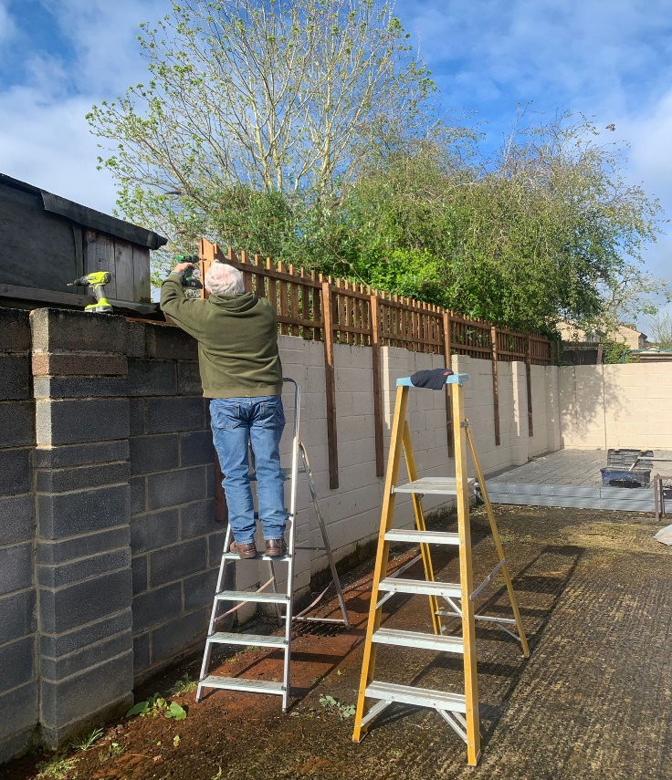

The Shed exists for members to have a friendly chat, some laughter, share experiences, make new friends, learn new skills and find fun in life. We meet every Tuesday at 2.30 pm in the Clubhouse at North Wilts Bowls Club, Westcroft, Chippenham.

The Shed is open Monday to Thursday 9 am until 12.30 pm for members to use the equipment or just to drop in for a chat. Training courses can be arranged through the website.

Want to know more? visit our website at: [www.chippenhamshed.co.uk](http://www.chippenhamshed.co.uk)