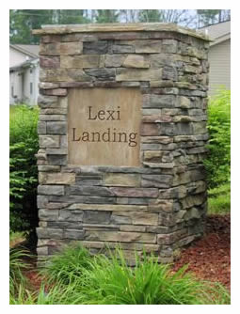
Lexi Landing HOA PO Box 1830 Powell, TN 37849

May 25, 2026
Dear Homeowner,
I hope this letter finds you well. It is that time of year to collect the yearly HOA dues. This letter serves as an official invoice for the annual HOA dues for the year 2026. Dues are 75.00, and are due July 1, and we will allow a grace period till September 1st, 2026. Dues are mandatory. Failure to pay dues can result in a lien being placed on the property. If you rent the property and your landlord is responsible for the dues, please ensure to forward this letter to the landlord.

Description | Amount
2026 DUES | 75.00
TOTAL DUE | 75.00
Below is a breakdown summary of what expenses we have on a yearly basis, so you know what your dues go towards each year:
Dues Paid 2025: 10546.75
Expenses 2025: 10922.00
KUB 5958.00
Professional 1939.00
Insurance 1065.00
Business 887.00
Payment Options:
- Online Payment: You can conveniently pay your annual HOA dues online by visiting our website at https://lexilanding.org/shop. Follow the instructions provided for online payment.
- Check Payment/Money Order: If you prefer to pay by check or money order, please make your check/money order payable to Lexi Landing HOA and mail to: Lexi Landing HOA PO Box 1830 Powell, TN 37849
Contact Information: If you have any questions or require assistance regarding your invoice or payment options, please do not hesitate to contact our HOA management team at lexilandinghoa@gmail.com
Thank you,
Amy Asbury,
HOA Treasurer

