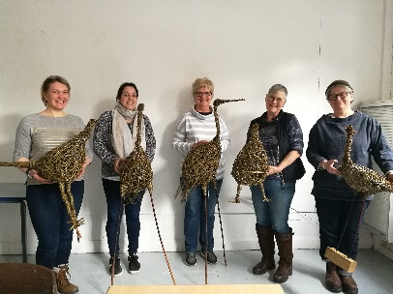LFWI

Cookery & Craft Sub Committee

**Willow Weaving Workshop**

**Tutor:** Joevanka Gregory

**Dates:** Sunday 12th July or Tuesday 14th July 2020

**Venue:** LFWI Offices Croston House, Leyland PR26 6TU

**Time:** 10.00am to 3.30pm

**Cost:** £20.00

The course is being run by the well-known Joevanka Gregory who is an expert in the delights of Willow Weaving.

On the day you will be making a bird sculpture to display in the home or maybe in the garden. There will be a choice of Chicken, Heron, Curlew, Pheasant or a bird of your choice.

Cost of the willow is £20.00 per person payable to the tutor on the day.

Don’t forget to bring a packed lunch and as usual, tea and coffee plus biscuits will be available all day.

Closing Date: Monday 15th June 2020

-----------------------------------------------------------------------------------------------------------------------------------------------------------

**March 2020**

**LFWI Cookery & Craft Sub Committee**

**Willow Weaving Workshop**

Name of WI ..............................................................Secretary…………………..........................................

Address ........................................... .........................Postcode ............................................................

Telephone ................................................................Email ...................................................................

**Sunday 12th July 2020:……………… or Tuesday 14th July 2020………………..**

**By providing this information, you are giving permission for your data to be used for WI/Federation purposes.**

Please complete the form and return to LFWI Offices, Croston House, Lancashire Business Park,CenturionWay, Leyland PR26 6TU

Closing Date: Monday 15th June 2020