Black Nurses Association
of
Greater Houston
P.O. Box 20056
Houston, TX 77225
bnagh19@hotmail.com
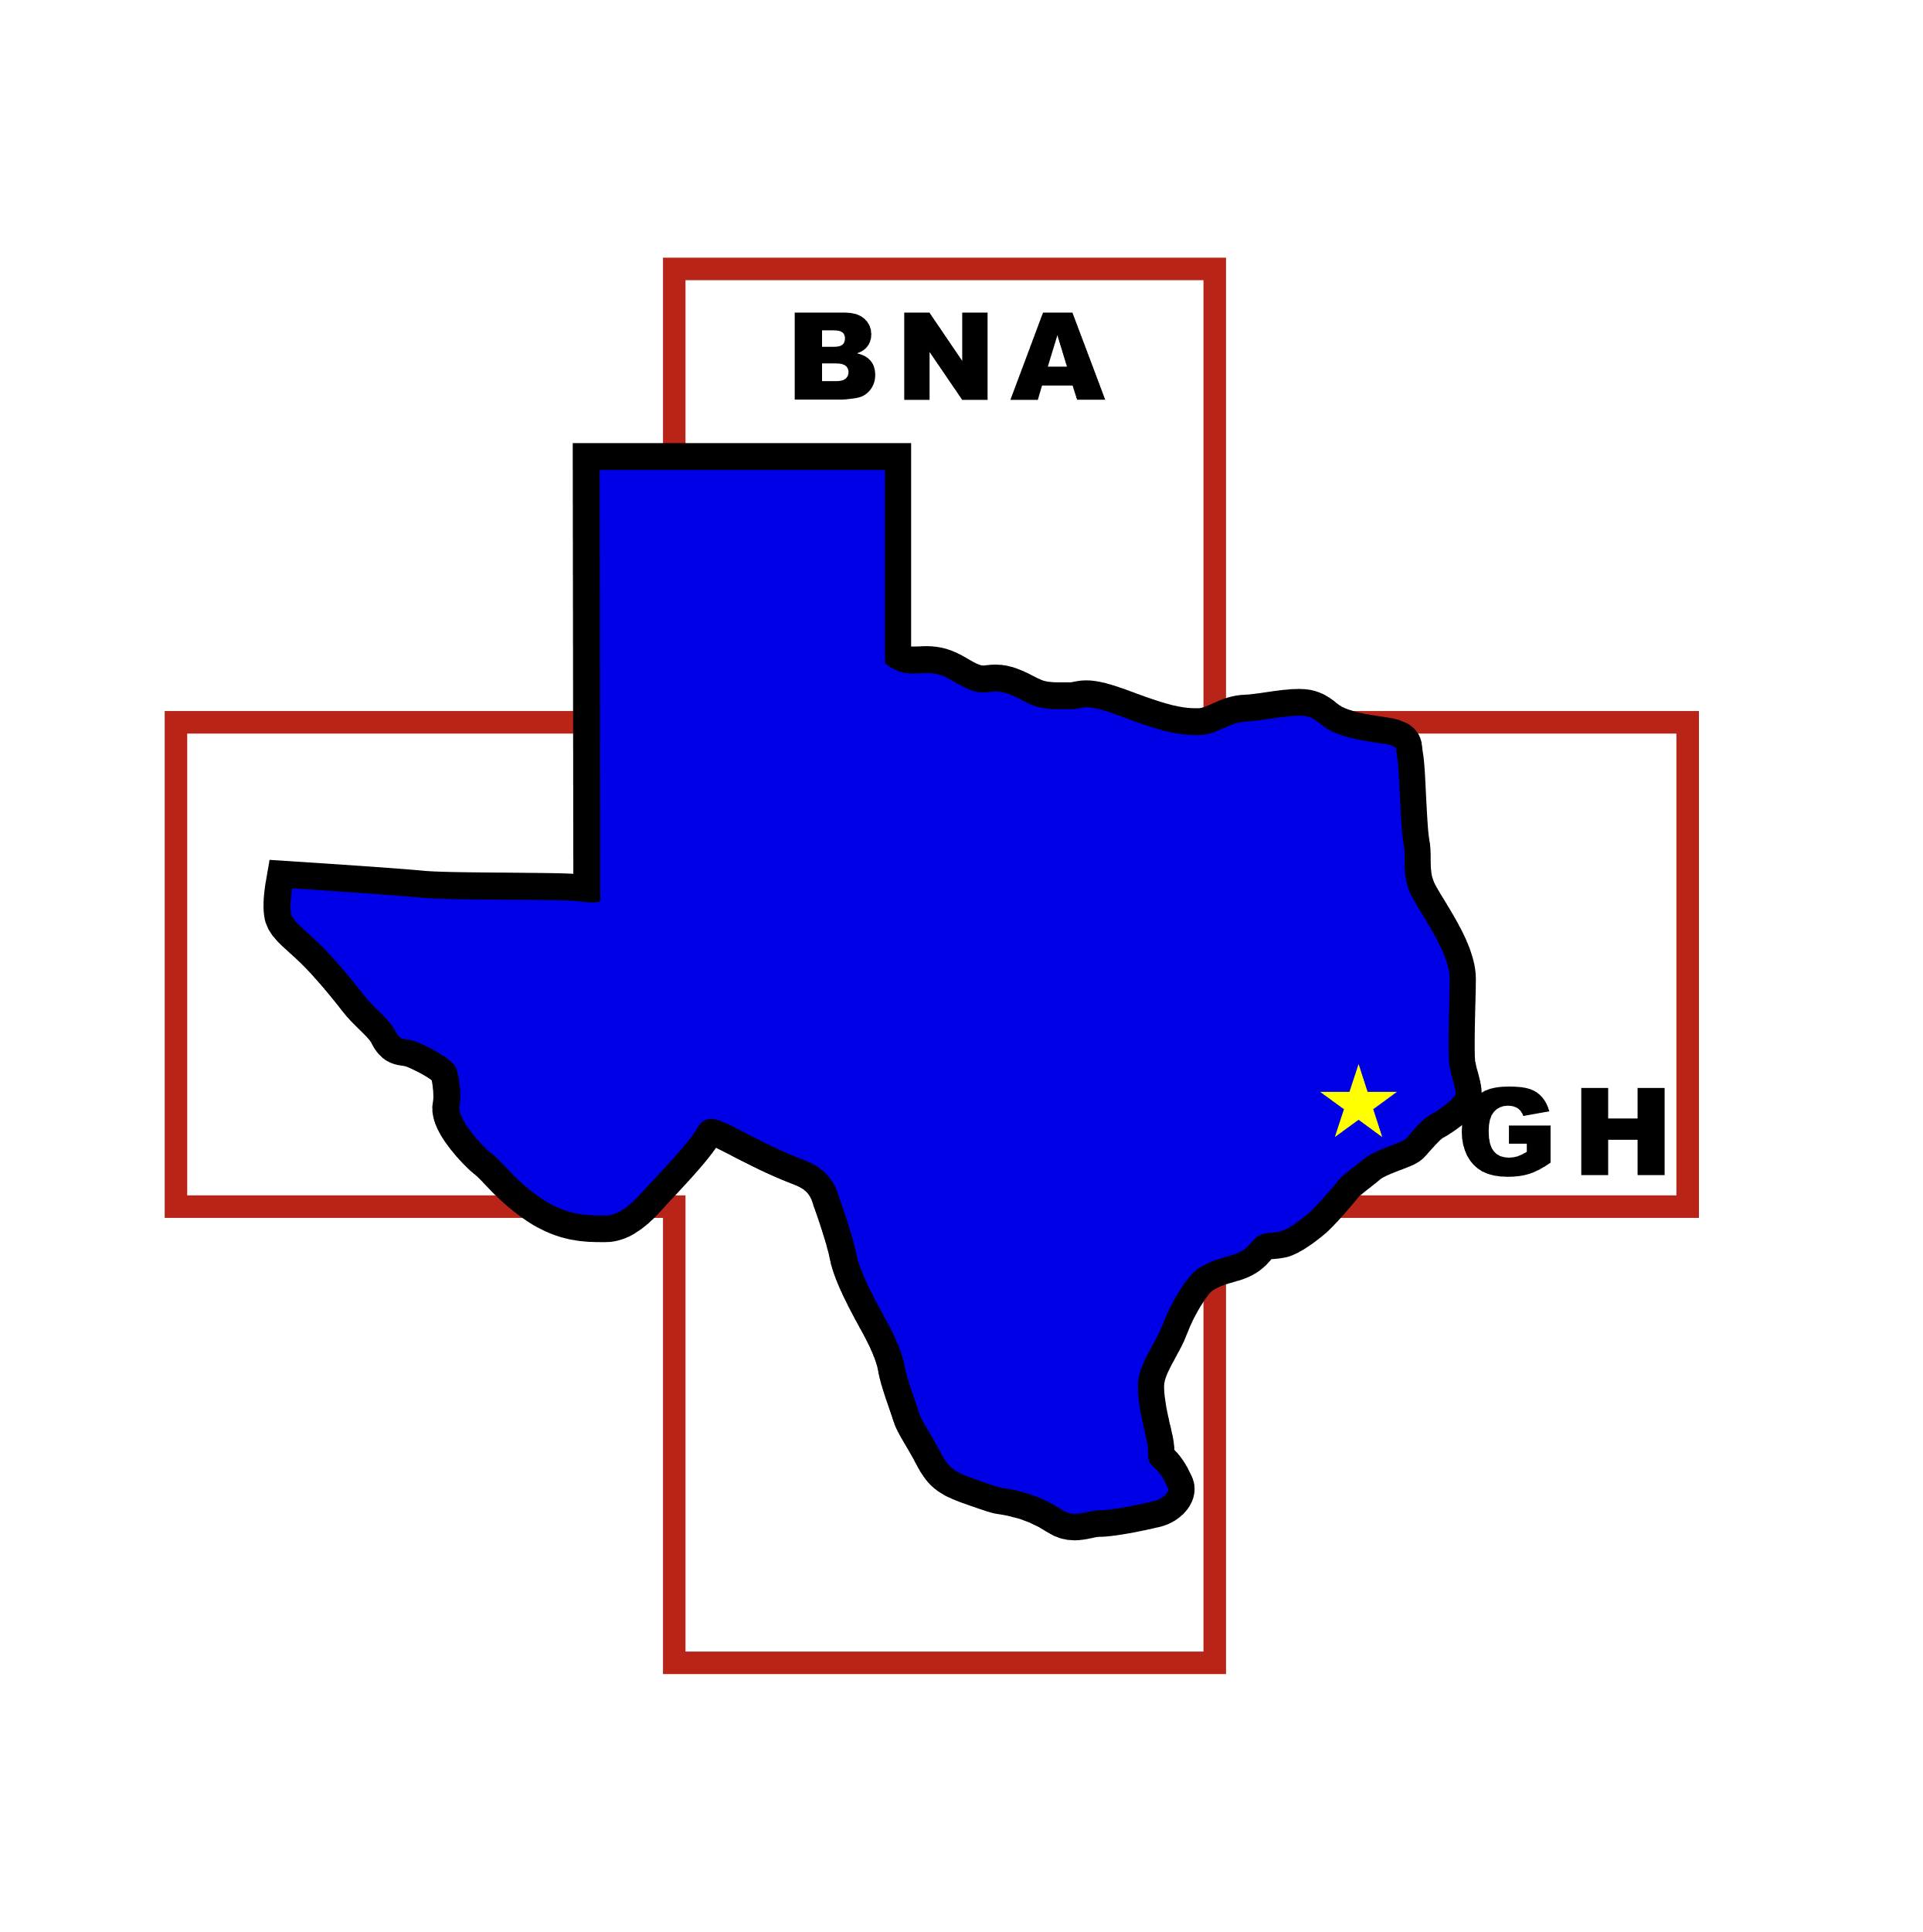

Undergraduate and Graduate Scholarship Application Criteria

The Scholarship Committee of Black Nurses Association of Greater Houston will consider applicants who meet the following criteria

All requested information is required for your application to be considered

- Enrolled in an accredited School of Nursing (PhD, MSN, BSN, or AD).
- In good academic standing in that School of Nursing at the time of application.
- Have at least one full year of school remaining.
- Involved in extracurricular and/or organization activities, such as church, nursing organization, Health and Wellness or community activities.
- Active member of Black Nurses Association of Greater Houston (BNAGH)

Must Provide:

- Official transcript from current school of nursing.
- Completed Scholarship Application. (FORM 1)
- One letter of recommendation from a faculty member at the applicant’s school of nursing. FORM 2 must be used for the recommendation.
- An essay - 300 words or less. See page four for instructions.
- A clear/clean professional picture (Headshot or passport size picture is adequate)
- Documented evidence of at least four (4) hours of extracurricular and/or organizational activities.

Completed applications and all required information must be post office marked by

March 22, 2021

MAIL TO:

BNAGH Scholarship Committee
P.O. Box 20056
Houston, Texas, 77225

You may email questions to: BNAGH19@hotmail.com
Attention: Scholarship Committee

Black Nurses Association
of
Greater Houston
P.O. Box 20056
Houston, TX 77225
bnagh19@hotmail.com
FORM 1: Application for a BNAGH Scholarship
(Please Print or Type)

Name _______________________________________________________________________
First Middle Last

Current Address ______________________________________________________________

____________________________________________________________________________
City State Zip Code

Telephone # ___________________________________ _________________________________________________
Day Evening
Email Address______________________________ Fax ___________________________

Name and Address of Current School of Nursing _____________________________________

_______________________________________________________________________________________________________

Degree Program ______________________________________________________________

Check all that apply: AD ___ BSN ___ MSN___PhD___ Full-Time___ Part-Time____

Expected Date of Graduation: Month____________________Year _____________________

List Involvement in extracurricular activities including church, health related programs community programs/activities, volunteer services, organization affiliations and memberships. Provide supporting documentation for activities, such as a signed letter from an event/activity organizer, agenda or flyer of event with documentation of participation ____________________________________________________________________________ ____________________________________________________________________________

_______________________________________________________________________________________________________

Certificates and Awards: ________________________________________________________

_______________________________________________________________________________________________________

_______________________________________________________________________________________________________

How would this scholarship benefit you? ___________________________________________
___________________________________________________________________________

_______________________________________________________________________________________________________

____________________________________________________ ________________________________________________
Signature of Applicant Date
Black Nurses Association
of
Greater Houston
P.O. Box 20056
Houston, TX 77225
bnagh19@hotmail.com

Form 2: Nursing Faculty Recommendation

Applicant’s Name___________________________________________________________

School of Nursing: __________________________________________________________

- How long have you known the applicant? ____________________________

- Please rate the applicant in each of the following areas:

Excellent Good Average Poor Do Not Know
Ability to work with others
Conceptual ability
Consistency
Creativity
Flexibility
Initiative
Integrity
Leadership
Maturity
Motivation
Sensitivity to patients
Communication Skills

Comments:

_________________________________________________________________________________________________________
Nursing Faculty Name (Print) Position

_________________________________________________________________________________________________________
Nursing Faculty Signature Date

Black Nurses Association
of
Greater Houston
P.O. Box 20056
Houston, TX 77225
bnagh19@hotmail.com

BNAGH SCHOLARSHIP APPLICATION
ESSAY QUESTIONS

On a separate sheet of paper, please respond to one of the following questions as identified for the level of nursing education you are currently pursuing. Your response must be no more than 300 words typed, single spaced, with a ten (10) point font. Be sure to include your name on the document.
Responses that do not follow the criteria as outlined above will not be reviewed.
- For pre-licensure nursing students who are in a Diploma, Associate Degree or Bachelor of Nursing program, please write your response to the following:

Describe what nursing means to you.

- For the LVN to RN or the RN to BSN student, please respond to the following:

What are the factors that have motivated you to seek a higher level of nursing education?

- For those seeking an advanced nursing education (MSN or PhD), please respond to the following:

What do you see as the critical issues impacting population health for which an advanced degree in nursing will make a difference in patient outcomes?

PLEASE RESPOND TO ONLY ONE STATEMENT/QUESTION THAT IS RELATED TO THE NURSING EDUCATION YOU ARE SEEKING. ONLY ONE RESPONSE WILL BE REVIEWED AND MULTIPLE RESPONSES WILL NOT BE CONSIDERED AND MAY AFFECT STANDING IN THE APPLICATION PROCESS.

Black Nurses Association
of
Greater Houston
P.O. Box 20056
Houston, TX 77225
bnagh19@hotmail.com

Please Note:

All criteria on the preceding pages must be completed entirely. Otherwise, your application will be disqualified.

Transcripts must be an official copy from your college. All other transcripts are unacceptable and disqualifying.

Applications must be received by March 22, 2021 to be considered for the scholarship.

Thank you for your participation in the BNAGH scholarship program.

