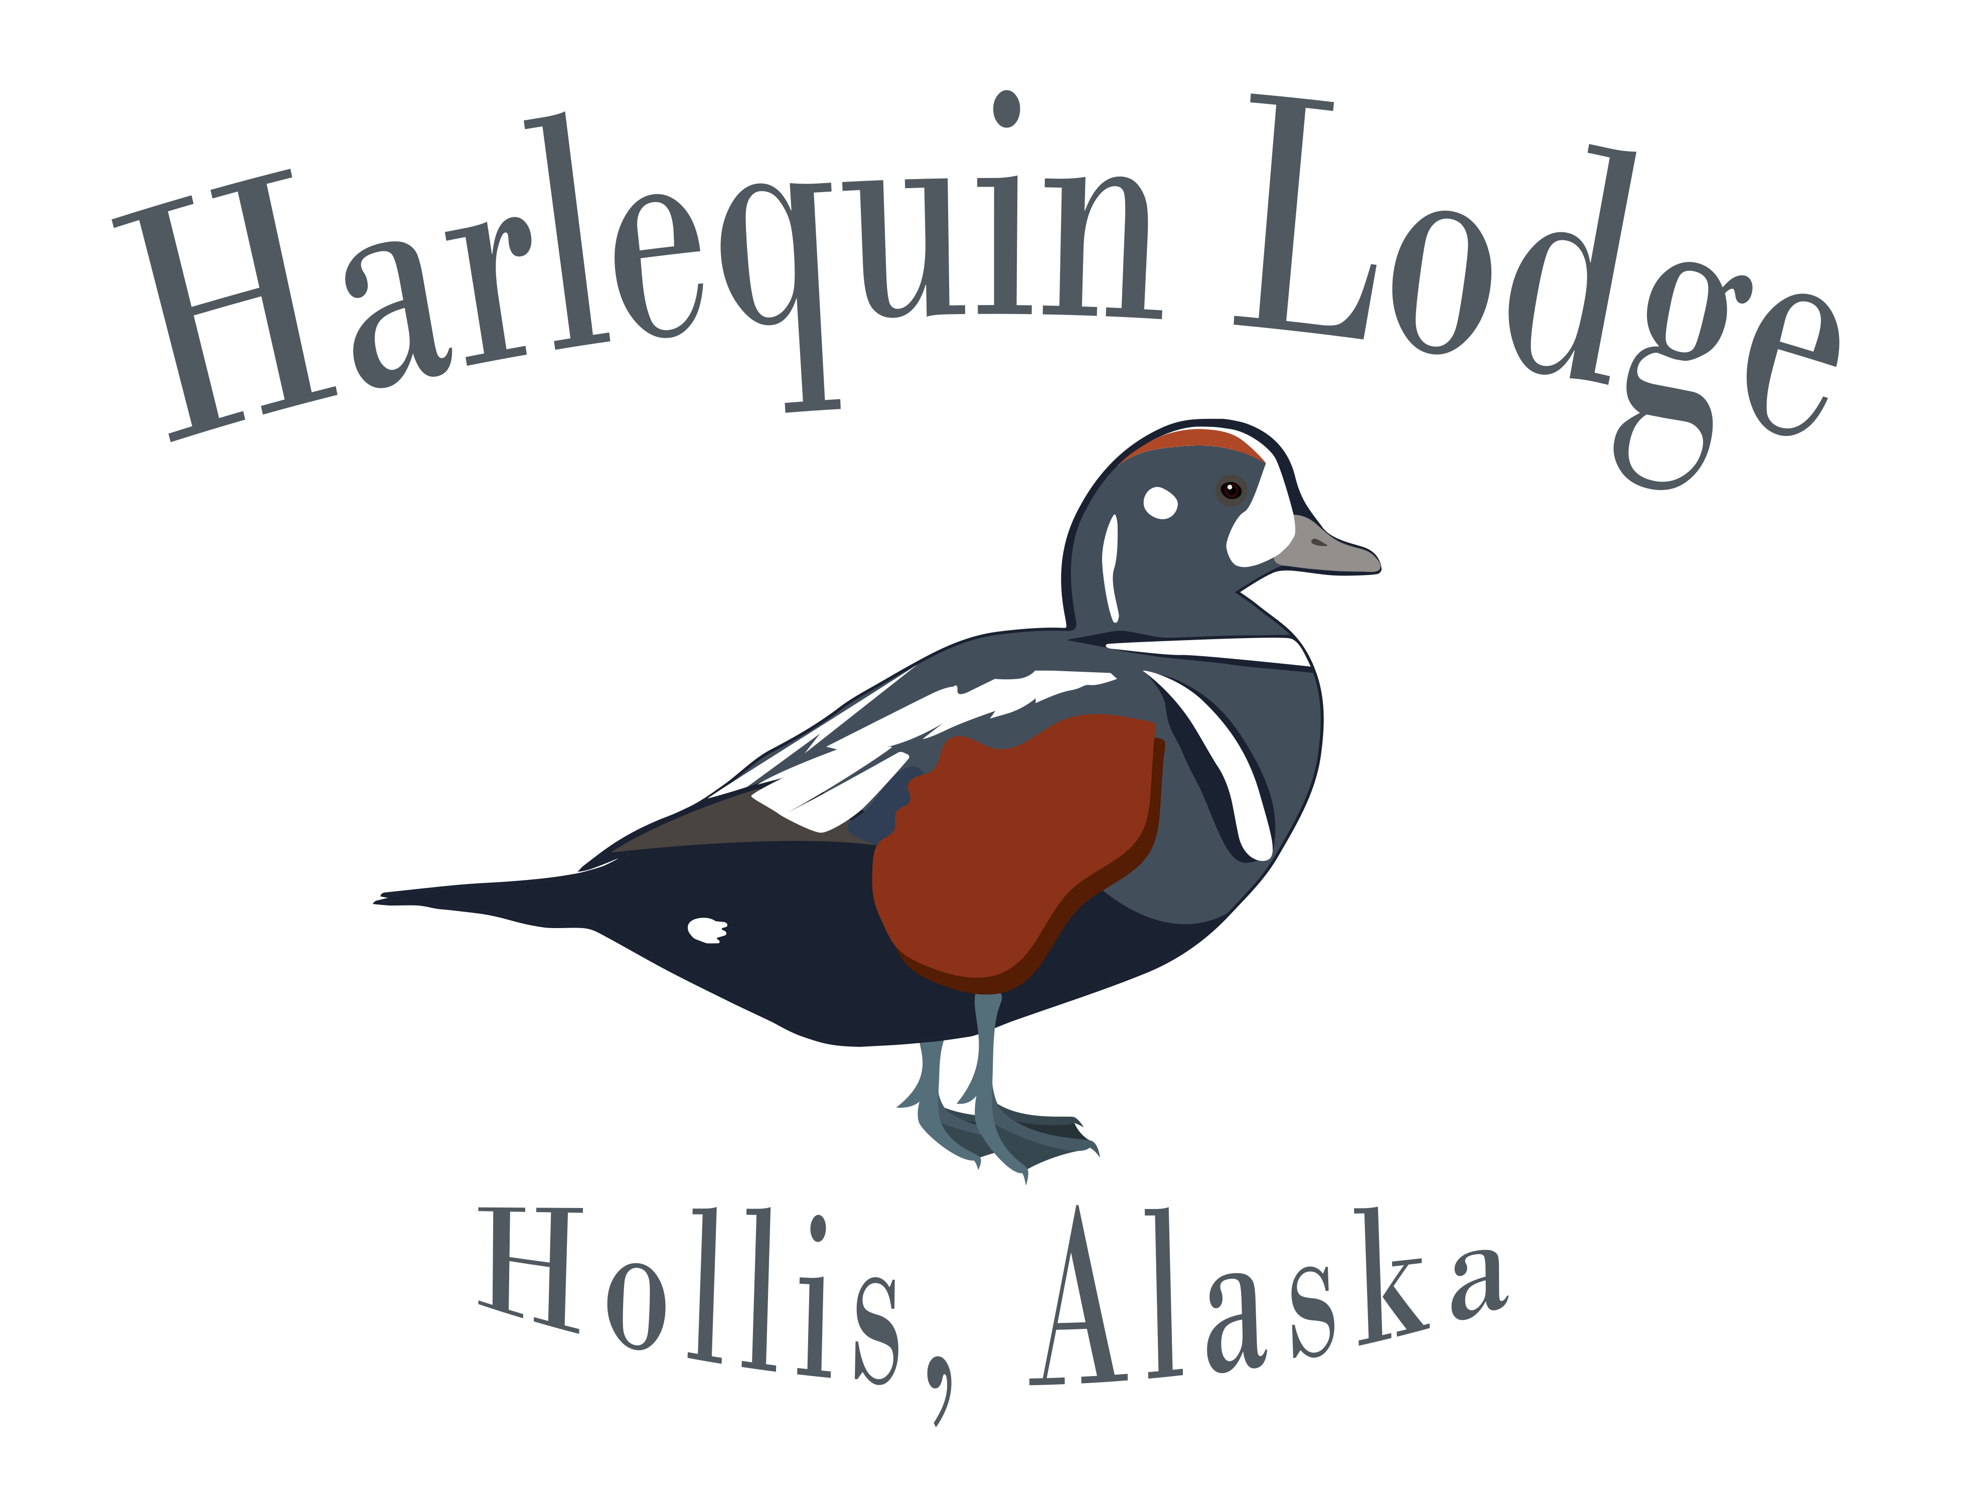
Information & Packing List

Thank you for reserving your vacation at Harlequin Lodge! We are pleased to have you join us!

We require a 50% deposit to confirm booking dates, and the balance of your trip package is due upon arrival. Credit/Debit Cards, Checks, Cash, and Venmo are accepted. If you choose to pay your balance by credit card, we accept Visa and Master Card. Please contact us by phone and we can take you CC info over the phone or send us an email and we will email you a credit card authorization form to fill out and fax back to us. To protect your privacy, we do not keep credit card numbers on file. If you choose to pay with a credit card, debit card, or Venmo a 3% fee for credit cards and a 2% fee for Venmo will be added to offset charges we incur. If you choose to send a check please send it to 79509 Stage Gulch Rd Echo, OR 97826. Make sure you put the week you are coming to the lodge on the check. Deposits are refundable 100% up to 60 days prior to your booking date.

Transportation will be provided once you arrive on Prince of Wales Island. You will fly into the Ketchikan Airport and options to get to and from Prince of Wales Island are as follows: Interisland Ferry (3 hour ferry ride departing daily from Ketchikan at 3:30 PM Boarding at 2:30 PM), Island Air (wheeled plane into Klawock), Taquan Air (float plane service to Hollis), or a chartered float plane ride. If you choose to come into Ketchikan the night before, a number of hotels are available, but book early!! We use the Landing in Ketchikan when we need to stay an extra night! www.landinghotel.com 800-428-8304 Harlequin Lodge is not responsible for any flight delays or cancellations due to weather, mechanical problems, acts of nature, etc.

Fishing Licenses
Fishing licenses are not included in your booking and can be purchased on line at www.admin.adfg.state.ak.us/license or you may purchase them upon arrival. You must have a SE Alaska Shrimp Permit if you want to give shrimping a try!

Recommended Packing List (June-Sept Fishing trips):
- Clothing for variable weather conditions (layers work well), such as:
  - Short-sleeved and long-sleeved shirts
  - Fleece pullover
  - Hooded sweatshirt or warm hat
  - Fleece pants or long johns to wear under waders
  - Short and long pants
  - Hooded rain gear
  - Heavy boot socks
  - Durable shoes, rubber “muck” boots recommended
- Hat or cap for sun protection and/or warmth
- Polarized sunglasses
- Mosquito nets or repellent
- Sunscreen
- Camera
- Sandals or slippers to wear inside the lodge
- Personal toiletries/medicines (linens are provided)
- Alcohol/tobacco, if desired (we cannot supply these items available for purchase on the Island)
- Cash for gratuities
- Fishing license (may be purchased online or upon arrival)
- Headlamp or lightweight flashlight
- Laptop, if desired (WIFI is available for free)
- Breathable waders if desired for river fishing(No felt bottom boots allowed since 2012)
- Fly rod if desired for potential river fishing
Remember to travel light. When traveling by float plane, baggage space is limited to 50 lbs. per person. You may wish to bring a duffel bag instead of a hard suitcase to save space. Laundry facilities are available for guest use at the lodge for a small fee. If you contact the lodge in advance, they may be able to have some alcohol shipped out for you.
Fish Filleting and Packaging:
Fish processing, packaging, and shipping is available for a small fee, we use a local fish processor where we will drop you catch off daily! The processor will fillet, vacuum pack, freeze, and box your fish in airline approved boxes. They are also able to ship fish boxes anywhere Alaska Airlines fly.
Gratuities:
Gratuities are welcome but not expected, if we did a good job for you, feel free to leave a gratuity!
Payments:
For your ease and convenience, we will keep a tab of any other expenses (i.e. clothing and souvenirs) during your stay with us. We will reconcile your tab the evening prior to departure.
Excursions from the Lodge
If you are on a self-guided hunting trip or just staying at the Lodge relaxing, additional excursions may be available from the lodge. We offer day fishing trips, day shrimping trips, whale watching, or a tour of the island for an additional fee! These trips can be pre-arranged or decided on the fly!!
Please forward this information to the rest of your party. Don't hesitate to let us know if you have any further questions!
We look forward to seeing you!

Thanks again for your business,

Lucas & Doug Wagner
Harlequin Lodge Captains/Owners
lucaswagner76@gmail.com
(541) 720-0266

