PARTICIPANT INFORMATION SHEET
FOR CHILDREN

To be shown and read by parent/carer if required

Study title: Sampling of the wall of the lateral Ventricle (SOLVe)

- What is research?  Research is a careful experiment to find out the answer to an important question. | 
- Why is this project being done?
We are doing this research to try and understand more about how the brain works and how it reacts to injury, by understanding more, we hope to develop new treatments to reduce brain injury.
- What is the wall of the lateral ventricle?
Everyone’s brain is constantly making a fluid called cerebrospinal fluid or C.S.F. this is made in one part of the brain and circulates all the way around your brain and spinal cord. The lateral ventricles are the fluid filled spaces in the middle of the brain and they are lined by very special and unique cells.
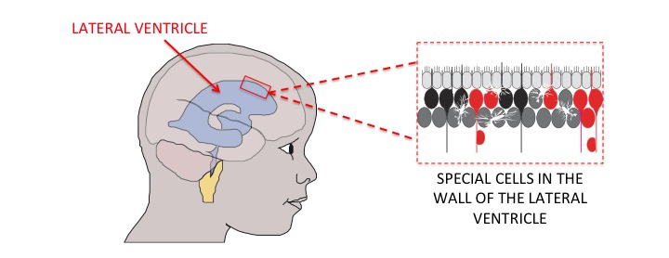

- Why me?
You have been chosen because you are going to have an operation on your brain. By taking part in the trial you can help us to find some answers that will allow us to understand more about the brain and hopefully develop new treatments to prevent brain injury.

We are asking 20 children all together. We have given your parents some information about the trial and what we would like to do and we will speak to you in hospital before your operation if you are happy to be involved.

- Do I have to take part?

No you do not! It is up to you. We would like you to read this information sheet. If you agree to take part, we would like you to write your name on two forms. We will also ask your mum, dad or carer to write their name on the forms and give one back to us. You can still change your mind later. If you don’t want to take part just say no!

- What will happen?  The aim of your operation is to isolate the part of the brain, which we think the seizures are starting in, from the rest of the brain, this is to prevent the seizure from spreading. Hopefully this will make you feel much better. | 

To isolate the part of the brain that is causing the seizures we cut the tissue around it, this can be thought of like digging a moat around a castle. The tissue that we remove is normally just sucked away but with your permission we would like to take this tissue and use it for some experiments. We want to do this to try and understand a bit more about how this part of the brain works.

Taking the tissue and using it for research, rather than throwing it away, will not cause you any harm and doesn’t change the way that your operation is done, but it’s important that you are happy for us to do this. If for any reason you’re not happy to donate this tissue then you don't have to give us any reason for this and it won’t affect your treatment in any way at all.

- What else might happen?

Because we are just taking tissue which would normally be thrown away there are no risks to you in entering this trial.

As well as using the tissue for research we would also like to take a blood sample and also a sample of CSF, this will all be done during the operation whilst you’re asleep so you won’t feel anything and again this won’t cause any risk at all.

- What happens when the research study stops?
The samples of tissue, blood and CSF will all be used in experiments and stored in the research laboratories at Great Ormond Street for about 15 years after the experiments are finished, any leftover material will be thrown away.

- What if something goes wrong?
Your mum, dad or carer will be able to talk to someone who will be able to tell them what they need to do about it.

- What if I don’t want to do the research anymore?
Just tell your mum, dad, carer, doctor or nurse at any time. They will not be cross with you. You will still have the same care whilst you are at hospital.

- What happens to what the researchers find out?
The samples will be stored in research laboratories at Great Ormond Street and any information that we find out from our experiments will be stored in a safe place and only the people doing the research study can look at it.

We will use any information that we find out to write articles that will be published in medical magazines and on websites that doctors read.
- Did anyone else check the study is OK to do?
This study has been checked by several people, to make sure it is alright.
- How can I find out more about this study?
Your mum, dad, carer or other grownup you trust may be able to answer your questions. The (doctors and nurses) looking after you can also help you find out more about the study.

Thank you for taking the time to read this – please ask any questions if you need to.

