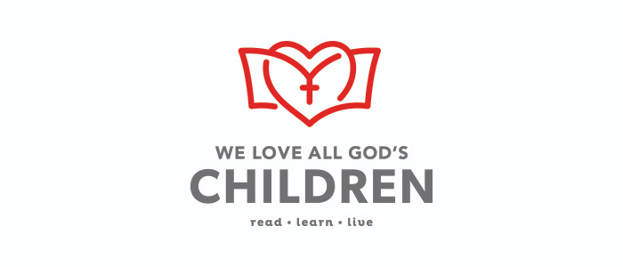

**2021 Charge Conference Report**

INSTRUCTIONS

* The Texas Annual Conference We Love All God’s Children Initiative engages all children ages 0 through 11 years of age regardless of race, religion, ethnicity, gender, economic status or national origin. In addition to providing opportunities for discipleship, early literacy, and health to members and constituents, United Methodist congregations should be intentional in reaching beyond church walls to provide a foundation for faith and life success for children not currently served by existing church ministries, particularly the underserved and the unchurched.
* “Underserved” is defined in this context as those who face challenges due to disparities in opportunities for quality early childhood education, health services, mentoring programs, etc. due to economic, social, cultural, and/or religious status.

EXAMPLE OF COMPLETED FORM

1. **Children who are currently part of your congregation (members, constituents, regular attendees):**
   1. Total number of children currently part of congregation served in **DISCIPLESHIP** ministries____87____
   2. Of this total, what number would you estimate to be **underserved**? __21______
   3. List **DISCIPLESHIP** ministries with children who are currently part of your congregation.

* Sunday School
* Children’s Church
* Wonderful Wednesdays
* Vacation Bible School
* Summer Camp
* Day School

1. **Children who are NOT currently part of your congregation (members, constituents, regular attendees):**
   1. Total number of children **NOT** part congregation served in **DISCIPLESHIP** ministries___65_____
   2. Of this total, what number would you estimate to be **underserved**? ___49_____
   3. List **DISCIPLESHIP** ministries with children who are **NOT** currently part of your congregation.

* Wonderful Wednesdays
* Vacation Bible School
* After-School Mentoring
* Day School
* Grands & Angels Outreach

**We Love All God’s Children**

**2021 Charge Conference Report**

**Name of Church/Town ___________________________________________________________________**

1. **Children who are currently part of your congregation (members, constituents, regular attendees):**

**DISCIPLESHIP (Spiritual Learning)**

* 1. Total number of children part of congregation served in **DISCIPLESHIP** ministries__________
  2. Of this total, what number would you estimate to be **underserved**? __________
  3. List **DISCIPLESHIP** ministries with children who are currently part of your congregation.

**EARLY LITERACY**

* 1. Total number of children part of congregation served in **EARLY LITERACY** ministries__________
  2. Of this total, what number would you estimate to be **underserved**? __________
  3. List **EARLY LITERACY** ministries with children who are currently part of your congregation.

**HEALTH**

* 1. Total number of children part of congregation served in **HEALTH** ministries__________
  2. Of this total, what number would you estimate to be **underserved**? __________
  3. List **HEALTH** ministries with children who are currently part of your congregation.

1. **Children who are NOT currently part of your congregation (members, constituents, regular attendees):**

**DISCIPLESHIP (Spiritual Learning)**

* 1. Total number of children **NOT** part congregation served in **DISCIPLESHIP** ministries__________
  2. Of this total, what number would you estimate to be **underserved**? __________
  3. List **DISCIPLESHIP** ministries with children who are **NOT** currently part of your congregation.

**EARLY LITERACY**

* 1. Total number of children **NOT** part congregation served in **EARLY LITERACY** ministries________
  2. Of this total, what number would you estimate to be **underserved**? __________
  3. List **EARLY LITERACY** ministries with children who are **NOT** currently part of your congregation.

**HEALTH**

* 1. Total number of children **NOT** part congregation served in **HEALTH** ministries________
  2. Of this total, what number would you estimate to be **underserved**? __________
  3. List **HEALTH** ministries with children who are **NOT** currently part of your congregation.