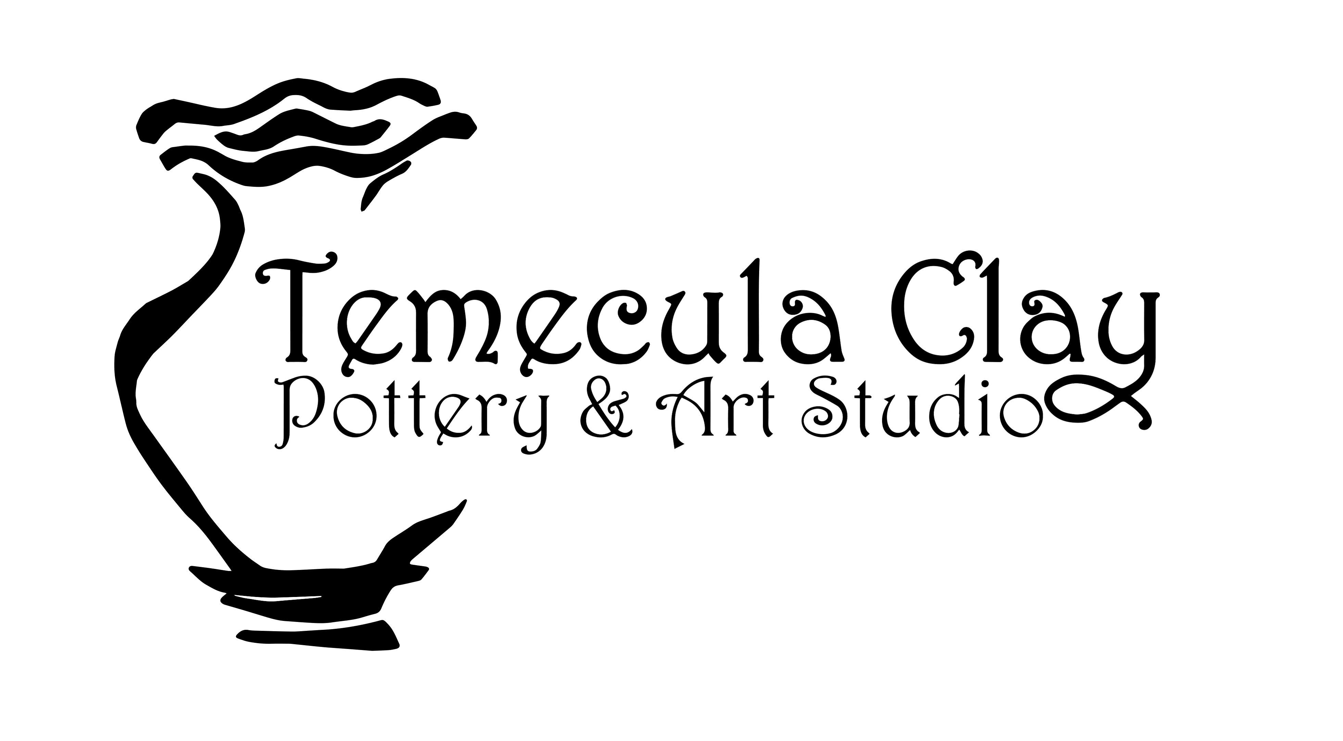  April  32127 D Temecula Parkway Temecula, CA 92592 www.TemeculaClay.com  951-414-6051 | 2018
Sunday | Monday | Tuesday | Wednesday | Thursday | Friday | Saturday
1 | 2 | 3 | 4 | 5 | 6  4-5:45 Kids Pottery  7-9 Adult Pottery Beginning Wheel | 7  11-12:15  Kids Clay Workshop,$15
Happy Easter! |  |  | 11-12:30  Story& Clay,$15  1-2:45  Homeschool Kids Pottery Class |  | 11-1 Adult Pottery  4-5:45 Kids Pottery  7-9 Adult Pottery Beginning Wheel
8 | 9  11-1 Beg. Adult Pottery  345-5 Kid Pottery | 10  1pm-2:45pm  Homeschool Kids Pottery Class | 11 | 12 | 13 | 14  11-12:15  Kids Clay Workshop,$15
1-3 Adult Pottery |  |  | 11-12:30  Story & Clay,$15  1-2:45  Homeschool Kids Pottery Class
15 | 16  11-1 Beg. Adult Pottery  345-5 Kid Pottery | 17  1pm-2:45pm  Homeschool Kids Pottery Class | 18 | 19 | 20 | 21  11-12:15  Kids Clay Workshop,$15
1-3 Adult Pottery |  |  |  |  | 11-1 Adult Pottery  4-5:45 Kids Pottery  7-9 Adult Pottery Beginning Wheel
22 | 23  11-1 Beg. Adult Pottery  345-5 Kid Pottery | 24  1pm-2:45pm  Homeschool Kids Pottery Class | 25  11-12:30  Story& Clay,$15  1-2:45  Homeschool Kids Pottery Class | 26 | 27  11-1 Adult Pottery  4-5:45 Kids Pottery  7-9 Adult Pottery Beginning Wheel | 28  11-12:15  Kids Clay Workshop,$15
1-3 Adult Pottery
29 | 30  11-1 Beg. Adult Pottery  345-5 Kid Pottery
1-3 Adult Pottery
 |  |  |  |  |  | Business Hours: Monday-Saturday 11am-8pm (closed Thursdays for fieldtrips) & Sundays 11am-5pm

Adult Pottery Classes Ages:16 & Up
8 Classes for $199; 4 Classes for $105; Single Class for $30- Class price does not include clay.
Make beautiful pottery by hand building and the potter’s wheel! Students will learn to create pottery using various methods of ceramics skills. Our experienced instructors will guide you through this fascinating medium and inspire you in various projects. You have thirty days to use your four classes or sixty days to use your eight classes from your first visit. You can mix your class days but must preregister.

Kids & Teen Pottery Classes Ages: 7 & Up
4-week Session for $95/mo.; Single Class Session: $25
Encourage your kids in art with ceramics classes! Our kid’s classes focus on techniques and encourage creativity, self-esteem and individualism. Students will learn to create pottery using various methods of ceramics skills including hand building and pottery wheel. You will have 30 days to use your classes from first visit.

Clay & Storytime Ages: 2 to 7 years
4-week Session: $60; Single class Session: $15
Enlighten your tot in creativity and the beauty of working with clay! Each week a member of our friendly staff will lead your child in a new adventure with a story and then we will recreate one of the story characters from a lump of clay. Please stay with your child for this class. You have thirty days from your first visit to use your four classes.

Pottery Painting All Ages
Choose from our selection of handmade, poured and unique bisque pottery to paint with your own designs. We offer a nice selection to choose, from mugs to figurines. Our pottery is priced as marked and we do not have a studio fee. No reservations are required!

Open Studio Ages: 16 & Up
Experience is required
$10/hour, $25/day, $75/month (once/week), $150 Unlimited
This is not a class time. Enjoy the use of Temecula Clays fully equipped studio. The studio has classes and workshops that may be using the space at certain times, you may use the space that’s open during these times. Materials & firing are extra. You may return to glaze your pottery for $6 studio fee plus firing per piece. Available during open hours

Fieldtrips, Scout Groups & Birthdays All Ages
Enjoy a unique and memorable visit to Temecula Clay. A member of our talented staff will help and guide you for your special event. One staff member per 10 guests. See each for min and max. All pieces are left at the studio for firing. Choose from our glazes that evening or return at a later date to glaze ($6 if you return to glaze) A $75 deposit is required and is non-refundable if cancelled within one week of the event. Choose One: Pottery or Canvas Painting Party, Clay Hand Building or Pottery Wheel (Ages 8 & up-Min 4, Max 7)

Handmade Pottery by Local Artists
Stop in and shop our beautiful wares, handmade by local potters at Temecula Clay! Our selection is always changing so stop by often. Handmade pottery can be wrapped and given as gifts or go home with you to b treasured!

Pre-Registration is a must for all classes & groups

