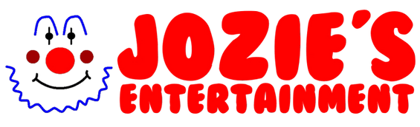

Application form for character and Mascot roles
Thank you for applying at Josie’s Face Painting and Entertaining. You will have so much fun working with our team. Please note that the more YES answers you provide, the more job roles we can offer you.
Please add a photo of your face

Name:
Phone number:
Age:
Address:

Do you drive? Speak another language?
What distance are you willing to travel (in miles) from address provided?
Are you willing to work weekends: Yes /No (Times vary from 9-9pm)
Are you willing to wear a wig? Yes/ No
Circle all the roles your applying for you can circle as many as you like…
(The more roles the more work!)

Prince Characters Princess Characters Mascots Clowns
Superheroes Pirates M/F Character roles

Can you sing? Yes/ No (Doesn’t have to be professional)
Do you know any songs by Disney including Disney Princess songs?
Please list a few:

Are you willing to learn any songs by Princesses and Disney songs? Yes/ No
Can you dance (move to music) to music?
Would you read stories? Yes/No
Play a selection of games with children? Yes/ No
(For example: musical bumps, music statues, pass the parcel)
Do you have any Entertaining skills?
Please note if you have any not listed.
- Juggling
- Balloon modelling
- Roller skating
- Face painting
- Magic
- Gymnastics
- Circus skills
- Comedy
- Fire acts
- Horse riding
- Mime
- Plate spinning
- Stilt walking
- Unicycle
- Ventriloquism
Are you interested in becoming a Face painting, Glitter artist, tattoo artist or balloon modelling artist? Yes/No State which ones.
Would you be interested in our training workshop? Yes/ No or One to one training: Yes/No
Would you be interested in working our machines? (please circle)
Popcorn machine Candy floss machine Bubble machine No
Would you be interested in working with team members at our events, country shows, cooperate events, weddings and parties?
Yes/ No

Can you please send us a video of you introducing yourself by saying:
- Your name
- Age
- Your favourite place in the world and why
(this is so we can hear your voice)
If you can do the video in the voice of a character you would like to go for that would be great!
If your going for a princess role and would like to sing, please send a video of yourself singing a Disney song (preferably a princess song).

Price list
Please note this is on an hourly rate. The longer you are with us the more your rate of pay goes up.
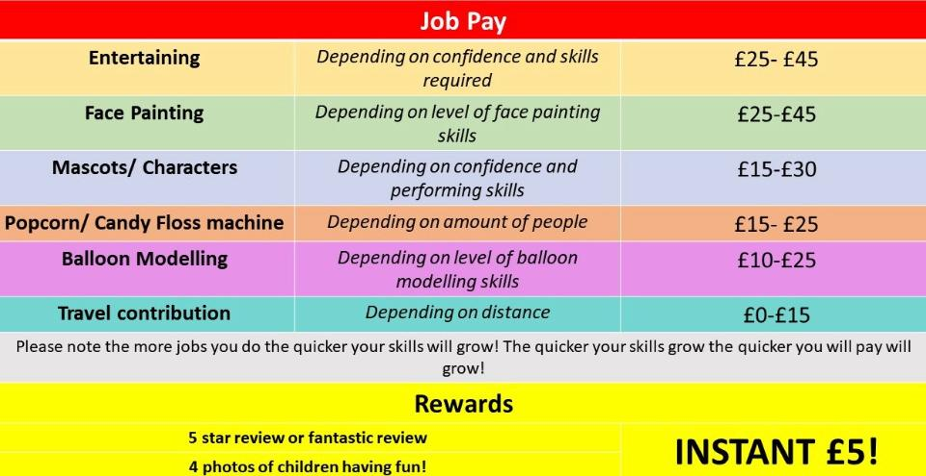
Note anything you would like to add:

Please list any names of people you may think would be interested and their email addresses/phone number.

Please send this back ASAP

If you have any questions, please call us on 07908145877
Thank you from Josie and team

