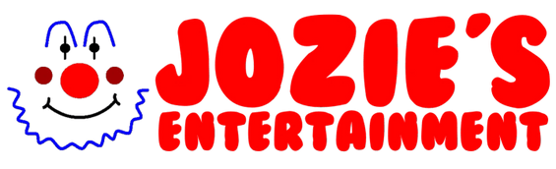

Application form for Face Painting
Thank you for applying at Jozie’s Entertainment. You will have so much fun working with our team. Please note that the more YES answers you provide, the more job roles we can offer you.

Name:
Phone number:
Age:
Address:

Do you drive?
What distance are you willing to travel (in miles) from address provided?
Are you willing to work weekends: Yes /No
Are you willing to wear a wig? Yes/ No
Circle all the roles your applying for you can circle as many as you like…
Do you have any Entertaining skills?
Please note if you have any not listed.
- Juggling
- Balloon modelling
- Roller skating
- Face painting
- Magic
- Gymnastics
- Circus skills
- Comedy
- Fire acts
- Horse riding
- Mime
- Plate spinning
- Stilt walking
- Unicycle
- Ventriloquism
Are you interested in becoming a Face painting, Glitter artist, tattoo artist or balloon modelling artist? Yes/No State which ones.
Would you be interested in our training workshop? Yes/ No or One to one training: Yes/No

Would you be interested in working with team members at our events, country shows, cooperate events, weddings and parties?
Yes/ No

Can you please send us a video and pictures of your work?
Note anything you would like to add:

Please list any names of people you may think would be interested and their email addresses/phone number.

Can you please fill out your rates below:
Hour/s | Price | What’s included?
1
2
3
Special Party Package?

Special Party Package?

Special Party Package?
Please send this back ASAP

If you have any questions, please call us on 07908145877
Thank you from Josie and team

