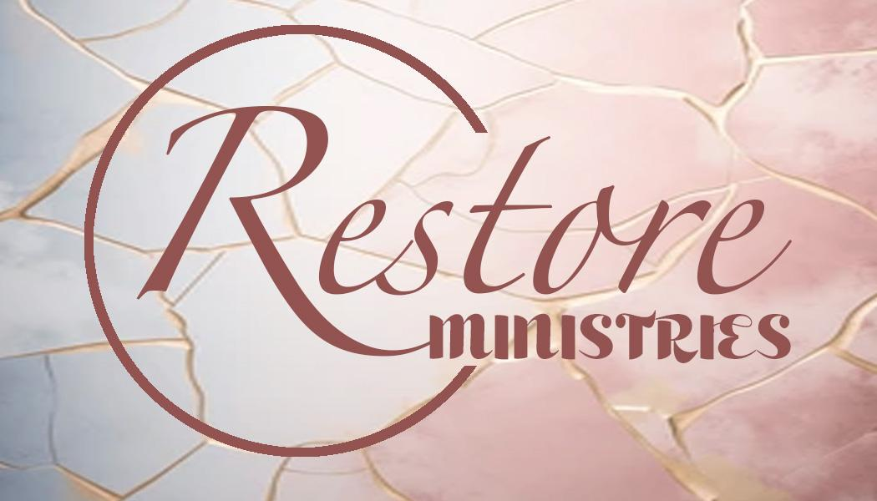
Restore Ministries Resident Application
Restore Ministries is a Christ-centered, Christian program.
We accept pregnant women, women with children, and women hoping to establish relationships with their non-custodial children. We are unable to accept children over the age of 9 or women who have no children. Restore Ministries is a NON-SMOKING facility.
Instructions: The applicant must personally complete the entire application, by herself, with no help from others. All questions must be answered accurately and thoroughly, or it will not be processed.
Name:___________________________________________________________ Date: ________________________________ Maiden Name or Aliases:____________________________________________ SSN: ________________________________ How did you hear about Restore Ministries? __________________________________________________________________ Have you ever applied to Restore Ministries before? Yes / No If yes, when? _________________________________ Phone:_______________________Date of Birth:___________________ Age:_________ Race: _______________________ Current Address:_____________________________________________________ Length of Residency:_________________
Please Check the box below that most accurately describes your current living situation:
Non-Housing (street, car, etc.)
Mother transient, children with relatives/friends Domestic Violence situation
Mother & children with relatives/friends Emergency Shelter
Transitional Housing for homeless persons Psychiatric Facility
Substance Abuse Treatment Facility Hospital
Jail/Prison
Rental Housing
Own Home
Other: __________________________

If you are currently residing in a facility including jail or prison, please provide the following information:
Name of Facility:_________________________________________________________________________________________ Representative’s Name and Contact Information: _______________________________________________________________ Date of Admission: ________________________ Anticipated Release Date: ________________________ Previous Address: ____________________________________________________________ Length of Residency: _________
Please list the name and contact information for two individuals we may contact if we are unable to reach you.
Name:__________________________________________________________ Phone:_________________________ Name:__________________________________________________________ Phone:_________________________
IDENTIFICATION - Circle “Yes” or “No” to indicate if you have a copy of the following:
Birth Certificate: Yes / No Driver’s License or State ID: Yes / No Social Security Card: Yes / No
RELIGION - Restore Ministries is a Christ-centered, faith-based organization and participation in religious activities (devotionals, Bible study, church attendance, etc.) is expected.
Please list all religious and/or spiritual organizations you have been affiliated with both past and present. _______________________________________________________________________________________________________ Where do you see yourself spiritually? ________________________________________________________________________ _______________________________________________________________________________________________________ Have you ever been exposed to or participated in witchcraft or wicken activities? Yes / No
If yes, please describe:_____________________________________________________________________________________ MEDICAL HISTORY
Please provide the information below for all medications you are currently taking or prescribed.
Medication | Reason for taking | Dosage | Time per day | Date prescribed

Please provide the information below for all medications you have taken during the past 6 months.
Medication | Reason for taking | Dosage | Time per day | Date prescribed

Please check “Yes” or “No” to indicate if you have ever been diagnosed with or experienced the following.
Yes | No |  | Yes | No
Hepatitis A |  | Tuberculosis (TB)
Hepatitis B |  | HIV/AIDS
Hepatitis C |  | Physical disability

Please list all allergies:_____________________________________________________________________________________ Are you currently pregnant? Yes / No If yes, how many weeks? ____________ Due Date:________________ Have you ever had an abortion? Yes / No
Please check “Yes” or “No” to indicate if you are able to perform the following actions.
Yes | No |  | Yes | No
Cooking |  | Mopping
Dusting |  | Vacuuming
Laundry

If you are unable to perform any of the items listed above, please indicate the reason why:_______________________________ _______________________________________________________________________________________________________

MENTAL HEALTH HISTORY
Please check “Yes” or “No” to indicate if you have ever been diagnosed with the mental illness listed below.
 | Yes | No |  | Yes | No |  | Yes | No
Anxiety |  |  | Antisocial Personality Disorder |  |  | OCD
Bipolar |  |  | Borderline Personality Disorder |  |  | PTSD
Depression |  |  | Multiple Personality Disorder |  |  | Schizophrenia

List any other mental health diagnoses not listed above:__________________________________________________________ Please check “Yes” or “No” to indicate the mental health services you have received in the past.
 | Yes | No |  | Yes | No |  | Yes | No
Case Management |  |  | Medication Management |  |  | Inpatient Treatment
Counseling |  |  | Mental Health Court |  |  | Outpatient Treatment
Hospitalization |  |  | Mobile Crisis

If yes, please list the facility name, contact information, and dates of treatment: _______________________________________ _______________________________________________________________________________________________________ Have you ever had thoughts of hurting yourself and / or others? Yes / No
If yes, when was the last time you experienced these thoughts? ____________________________________________________ Does anyone in your family have a history of mental health illness? Yes / No
If yes, please indicate the mental health illness and the family member diagnosed: _____________________________________ _______________________________________________________________________________________________________
INSURANCE INFORMATION
Behavioral Health Insurance: _______________________________________ Policy Number: _________________________ Dental Insurance: ________________________________________________ Policy Number: _________________________ Health Insurance: ________________________________________________ Policy Number: _________________________

SUBSTANCE ABUSE
Tobacco Use
Do you currently smoke tobacco or nicotine products? Yes / No If yes, for how long? _____________________ Have you ever tried to quit? Yes / No If yes, how long were you successful? _____________________________ If you currently smoke, please describe how you feel about quitting? ________________________________________________ _______________________________________________________________________________________________________
Alcohol Use
Have you ever used alcohol? Yes / No If yes, how long? _____________________ Age of first drink? ________ Do you feel that you are addicted to alcohol? Yes / No
Have you ever been in treatment for alcohol abuse? Yes / No If yes, how many times? _________ Please provide the name of your most recent treatment facility: ____________________________________________________ Did you complete the treatment? Yes / No If no, why not? _______________________________________________ Does anyone in your family have a history of alcohol abuse? Yes / No

Drug Use
Have you ever abused drugs? Yes / No Do you feel like you are addicted to drugs? Yes / No Please provide the information below for all drugs you have used.
Drug | Method of  Admistration | Age of  first use | Frequency  of use | Quantity  used | Date of last  use | Longest  period clean

Have you ever been in a drug treatment or recovery program? Yes / No If yes, how many times? __________________ Please provide the name of your most recent treatment facility: ____________________________________________________ Did you complete the treatment Yes / No If no, why not? ______________________________________________________ Does anyone in your family have a history of drug abuse? Yes / No

VIOLENCE/ABUSE HISTORY
Please circle “Yes” or “No” to indicate if you have experienced the situations below as a child or adult.
 | As a Child | As an Adult
Have you ever been a victim of domestic violence? | Yes / No | Yes / No
Have you ever been a perpetrator of domestic violence? | Yes / No | Yes / No
Have you ever been a victim of sexual assault, rape, or incest? | Yes / No | Yes / No
Have you ever been a perpetrator of sexual assault, rape, or incest? | Yes / No | Yes / No

Does anyone in your family have a history of domestic violence? Yes / No
LEGAL HISTORY
Are you currently on probation or parole? Yes / No If yes, for what charges? ________________________________ _______________________________________________________________________________________________________ Please list the information below for all correction, probation, and parole officers.
Officer’s Name | Probation Office | Phone Number

Have you been convicted of a felony? Yes / No Do you have any pending charges? Yes / No List the 5 most recent convictions/charges.
Date | County | Charge | Outcome / Sentencing

EDUCATION HISTORY
Do you have a GED? Yes / No If no, are you interested in obtaining your GED? Yes / No
What is the highest grade completed? ______________ What are your education goals and interests? ________________ _______________________________________________________________________________________________________ _______________________________________________________________________________________________________ EMPLOYMENT BACKGROUND / INCOME
Complete the information below for your last 3 employers. Please list the most current first.
Employment  Dates | Employer Name,  Address & Phone Job Title | Primary Responsibilities | Wage /  Salary | Reason for  Leaving
From:
To:
From:
To:
From:
To:

Please check “Yes” or “No” to indicate if you receive the following benefits. If yes, please also list the amount.
Program | Yes | No | Amount per Month
WIC
SNAP Benefits
Families First
Supplemental Security Income (SSI)
Social Security Disability Income (SSDI)
Child Support
Other
TOTAL

Checking Account: Yes / No Debit Card: Yes / No Savings Account: Yes / No
RELATIONSHIP BACKGROUND - please circle one
Marital Status: Single / Dating / Married / Separated / Divorced / Widowed
How do you feel about giving up romantic relationships for the duration of your recovery program? _______________________________________________________________________________________________________ _______________________________________________________________________________________________________ _______________________________________________________________________________________________________
CHILDREN’S INFORMATION
Do you have any children? Yes / No If yes, how many? __________
How many children will be coming with you? _______
Name | Age | Sex | DCS  Status  Involvement  of  Past or  Custody  Present | List All  Developmental or Physical  Disabilities | List All  Mental  Health  Diagnoses | List  Mental  Health  Treatment Provider | Has your  child ever  thought of hurting  themself  or others?

PERSONAL NARRATIVES
My personal goal and dream for myself: ______________________________________________________________________ _______________________________________________________________________________________________________ _______________________________________________________________________________________________________ My personal goal and dream for my children: __________________________________________________________________ _______________________________________________________________________________________________________ _______________________________________________________________________________________________________ How do you feel about a 1-2 year commitment? ________________________________________________________________ _______________________________________________________________________________________________________ _______________________________________________________________________________________________________ How do you feel about living in a community setting? ___________________________________________________________ _______________________________________________________________________________________________________ _______________________________________________________________________________________________________ How do you see our program enabling you to become self-sufficient? _______________________________________________ _______________________________________________________________________________________________________ _______________________________________________________________________________________________________ How do you feel about the necessary rules and restrictions as a resident? _____________________________________________ _______________________________________________________________________________________________________ _______________________________________________________________________________________________________ How do you feel about not having a cell phone and personal calls being limited to four calls per week?
_____________________
_______________________________________________________________________________________________________ _______________________________________________________________________________________________________ What are your expectations of Restore Ministries? ______________________________________________________________ _______________________________________________________________________________________________________ _______________________________________________________________________________________________________ What are your concerns about moving to Restore Ministries? ______________________________________________________ _______________________________________________________________________________________________________ _______________________________________________________________________________________________________ Why would you like to be considered for residency in our program? ________________________________________________ _______________________________________________________________________________________________________ _______________________________________________________________________________________________________ _______________________________________________________________________________________________________ _______________________________________________________________________________________________________ _______________________________________________________________________________________________________ _______________________________________________________________________________________________________ _______________________________________________________________________________________________________ _______________________________________________________________________________________________________ _______________________________________________________________________________________________________ _______________________________________________________________________________________________________ _______________________________________________________________________________________________________ _______________________________________________________________________________________________________ How do you feel you would benefit from being involved in our programs? ___________________________________________ _______________________________________________________________________________________________________ _______________________________________________________________________________________________________ _______________________________________________________________________________________________________ _______________________________________________________________________________________________________ _______________________________________________________________________________________________________ _______________________________________________________________________________________________________ _______________________________________________________________________________________________________ _______________________________________________________________________________________________________ _______________________________________________________________________________________________________ _______________________________________________________________________________________________________

Authorization for Release of Information
Name: __________________________________________________________ DOB: __________________________ Address: _______________________________________________________________________________________________ SSN: ________ - _________ - __________
I hereby authorize the release of the following information:
Yes No
_____ _____ 1. Medical history, examinations, laboratory tests, and treatment reports
_____ _____ 2. Psychological test reports
_____ _____ 3. Psychiatric evaluation reports
_____ _____ 4. Social history data, including family, education, employment, and other relevant material _____ _____ 5. Summary of previous mental health treatment
_____ _____ 6. Periodic reports of treatment progress, including attendance and participation _____ _____ 7. Other, please specify: ______________________________________________________________ _______________________________________________________________________________
Persons/facilities authorized to make disclosure:
1. _____________________________________________________________________________________________ 2. _____________________________________________________________________________________________ 3. _____________________________________________________________________________________________ 4. _____________________________________________________________________________________________
Persons/facility authorized to receive the disclosure:
Restore Ministries, Inc.
P.O. Box 345
Boonville, IN 47601
I understand no information may be disclosed by an agency to another agency or individual without my written consent. This authorization may be revoked at any time by my written statement, and it is
automatically revoked at the end of treatment unless otherwise specified.
This consent for the release of information is given freely, voluntarily, and without coercion.
____________________________________________________________________________ ________________________ Signature of Client Date
____________________________________________________________________________ ________________________ Signature of Witness Date

Applicant’s Certification and Agreement
I, ______________________________, personally completed this application without assistance or input from others. I confirm all information to be true and accurate. I authorize Restore Ministries to use the information I provided to make a decision regarding my acceptance into this program.
____________________________________________________________________________ ________________________ Applicant’s Signature Date of Completion
I, _____________________________, understand job opportunities are offered but not guaranteed. If I am accepted, I agree to follow all program guidelines. Upon admission, I agree to sign the resident handbook containing behavioral agreements, policies, and procedures as well as an updated release of information.
____________________________________________________________________________ ________________________ Applicant’s Signature Date of Completion
I, _____________________________, understand that alcohol, drug, and nicotine testing will be conducted prior to admission and consistently during residency. I agree to complete these screenings upon request and understand that testing positive for alcohol, drugs, or nicotine could result in discharge from the program.
____________________________________________________________________________ ________________________ Applicant’s Signature Date of Completion
APPLICATION AND ADMISSION PROCESS
Once your application is received, you will be contacted via phone by our Case Manager. During this conversation, our Case Manager will verify whether or not you meet our program requirements and if Restore Ministries is a good fit for your needs. If approved, you will be added to our waiting list of pending applicants. When openings become available, pending applications will be contacted based on the date their application was received. A face-to-face interview will be conducted in order for Restore Ministries to obtain additional information necessary to determine the applicant’s acceptance or denial to our program. Applicants must be able to pass an alcohol and drug screen prior to admission. Please, if you have further questions, don’t hesitate to contact Restore Ministries. Thank you for your interest in our program and we look forward to working with you!
Return application to:
Case Manager
P.O. Box 345
Boonville, IN 47601
Email: Restoreministriesinc@gmail.com

