Integrating Heart Energy into Psychotherapy: Heart Assisted Therapy
John H. Diepold, Jr., Ph.D.
APA Poster Session, San Francisco, CA / August 9, 2018

Heart Assisted Therapy (HAT) integrates and synthesizes traditional psychotherapy models with biophysical science. HAT is a deeply mindful, humanistic, integrative, and holistic mind-body approach to psychotherapy. HAT incorporates the use of heart energy and respiration in concert with cognition, emotion, sensation, and a stabilizing breathing treatment while overlapping hands are placed over the heart (“heart-breaths”). The HAT model intrinsically engages the natural influence of the heart-brain-hands connection throughout the process of psychotherapy.
The HAT model is a gentle, self-nurturing, and self-regulatory approach that is easy for both the patient and therapist to engage. There are only 4 Guiding Principles that serve to assist the therapist throughout the protocol: 1) Accept the negative, 2) Ponder the neutral, 3) Accentuate the positive, and 4) Prepare for the future. HAT incorporates the totality of the individual’s associated experiences to the identified trauma or issue, thus assuring a thorough treatment outcome.

This approach arose from 35+ years of clinical experience (e.g., with traumatized individuals, test-takers, and athletes), and both complements and integrates traditional psychotherapy paradigms. HAT is designed to complement existing skills and orientations of the psychologist. The HAT model uses “awareness streaming” in concert with the body’s electro-physiology and respiration to facilitate healing and stabilizing shifts in emotion, sensation, cognition, and behavior.
Heart-breaths used in HAT involve normal respirations of the individual. There is no requirement or expectation that the person engages in any form of deep breathing, diaphragmatic breathing, or yoga-style breathing patterns. With HAT we work with what is characteristic of the individual, especially when addressing emotional topics and experiences.
Here are the directions when initiating the “9 Self-Regulating Heart-Breaths” (9 SRHB) that begin every HAT intervention. The therapist also performs the heart-breaths as they guide the individual through the process.
- Overlap your hands and place them directly over the center of your chest over your heart.
- Free your mind and blankly focus your attention on something in front of you (e.g., an empty space on the wall).
- Take 3 normal respirations while keeping your hands over your heart (Heart-breaths).
- Reverse your hands and again place them over your heart.
- Again take 3 normal respirations while keeping your hands over your heart.
- Reverse your hands once more and again place them over your heart.
- Again take 3 normal respirations while keeping your hands over your heart.
Proper hand positions when doing heart-breaths involve overlapping, flat hands placed over the heart in the center of the chest as shown in the figure below. The therapist can learn to use their natural hand positions as a guide throughout the HAT protocol. It is helpful to learn your natural hand positions over your heart as this information will always keep you on track.
The HAT process also involves reversing the hand placements at various points of the protocol. Respiration is monitored and used as a guide throughout the therapy process utilizing the 4 Guiding Principles and Acceptance Statements where indicated.
The heart-breath hands positions are normally occurring and often an unconscious activity that is evident world-wide. I posit it is an innate self-regulatory response, and that it is a potent electrophysiological intersection engaging biophysical, meridian, and chakra activities.
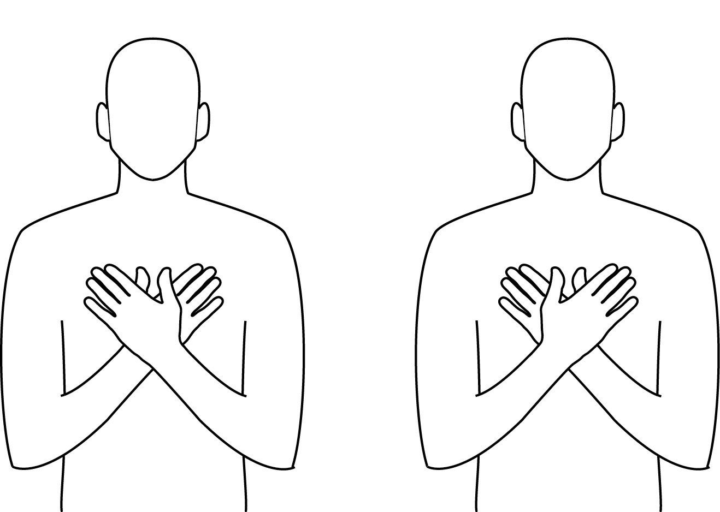
Heart energy is influential and interacts with the above referenced physical and bioenergy systems. Consider the following findings: 1) The heart produces the strongest rhythmic electromagnetic field of any organ in our body, 2) The electromagnetic field (EMF) produced by the heart is up to 5,000 times larger than the EMF produced by the brain, 3) Our heart rhythms affect the brain’s ability to process information, 4) Our emotions are manifest in the patterns of our heart’s field, and 5) The heart informs the brain’s ability regarding perception, emotional experience, and enhanced mental processing (e.g., Childre & Martin, 1999; McCraty, 2012). Accordingly, incorporating heart energy into psychotherapy allows for a system-wide influence of resources for change.
In efforts to understand the gentle yet impactful clinical outcomes with HAT, pilot study research has shown statistically significant increases in alpha power via EEG data compared to control, and increased brain registration of the electrical signal from the heart (ECG triggered ERP's), when overlapping hands are placed over the heart compared to controls.

This poster session shares some information about the basic science of the HAT protocol, the heart-brain-hands interactions, the role of respiration when using HAT, the heart-breath hand positions, and additional research findings. Clinical outcome data will also be shared.

Behavioral and Perceptual Findings (Pilot Data):

Perceptions of Comfort for Spontaneous and Opposite HAT Hand Positions
Analysis of the subjective experience of spontaneous hands position, compared to reversed position of the hands over the heart and a control position, reveal statistically significant positive results on measures of perceived comfort ( e.g., warmth, relaxed, calm, and focused) with no differences in age, gender, or handedness.
In an initial pilot study, 15 Subjects consisting of 6 females (mean age 54.7) and 9 males (mean age 48.3) were asked to overlap their hands and place them over their heart. Six subjects spontaneously placed their right hand over their left, and 9 subjects spontaneously placed their left hand over their right. Of the subject pool, 9 were right handed, 3 were left handed, and 3 were ambidextrous. Results reveal no pattern or differences in mean ages, gender, or handedness pertaining to spontaneous placement of left hand over right or right hand over left.
Below are three primary summary graphs from an expanded study of data (n=74) collected with colleagues studying ratings of comfort (scale 0 -10) for left over right (LoR) and right over left (RoL) hand positions as a function of sex, handedness, and experienced comfort. Analyses were done in Statistica and then graphed in Excel.
The left graph below shows ratings of LoR and RoL when natural (spontaneous) position is left over right (left set of lines) versus right over left (right set of lines), separate for females (blue) and males (red). Males and females are very similar. Data clearly shows people rated LoR higher if their natural (spontaneous) hands position is left over right and lower in comfort when they reversed their hands. A similar pattern was found when the natural (spontaneous) hands position is right over left. This effect is highly significant (p <.000001).
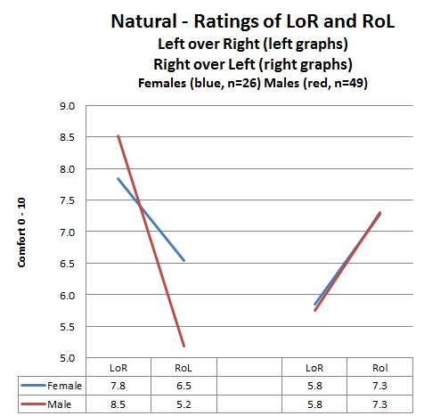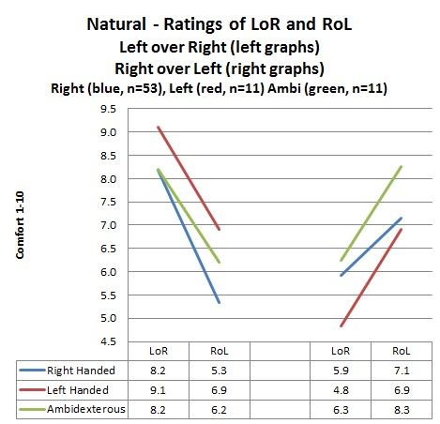
The right graph above compares LoR and RoL ratings for right handed, left handed, and ambidextrous persons. All three handedness groups show ratings of preference and comfort to their natural (spontaneous) position and are highly significant (p < .000001).
The graph below shows LoR and RoL comfort ratings as a function of people saying LoR is higher, or RoL is higher, or neither. Results are clear, and significant (p <.000001).
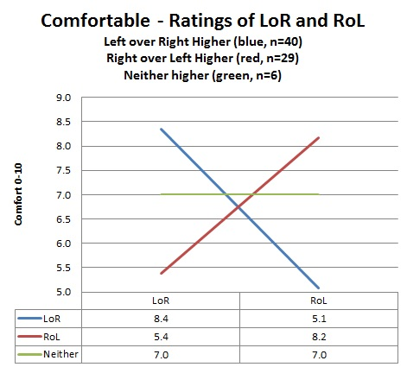
Conclusions: Regardless of age, gender or handedness, the natural (spontaneous) hands placement (left over right or right over left) is strongly associated with perceived comfort of the position compared to the reverse.
Biophysical Findings:
Physiological Correlates When Engaging Spontaneous HAT Hands Position
- Equipment: ECG Triggered ERP LabView Analysis Program. This analysis program was written in LabView to perform off line analyses of EEG (brainwave files) triggered by the R spike in the QRS complex (contraction of the left ventricle) of the ECG (electrocardiogram) waveform. Using the telemetry device (B-Alert 10X), we record 9 channels of EEG brainwaves, and 1 channel of the ECG. The specially written program is designed to reveal evidence of the ECG in the EEG. The final result is one averaged ECG waveform plus nine averaged EEG waveforms, one per channel, all synched to the QRS of the ECG.
- The initial “peek” into the heart-brain-hands connection: A single subject was studied and involved 4 conditions that ran for 3 minutes each while data was collected. The 4 conditions were: 1) Eyes open with hands in the lap, 2) Eyes closed with hands in the lap, 3) Taking pulse with left hand, and 4) Spontaneous overlapping hands position over the heart as used in HAT (L/R for S) with eyes open. When reviewing these pilot data, keep in mind that (1) there was no control for the order of the measured conditions, and (2) there was no matched control group (for example, replacing the HAT condition with a hands on abdomen control instead of on the heart). This was an initial look regarding “proof of concept” comparing a HAT standard procedure (overlapping hands over the heart) with other procedures using the new ECG triggered ERP system.
Grand ECG triggered ERP Average of all 9 EEG channels comparing condition1 (Eyes Open) and condition 2 (Eyes Closed) over 157 seconds.
The following graph show the visible cardiac R spike to be a) statistically greater in amplitude when the eyes were closed compared to eyes open, b) the visible cardiac R spike to be greater in amplitude when taking the pulse compared to eyes closed and eyes open, and c) the cardiac R spike was even greater in amplitude when overlapping hands were spontaneously placed over the heart (HAT) compared to any of the other conditions. These effects were all statistically significant (p’s <.001).
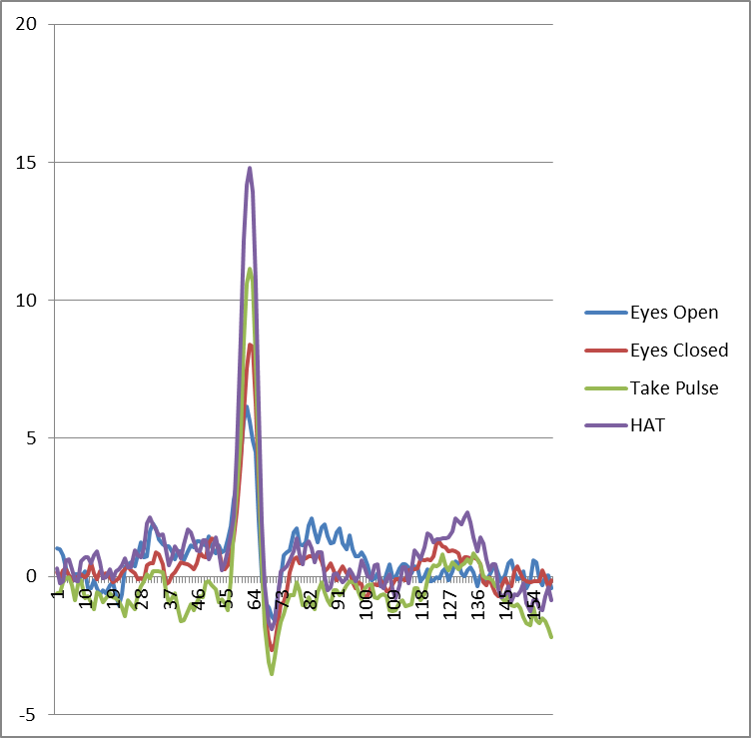
Cardiac R Spike and T Wave Comparisons
In the graphs below, the right graph pulls apart and graphically displays the cardiac T wave comparisons of Taking Pulse and the HAT Spontaneous Hands Position. The cardiac T wave reflects the re-polarization (recovery) of the ventricles. As was evident with the R spike (left graph), the brain’s registration of the T wave is statistically greater in amplitude when overlapping hands were placed over the heart (HAT) compared to taking the pulse.
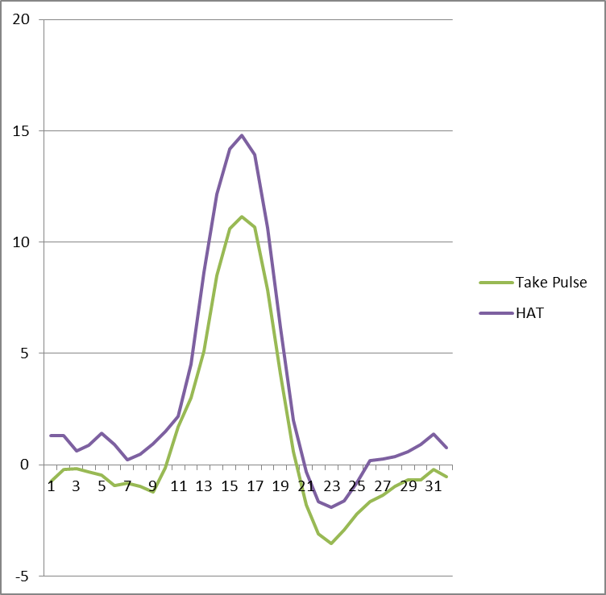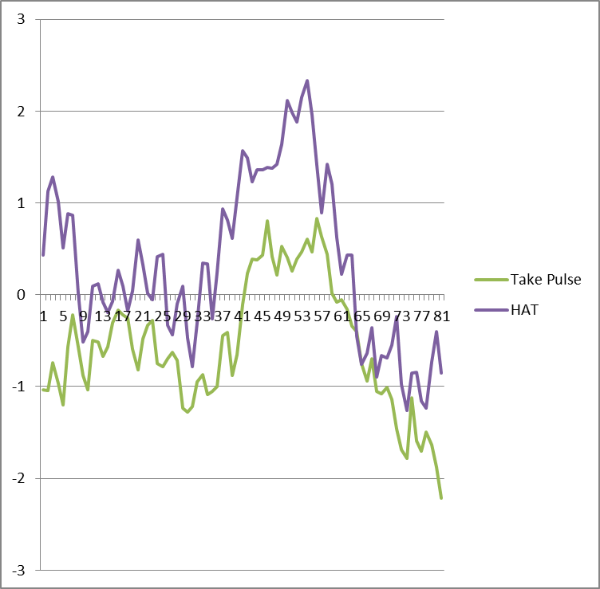

Measures of HAT Clinical Outcomes
Analysis of available clinical pre and post outcome data on patients treated with HAT for combat related PTSD, trauma, and loss/grieving events, clearly demonstrate statistically the healing benefits of HAT, which also transpires in a remarkably short time-span. A 3 - 6 month follow-up is currently being conducted.
The graph below is a curve summarizing the findings for 22 treated incidents. Feedback on various pre and post measures were obtained after HAT treatment of the traumatic event as acquired by 2 therapists. The data strongly point to the clinical efficacy of HAT.
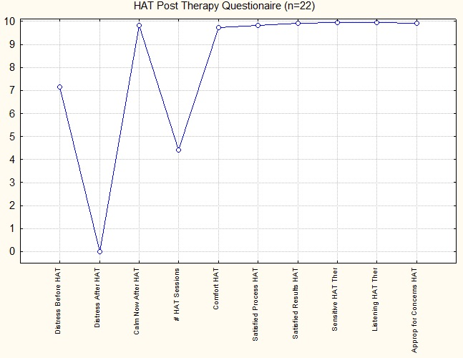

The graph reflects the mean patient ratings of distress (0-10) before HAT (7), and then after HAT (0). The ratings of calmness after HAT (9.9) supports the reported absence of distress post-HAT. The average number of HAT sessions for a treated incident was 4 to 5. The patients’ reported comfort and satisfaction with the HAT psychotherapy approach was close to 10 across the variables.

The graph below visually displays the table information that follows depicting t test analysis comparing Pre and Post Distress values (p<0.0000001).
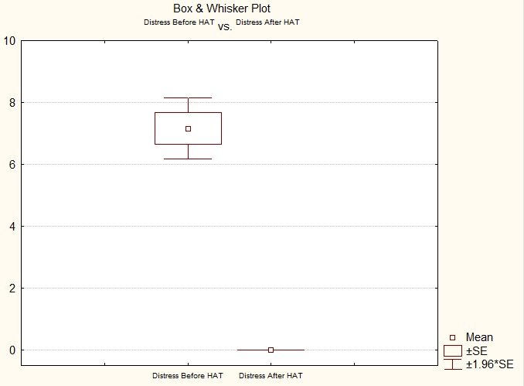

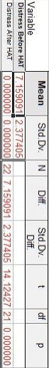
Conclusions: Our pilot data indicates that patients recover from their highly distressing life experiences with HAT within an average of 4 to 5 sessions. Upon completion of the HAT protocol, there is a reported absence of distress to the treated life event. Patients report they like the HAT approach in psychotherapy and find it appropriate to their needs.
Research regarding HAT is ongoing at the University of Arizona under the direction of Gary E. Schwartz, Ph.D. Expansion of the pilot studies investigating the electrophysiological interactions of the heart-brain-hands connection (e.g., ECG triggered ERP, EEG, heart rate variability) is underway. The pilot data suggest that hands held over the heart have pronounced influence with the heart and brain that facilitate the calming results after completion of the HAT protocol.
The interested clinician is referred to Heart Assisted Therapy (Diepold, 2018) to learn more about the development and applications of Heart Assisted Therapy.
References
Childre, D. & Martin, H. (1999). The HeartMath Solution. San Francisco: Harper Collins.
Diepold, J. H. Jr. (2018). Heart Assisted Therapy: Integrating heart energy to facilitate
emotional health, healing, and performance enhancement. Parker, CO: Outskirts Press.
McCraty, R. ( 2012). The Energetic Heart: Bioelectromagnetic interactions within and between people. Boulder Creek, CA: Institute of HeartMath.

