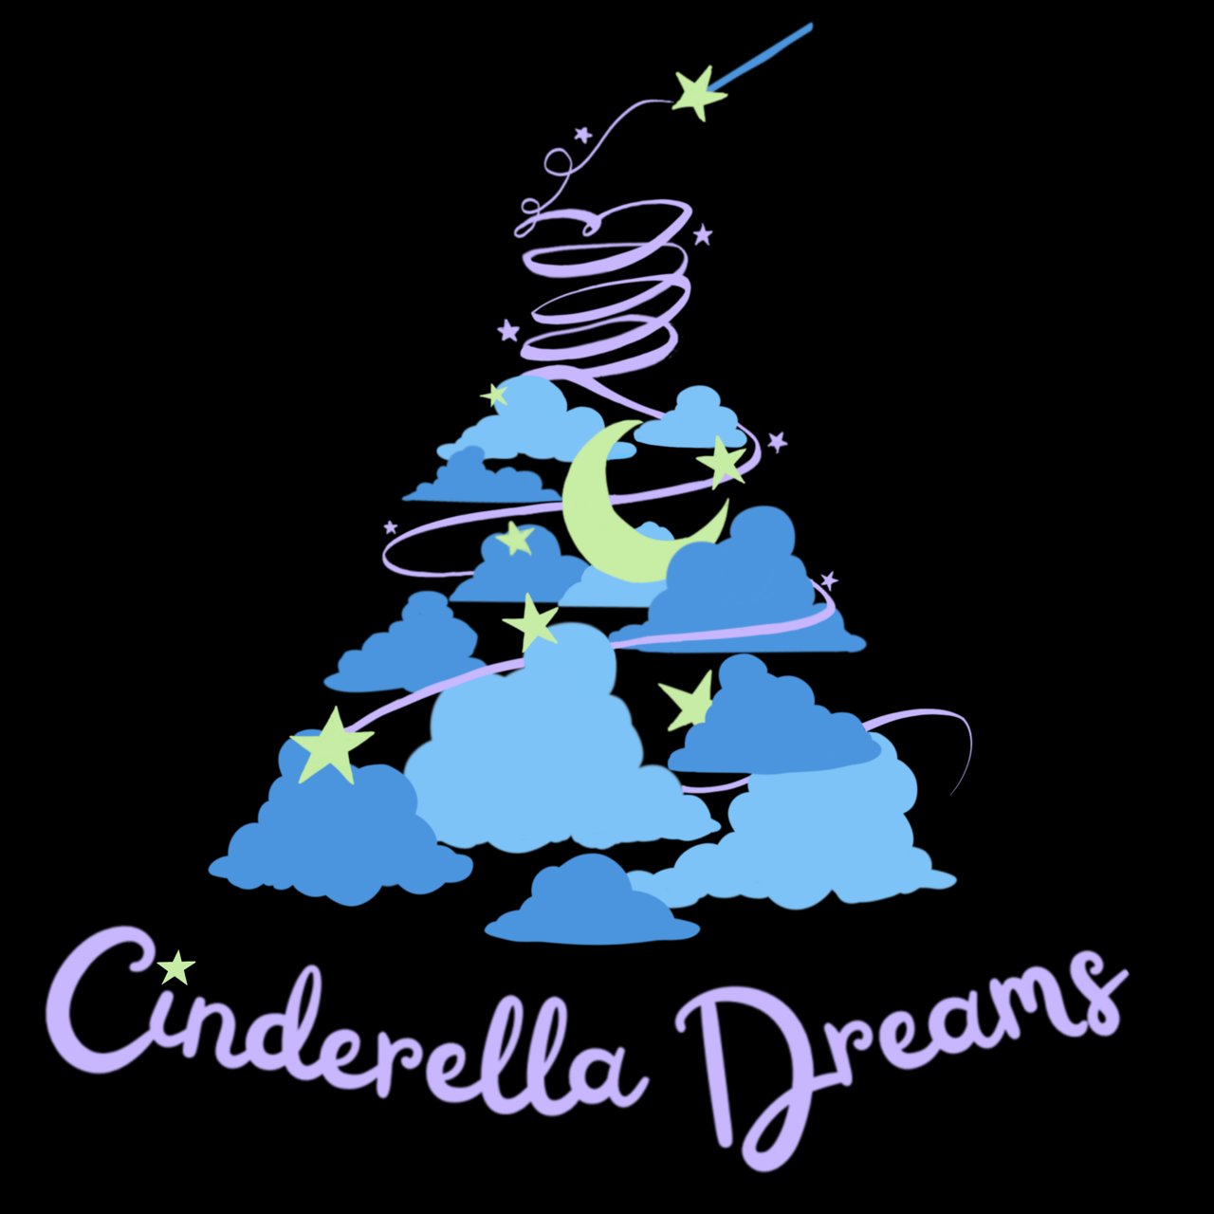

Cinderella Dreams Dress Donation Request

Mission: Educating and empowering teens through planned events and drives with the express goal of building confidence, self-esteem and leadership skills with an ultimate goal of providing a positive foundation in life.

Cinderella Dreams is seeking dress donations to support our mission of empowering teens through our annual Cinderella Dreams project. Each spring, our 501(c)3 nonprofit organization holds a 'shopping' event, where high school teens can shop for and select a dress and accessories for free or with a suggested $5 donation to help the cause – thereby allowing teens that would otherwise be unable to attend prom or other formal events still have their Cinderella moment.

We need your help collecting prom dresses! Dresses need to be:

* Formal (long or short)
* Newer styles - 2020 or later
* All sizes!! Plus sizes are especially needed (20+)
* No casual/summer or wedding dresses, please

**All dresses can be dropped off at any local Puritan Cleaners location**.

As a registered 501(c)3 we would be happy to provide you with an acknowledgment letter for your donation. For your records, our organization EIN is 88-0746979 and our legal address of record is 1324 Sycamore Square, Midlothian Virginia 23113.

Thank you for considering supporting our drive! If you are interested in getting involved in our shopping days, please look out for hands-on volunteer opportunities on our social media pages.

[www.cinderelladreamsrva.org](https://www.cinderelladreamsrva.org)