MENTOR IRB User Guidelines

**Axiom’s Mentor RRB** was built by researchers, the software is designed to deliver an intuitive and responsive interface that is easy to use and streamlines submission and the management of review, approval and post approval reporting. This software is the RRB web-based application adopted by Tribal Nations Research Group. This RRB software tracking system will enable the RRB to better serve researchers. It is completely online and will allow the IRB to manage the review process from investigator submission to final close-out reports including data return. We have customized Mentor RRB to fit the needs of the researchers that are associated with Tribal Nations Research Group. All researchers are required to submit their RRB applications, amendments, continuations, data, and annual reports via Mentor RRB.

This document was designed to provide you with the basic instructions you will need to access and navigate Mentor RRB. Specific information is included that will help you create and submit your RRB application and/or updates. Email notifications generated by Mentor RRB will allow you to track your submission. If you have any questions about accessing, using, or submitting your RRB application, please contact, Anita Frederick, President of Tribal Nations Research Group at 701-477-5526 or email [anita@tnrg.org](mailto:anita@tnrg.org) or [admin@tnrg.org](mailto:admin@tnrg.org)

Mentor RRB can be accessed at any time and from anywhere in the world at [https://www.mentor.com/login/axlogin.cfm](https://www.axiommentor.com/login/axlogin.cfm)

# Table of Contents

Contents

Table of Contents 2

Login 3

First Time Users 3

Returning Users 3

Key Features for PI 4

RRB Review Process 9

How to Submit an Amendment 10

How to Submit a Report for Continuing Review or Project Closeout 11

How to submit an Adverse Events 14

Protocol Deviations 15

Submitting publications/presentations/abstracts for RRB approval 16

# Login

## First Time Users:

Click on the link below to request a username and password

<https://tnrg.org/tmbci-rrb-access-request> the following screen will appear, here you can fill out the form that will be sent to the TNRG team. You will receive an email with a username and password, if takes more than two weeks please call the office (701) 477-5526

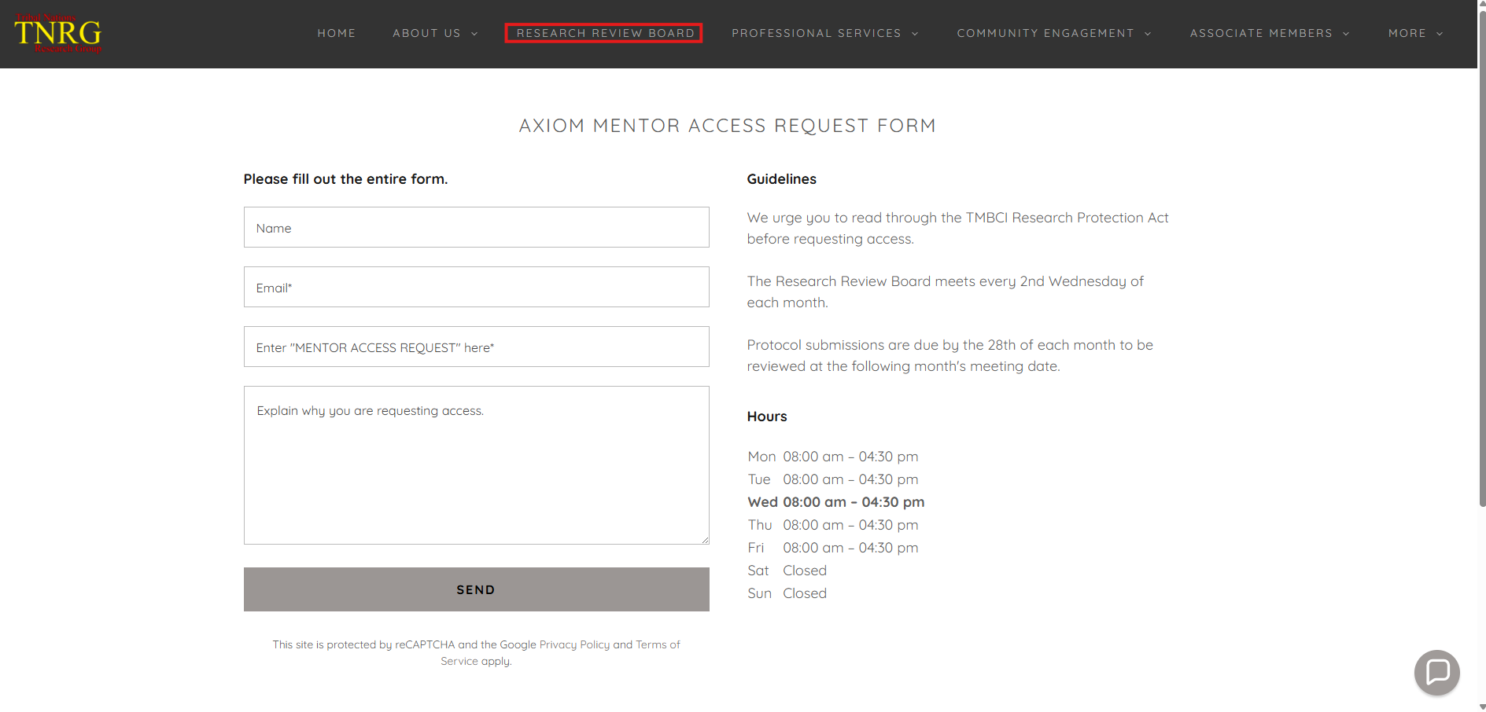

## Returning Users

Go to [https://www.mentor.com/login/axlogin.cfm](https://www.axiommentor.com/login/axlogin.cfm)

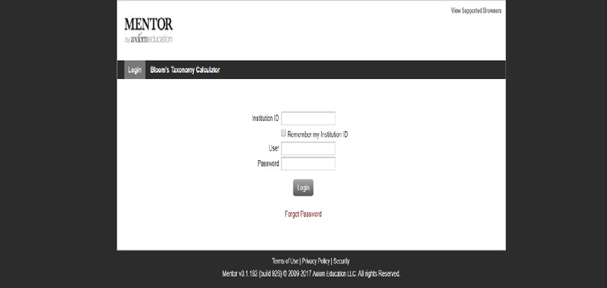

* You will be directed to **Axiom** **Mentor Login**
* Enter the following
  + **Institution ID =** TMBCI
  + **Enter Username=** (your email)
  + **Enter Password**
* Click on **Login**
* You will be directed to the **Mentor IRB Info Page.** On this page you will find menus and helpful documents specific to the TMBCI RRB submission process.

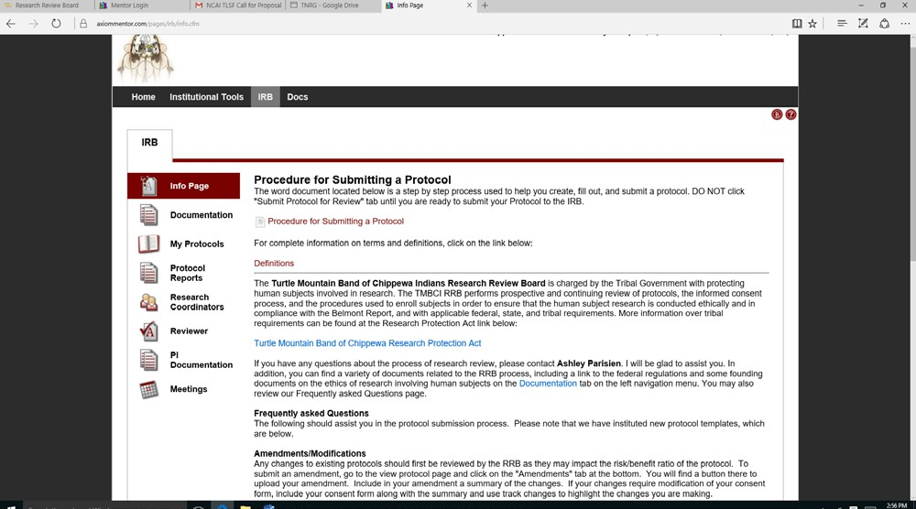

# Key Features for PI

On the top left-hand side of the **IRB Page** you will see several tabs:

* **Info Page:** This page contains all information the PI needs to submit a New Protocol or update an existing Protocol.
* **Documentation:** This tab has several resource documents that are available to help you prepare your RRB application. Documents including Federal Policies and Regulations/Miscellaneous Items, Historical documents, Informed Consent Documents, OHRB Items, TMBCI Research Protection Act, and the NIH Protecting Human Research Subjects Tutorials can be accessed via this tab.
* **My Protocols:** A list of currently active protocols for each principal investigator. The PI can choose to list new (unapproved), active, or terminated. This is also where you will Submit and manage your protocols.
* **Protocol Reports:** This is where you will check to see if you have any items due or reports that need to be submitted.
* **Research Coordinators:** PI’s who have research coordinators or secretarial support can designate individuals to manage their RRB protocols in Mentor.
* **PI Documentation:** This tab allows you to upload the Completion Report (certificate) indicating that you have completed CITI training. If you did not save a copy of your certification, go to [www.citiprogram.org](http://www.citiprogram.org/) and upload it through the PI Documentation. You will be required to renew your certification every three years. Mentor RRB will notify you one month prior to your renewal date. However, if you are submitting an RRB application prior to the above date and have not yet completed CITI training, you will need to include (copy/paste) your NIH certificate at the end of your Protocol Summary Form.
* **Meetings:** This tab will give you meeting information relating to your past and current protocols.

**Procedure for Submitting a Protocol**

The following steps below will help you create a protocol. Throughout the procedure instructions, there are side notes that are typed up for your benefit so that you don’t make a mistake in the process as it isn’t possible to correct or fix some mistakes in Mentor Software and side notes are always bolded. Please do read them and take your time as haste makes waste! **Side note: DO NOT** click “Submit Protocol for Review” tab until you are ready to submit your Protocol to the RRB! In the event you accidently submit a protocol, it is there forever in the system, and there is no way to make changes other than submitting a protocol amendment or creating another protocol.

1. When you log in, you will see the following headings to the top left part of your web page:

**Home Institutional Tools RRB Docs**

1. Click on the heading **RRB**, and it will bring you to the Info Page.
2. Looking to the left, you see a number of tabs labeled in the following order: Info Page



Documentation My Protocols Protocols Reports

Research Coordinators Reviewer

PI Documentation

1. Click on the tab labeled **My Protocols** and it will bring to the page titled My Protocols.
2. Located above the heading My Protocols is a tab titled: “**Create New Protocol**”, click the tab. The tab resembles something like this:

Create New Protocol

1. It will open a popup web page titled **“Create RRB Protocol”.** When it opens up, fill in the required information that pertains to your research project. Anything with a red Asterisk * is required to create the protocol.
2. If you are a student you will be asked to include the name of your faculty advisor who will serve as co-PI on the protocol. You will receive a message if Mentor RRB is unable to find/create an account for the selected faculty advisor in which case you will need to contact Anita Frederick ([admin@tnrg.org](mailto:admin@tnrg.org)) and she will be happy to assist you in getting your faculty advisor into Mentor so you can proceed with your RRB submission.
3. Make sure to use the pull-down menu to indicate on this form the appropriate **Review Type category** (Human Subject Board Review, Non-Human Subject Full Board Review Required, Preliminary Review Letter of Support, Presentation). The RRB will make the final judgment on the eligibility of your protocol for these categories, but it is helpful to have the investigator make an initial choice.

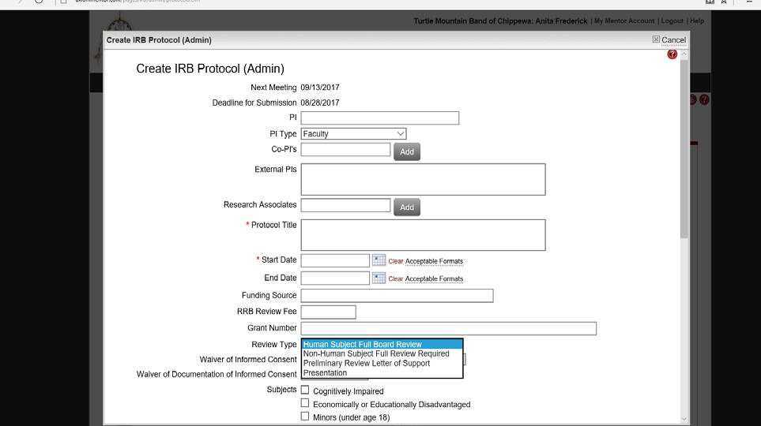

* + Once you click on the appropriate **Review Type**, you will need to select one of the options that best describes your study and complete several additional questions specific to your proposal.
  + If you need help in determining the review type, please refer to the **Definitions** on the **Info Page**.
  + At the bottom of this form, you will find an **Upload Protocol** field. Click the **Browse**

button and locate your completed RRB **Protocol Summary Form** on your computer.

* + Double click the file to select it. Repeat this process to upload your Consent Form(s). If you need to upload additional documents, you will need to first click

on **Save**. Then scroll to the top of the menu bar and click on **Upload Documents**. Use the file upload on the **Drop‐Down** menu box to upload any additional documents. You must click **Save** for final protocol submission.

* + At the end of the form, you will see a text box. If you would like to send **a Message to RRB Chair**, then use this text box to write your message

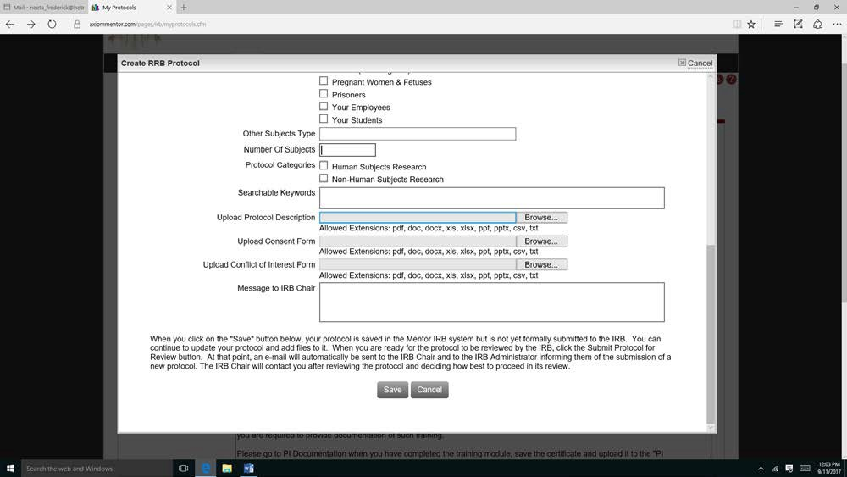

1. When you are finished filling in your information and ready to create the protocol, click the **“Save”** tab at the bottom. Once you clicked the save tab, it will bring you back to the My Protocols page. This page should appear within 3-6 seconds. If it doesn’t appear within that time, refresh your webpage and you will see your protocol and it will resemble something like this:

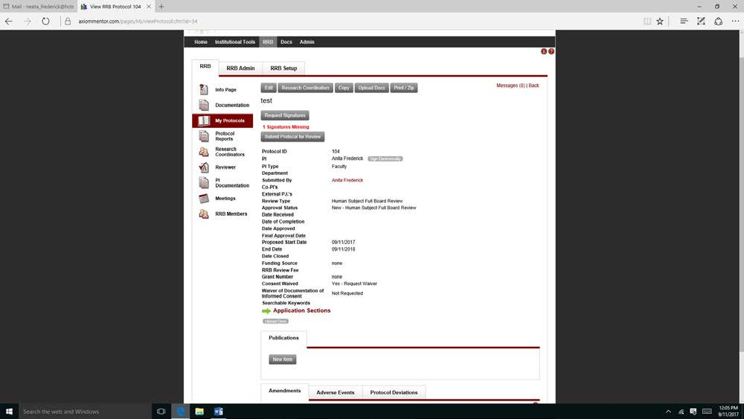

1. To fill out the rest of the application process, locate the Green Arrow with words titled

**“Application Sections”** and click on it. It will resemble something like this:

[**Application Sections**](https://www.axiommentor.com/pages/irb/SectionsOfProtocol.cfm?id=21)

1. It will bring to the Application Sections, and fill out each section as it pertains to your research project. When finished filling out a question within a section, click save to move onto the next question. **Side Note:** When you are finished filling out each section, you will get a popup section giving you two options. Click on **“Review Answers before Submitting”** tab and it will give you the option to review and change your answer if needed. In the event you clicked on the submit survey tab, it will not give you the option to change your answers in that section. Afterword, move on to the next section. It may resemble something like this below:

Question

Submitting your Survey will prevent you from making any further changes to your answers.

How do you wish to proceed?

Submit Survey

Review Answers Before Submitting

1. When you are finished filling out the Application Sections, you may want to review your work and make changes as needed. To review information back on the Protocol page, click on the word titled “View Protocol Page” located at the top of the page and to the right. It will resemble this:

View Protocol Page

1. If you need to attach additional documents or provide additional documentation as part of your protocol such as the consent form, another RRB approval, or survey instruments click on the tab titled **“Upload Docs”** and attach any additional documents as needed. **Side Note:** When you attach additional documentation, it may not immediately appear. It should appear within 3-6 seconds after clicking save. Upload Docs will resemble something like this:

Upload Docs

1. When you are ready to submit your protocol, click the tab titled **“Submit Protocol for Review”**

located on the view protocol page and it will resemble something like this:



1. A digital signature is required, once you submit the protocol for review you will need to go back into the my protocol tab, click on the protocol you submitted and submit an electronic signature, see below, click on the sign electronically tab and the date signed will be populated.

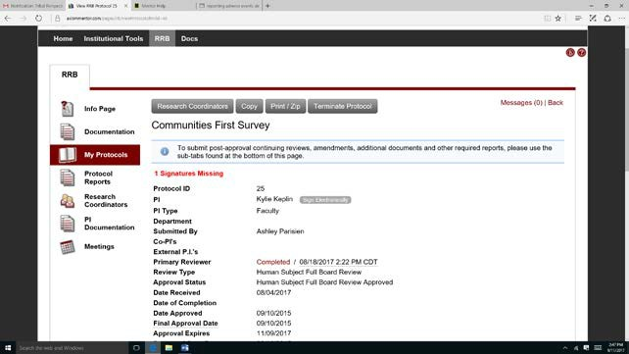

Changes:

* + Once you have completed all fields and uploaded your RRB proposal and any other pertinent documents, you may realize that edits or changes are needed if this is the case click on the applications sections and make the necessary edits, Click **Save** at the bottom to submit your updated information.
  + After you submit a new protocol, Mentor RRB will automatically notify the RRB via email of the new submission. An RRB Representative from the Tribal Nations Research Group will review your protocol and accept it as is or request revisions. Once the RRB Representative accepts your protocol, the RRB Chair will be notified via Mentor RRB. The RRB Chair will send you notification of the RRB’s action once final review has been completed.

# RRB Review Process

* + Currently all protocol submissions require a full board review. A primary reviewer will be assigned to your protocol and make recommendations to the full board based on the following categories
    - Denied-The RRB will not approve the protocol based on various circumstances, the PI will receive a detailed letter stating these circumstances and whether or not the application can be resubmitted.
    - Tabled-The RRB tabled the protocol because more information is needed to approve. This most often would require a discussion with the PI and additional information needed.
    - Approved with modification-The RRB has approved the protocol but provides some needed modifications to the protocol. Required modifications will need to be submitted and once received the Research Director will present the RRB’s decision to the Tribal Council for concurrence, and if concurred a signed research permit will be emailed to all investigators listed on the study. You may not start the study without a signed research permit.
    - Approved-The RRB has approved the study, no modifications needed. The

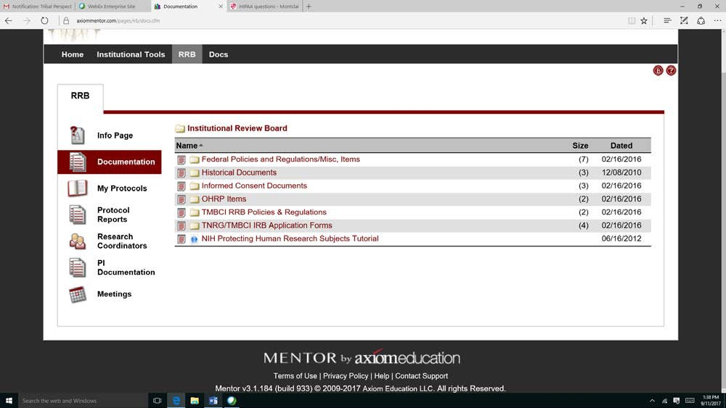

Research Director will present the RRB’s decision to the Tribal Council for concurrence, and if concurred a signed research permit will be emailed to all investigators listed on the study. You may not start the study without a signed research permit.

* + Your RRB representative will review your protocol and send you an email via Mentor RRB indicating revisions are needed or will approve your protocol in which case an email notification will be sent to the RRB Chair for final review.
  + The RRB Chair will review your protocol and send you an email via Mentor RRB indicating the specific revisions needed or send you an approval letter with attached consent form(s) and recruitment flyer if applicable.
  + Researchers cannot begin recruitment activities or data collection until the research permit is received.
  + All protocols need to be submitted by the 28th of each month, in order to be on the agenda for the next meeting.

# How to Submit an Amendment

* + Significant changes to the original approved protocol, such as revisions, modifications or addenda to a research protocol or other project approved by TMBCI/TNRG RRB must be submitted to the board for approval, before they can be implemented.
  + To submit an amendment, complete the Amendment Application that can be accessed via RRB Documents.
  + Then, click on the **My Protocols** tab. You will see the title of the Protocol you propose to amend. Click on the title and then scroll down to the set of tabs at the bottom of the page.

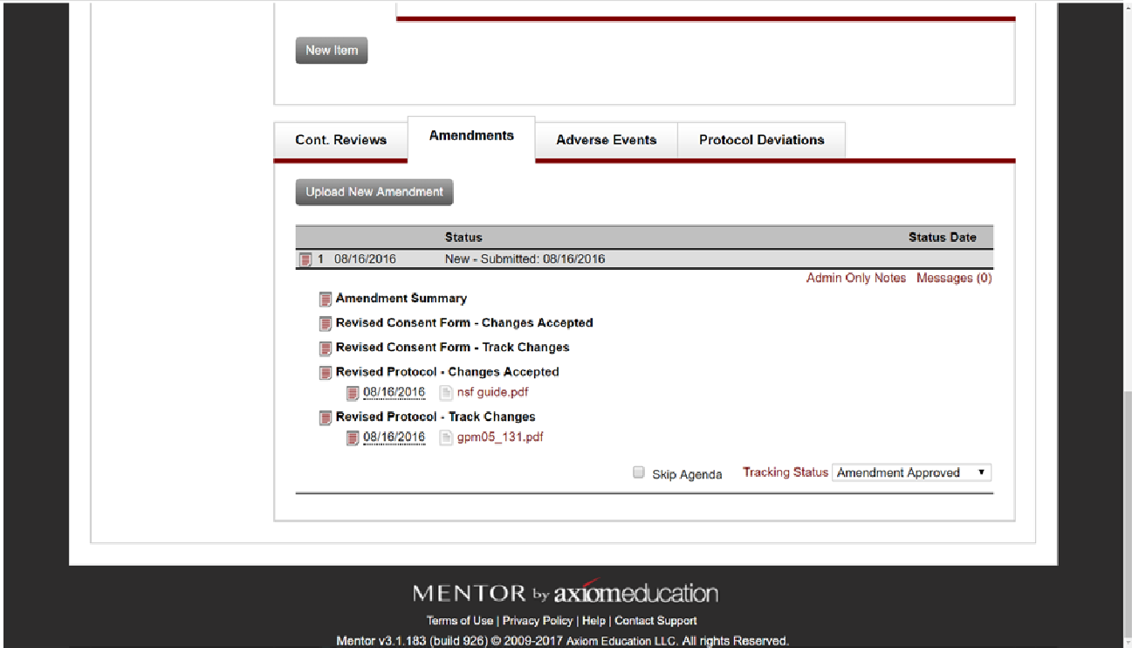

* + Click on **Amendments** and upload the completed **Amendment Application**.
  + Please include all necessary documents in the **Amendment Application**. For example, if your amendment includes modification of the consent form orrecruitment flyer then include those documents with the completedform.
  + The RRB Chair will review the amendment and send you an email via RRB Mentor indicating that additional information is needed or send you an approval letter with attached consent form (s) and recruitment flyer if applicable.
  + All consent forms and flyers will be stamped with TMBCI/TNRG RRB and include the original expiration date if applicable.
  + Researchers cannot implement the proposed changes to your original protocol until the approval letter and stamped documents are received.
  + It may be that your amendment will need to be reviewed at the next full board meeting.

# How to Submit a Report for Continuing Review or Project Closeout

* + A protocol that has received approval is reviewed annually to ensure compliance with original protocol and as a status update. The research study or other projects may not continue beyond the one year expiration date, without continued approval from the RRB.
  + Project Closeout Report is required of all approved research projects.
  + Mentor RRB will automatically notify you of an impending report due date.
  + To request a continuation of your research study or to submit a final report, click on My Protocols and then on the title of your research study.
  + Scroll to the bottom of the screen and click on continuing review record context menu.

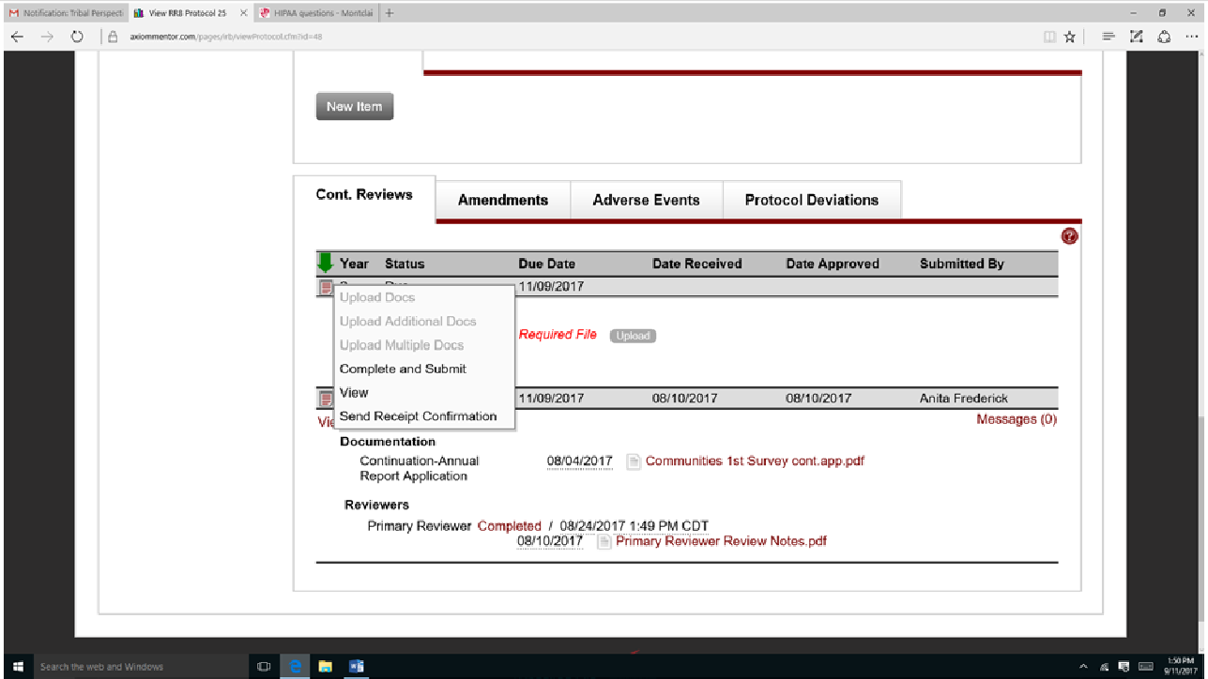

* + Click on the red notepad or below the green arrow.

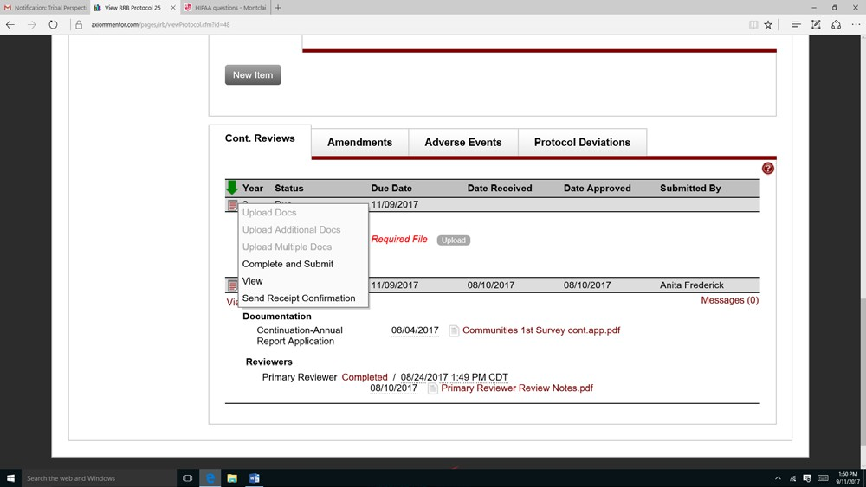

* + A drop-down menu will appear, click on **Complete and Submit,** the following screen will appear.

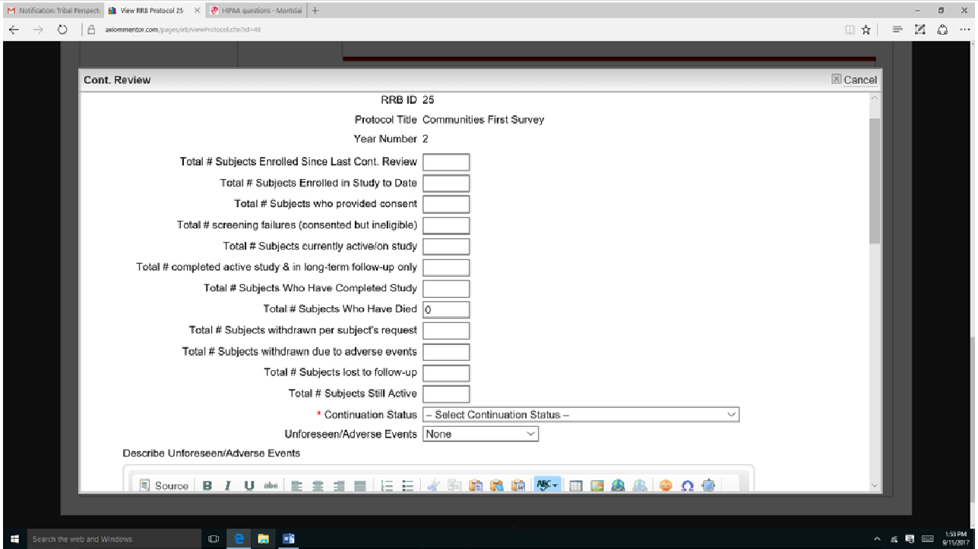

* + Complete all the questions, example: if you had no subjects who withdrew their application put “0”. When you get to \***Continuation Status** use the drop-down screen to select the appropriate status. (see below)

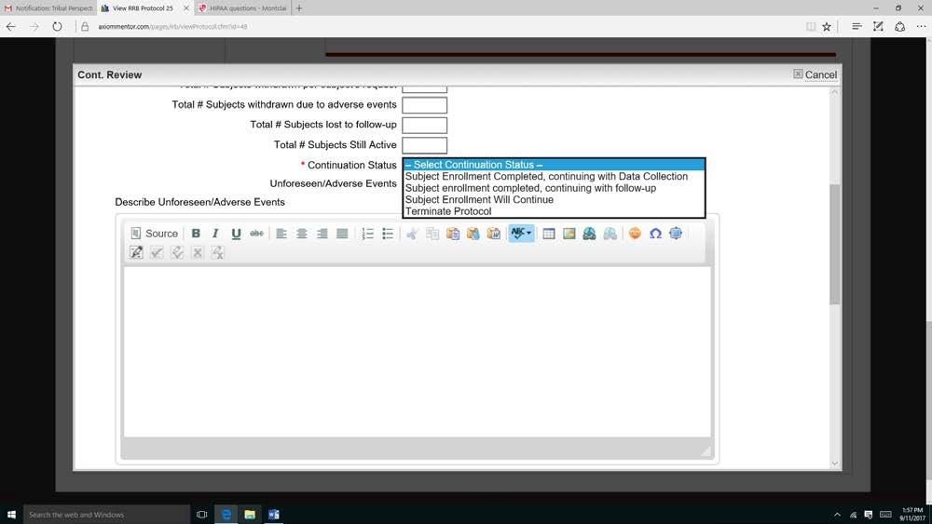

* + If your study is complete (done with recruitment, data collection, data analysis, and data reporting) select **“Terminate Protocol”** and continue filling out the remaining questions.
  + If you are requesting a continuation of your study please complete all questions, upload all consent forms and recruitment flyers so that the documents can be stamped with Tribal Nations Research Group’s Approval and new expiration date.
  + Do not forget to click **Submit Report.**
  + The RRB Chair will review your request for continuation and send you a letter via Mentor RRB indicating that you have RRB approval to continue conducting your study for an additional year.
  + If you have completed your study, the RRB Chair will send you a letter indicating that your study is terminated and thus, no longer active.
  + Please note that even when the research is permanently closed to the enrollment of new subjects and all subjects have completed all research-related interventions, continual review is required as long as the research remains active for long-term follow- up of subjects and continues to involve non-exempt human subjects’ research. Furthermore, continuing RRB review of research is required when the remaining research activities are limited to data analysis of individually identifiable private information.

# How to submit an Adverse Events

An adverse event is an unintended physical, psychological and/or social harm resulting from, or that occurred during participation in research.

* + If unanticipated risks or hazards are discovered during the course of the research, the PI shall immediately suspend research activities and notify the RRB chair in writing.
  + Click on the **My Protocols** tab and then click on your protocol.
  + Scroll down to the set of tabs at the bottom and click on the **Adverse Events** tab.
  + Click on the **New Adverse Events** tab to upload a description of the event.

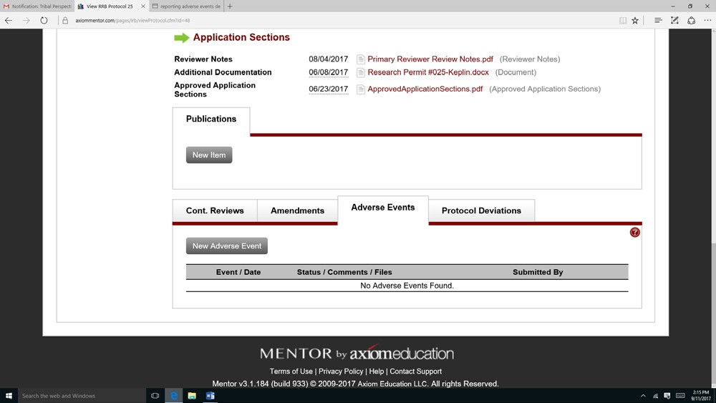

* You should include in your summary your judgement of whether the harm to the subject was a result of their participation in the project or incidental to it. You should also indicate if you think that the event warrants any changes to your protocol or consent form. If so, you should then submit an amendment to your protocol.
* It is best to talk with the RRB Chair before submitting your amendment.
* The Chair will consult with the RRB committee members to determine what actions to take.
* The research may not continue research activities until receiving written permission from the RRB Chair.

# Protocol Deviations

Investigators are required to report to the RRB any deviations that occur from the procedures set forth in the protocol. These deviations can occur, for instance, when subjects fail to meet a visit within the scheduled time frame of the protocol or when mistakes are made by study staff in implementing the research protocol. Once the protocol is approved, this tab will display a **New Protocol Deviation** button (see below).

* + Or Click on the **My Protocols** tab and then click on your protocol.

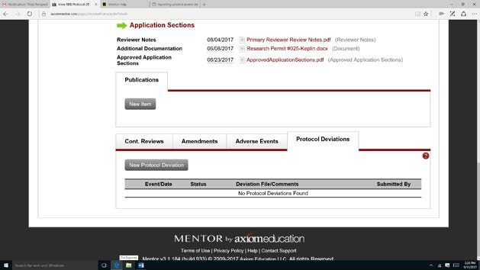

* Click on the **New Protocol Deviations** button and the following screen will appear.

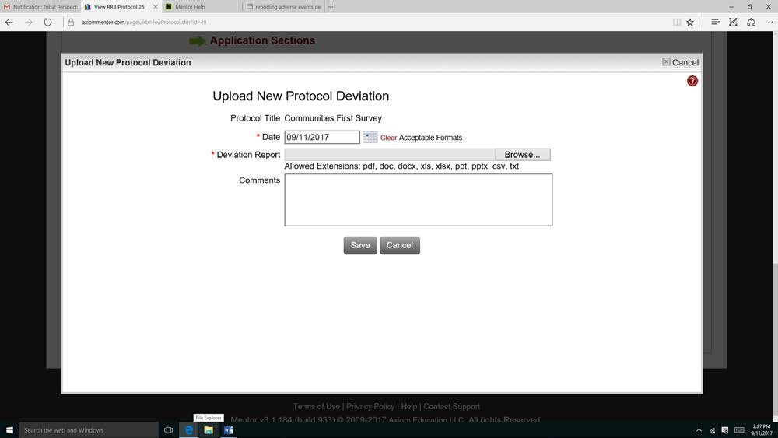

* Fill out the required information and upload a detailed description of the protocol deviation. The date field should indicate the date the deviation took place.
* The Chair will consult with the RRB committee members to determine what actions to take.
* The research may not continue research activities until receiving written permission from the RRB Chair.

# Submitting publications/presentations/abstracts for RRB approval

TMBCI RRB requires approval of all publications, presentations, and abstracts prior to submitting to an organization.

* Click on the **My Protocols** tab and then click on the protocol you will be submitting a request.
* Scroll to the bottom and click on new item.
* The following screen will appear:

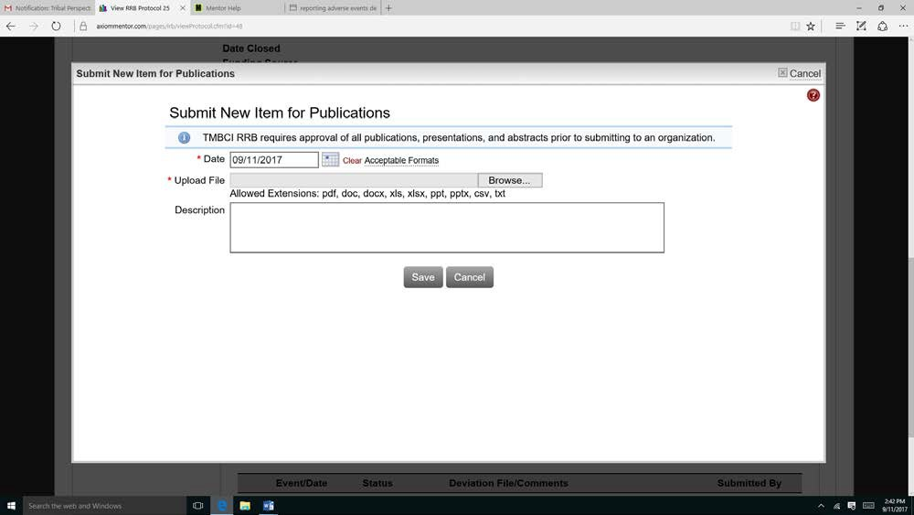

* Complete the required information and upload required documents, please provide a detailed description of your submission, where it will be published and form what purpose.
* The Chair will consult with the RRB committee members to determine what actions to take.
* Written permission from the RRB Chair is required before publication, presentation, or submission to an agency.