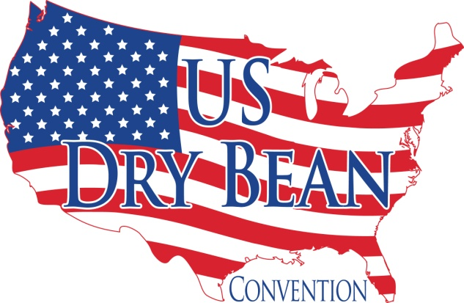

2022 Convention – Sponsor Shipping & Storage Instructions
If you are sending materials to the hotel, please ship to arrive no earlier than three (3) days prior to event. To ensure proper processing, please address all materials intended for events following the box label instructions. Boxes should be numbered “1 of 6”, “2 of 6”, “3 of 6” etc. This way they will know when incomplete shipments are received & can make you aware as soon as possible.

The Omni works with UPS on site. Follow the instructions below:
Separate fees apply for each direction of parcels (Inbound & Outbound).
- Freight
  - Sm. Rolling Crate (< 75 lbs.) $75
  - Lg. Rolling Crate (> 75 lbs.) $150
  - Pallet (Freight) $250
- Small Packages (UPS/FedEx)
  - Letter/Envelope/Padded Pak $5
  - 1-10 lbs. $7
  - 11-20 lbs. $15
  - 21-40 lbs. $25
  - 41-60 lbs. $45
  - 61-80 lbs. $70
  - 81-100 lbs. $100
  - 100+ lbs. $120
The following forms have been attached for your information and use:
Print the credit card authorization form and email it back to store6468@theupsstore.com prior to shipping
your items. They will not charge your card until after the convention.
Box Label for Promotional Items – to be delivered to the resort no later than 7/25:
240 Promotional Items
Box Label for Exhibit Items – delivered to the resort no later than 7/29 –
Setup will be Saturday 7/30 from 10 am – 4:30 pm

Please send a copy of your routing number(s) and total number of boxes shipped and be sure to indicate if the boxes are for exhibit or promotional. info@usdbc.com

Electrical:
Electricity is available at your exhibit for $95

Thank You,
Ari Pladsen
Executive Director

