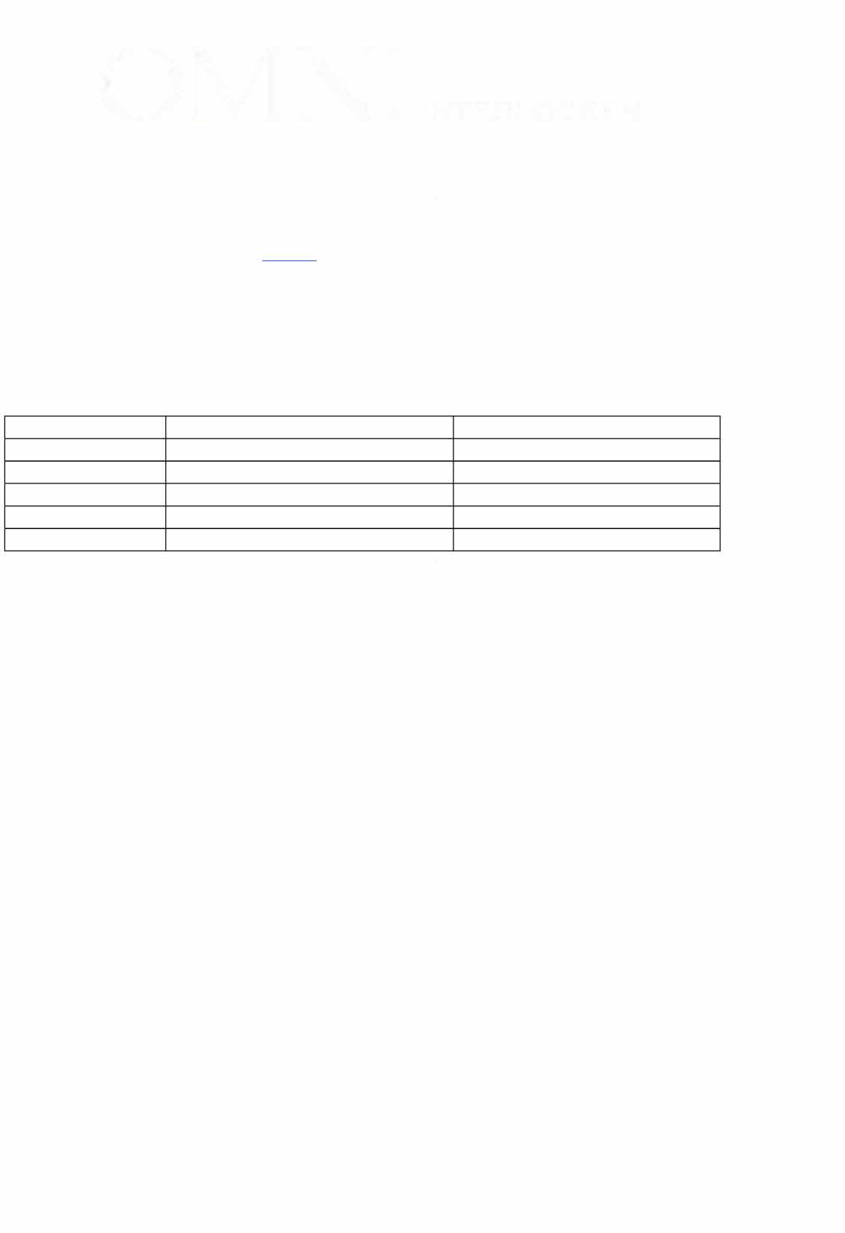**OMNI INTERLOCKEN**

**PACKAGE HANDLING FORM**

Please review procedures and pricing for Package Handling and submit all requested details at least 72 hours prior to expected delivery date. Failure to adhere to instruction will result in additional cost and delayed delivery. If separate parties are shipping packages for this program, please fill out separate forms. All forms can be submitted [tamara.full@omnihotels.com](mailto:tamara.full@omnihotels.com)

**PROGRAM NAME: US Dry Bean Convention 2025**

**PROGRAM DATE: July 19-22, 2025**

**SHIPPED TO (Exhibitor):**

**SHIPPED FROM:**

**EMAIL ADDRESS:**

**COURIER TRACKING NUMBER ITEM SIZE** & **DESCRIPTION**

**SHIPPING LABEL:** *All packages must be addressed as follows:*

ATTN: US Dry Bean Convention

Recipient and Exhibitor Name

Omni Interlocken

500 Interlocken Blvd

Broomfield, CO 80020

**HANDLING FEES:** Box deliveries will be assessed according to weight. Packages with notable weight, dimension or value should be included under "Description" above; additional cost or storage arrangements may be required. **Please indicate the number of boxes being shipped below**:

_0-10 lbs: $5.00 per box

_10.1-25 lbs: $10.00 per box

_25.1-50 lbs: $15.00 per box

_50.1-75 lbs: $25.00 per box

_75.1+ lbs: $50.00 per box

_Shrink Wrapped Pallet(s) or Wooden Crate(s): $150.00 each

*\*Must be self-contained and properly sealed*

**TRACKING INFORMATION:** Due via this form to [tamara.full@omnihotels.com](mailto:tamara.full@omnihotels.com) at least 72 Hours prior to delivery; **additional fees will be incurred for mislabeled, late or packages with no notice.**

**STORAGE:** Box handling fees include storage for up to 72 hours prior to event start. Early deliveries will incur additional $5 per box, per day or $25 per pallet, per day.

**DELIVERY:** Packages will be delivered to the Exhibit table at time and date agreed upon by Group and Hotel. If a package needs to be delivered early or picked up by an individual guest, the request must be placed in advance.

**OMNI INTER LOCKEN**

*The Hotel does not accept any liability for packages that arrive unmarked or fail to arrive at the Hotel. The Group is responsible for insuring its property for loss or damage. Please contact your Convention Services or Catering Manager with any questions.*

**Payment (check one):** All package fees will be charged at the time of delivery.

* **Charge Exhibitor Guestroom. *Hotel Confirmation Number:* __________________________________________________**
* **Send Credit Card Authorization to the following email address: ___________________________________________**

**Outgoing Shipping Instructions:**

Exhibitor must provide account number, shipping labels, and call shipper to schedule pick up. The hotel does not provide FedEx Air and UPS Ground labels. If an account number is not available, please go online to the shipper of choice to create a shipping label and make payment.