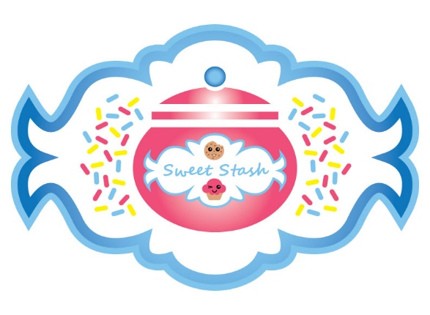
Sweet Stash Price List

CUPCAKES
Standard size $25 dozen, $13 half dozen
Specialty flavors standard size $30 dozen or $25 dozen if purchasing 3 or more dozen, $15 half dozen
*Mini size only available by the dozen and flavors limited, $15-18
Infused cupcakes standard size $60 dozen, $30 half dozen
Custom cupcake order prices may vary

Cupcake Flavors
*The Nilla
Vanilla cupcake topped with vanilla buttercream icing, sprinkles optional
*Chocolate Thunder
Chocolate cake topped with dark chocolate buttercream and chocolate shavings
*The Classic
Yellow cake topped with chocolate fudge icing
*Lemon Burst
Lemon cake topped with lemon cream cheese icing and a candied lemon slice
*Berry Best
Fresh strawberry cake topped with strawberry cream cheese icing, sprinkles optional
*The Velvety Red
Red velvet cake topped with cream cheese icing and red velvet cake crumbs
Specialty Cupcake Flavors
*Salted Caramel Pecan
Yellow cake with salted caramel pecan center topped with cream cheese icing, caramel drizzle, and chopped pecans
*Strawberry Shortcake
Yellow cake topped with whipped cream cheese icing, fresh strawberries, and strawberry glaze
Cookies and Cream
Vanilla cake folded with Oreo cookie pieces topped with cookie crumb vanilla buttercream and a mini Oreo cookie
Banana Pudding
Vanilla cake with a banana pudding center topped with banana whipped cream icing layered between 2 vanilla wafer cookies
Apple Pie
Vanilla cake lightly spiced with cinnamon topped with vanilla buttercream, apple pie filling, streusel, and pieces of pie crust
Peach Cobbler
Vanilla cake topped with vanilla buttercream, peach cobbler filling, and streusel
Lemon Blueberry
Lemon cake folded with fresh blueberries topped with lemon zest blueberry buttercream
*Turtle
Chocolate cake with caramel pecan center, topped with cream cheese icing, caramel drizzle, and pieces of turtle candy
German Chocolate
Chocolate cake topped with coconut pecan icing, a pecan piece and chocolate drizzle

Infused Cupcake flavors
These cupcakes are baked with liquor infused in the cake, and include a shot topper
Margarita
Key lime cake topped with lime zest buttercream and a lime slice, infused with Patron
-Strawberry Margarita includes fresh strawberries folded in key lime cake topped with strawberry lime zest buttercream, and strawberry and lime slices

Hennything Goes
Vanilla cake topped with cream cheese icing, caramel and chocolate drizzle, and pieces of chocolate toffee cookie, infused with Hennessy
Caramel Apple
Green apple cake topped with green apple cream cheese icing and caramel drizzle, infused with Crown Apple or Ciroc Apple
Peaches N Cream
Yellow cake folded with chopped peaches topped with peach buttercream and peach slice, infused with Crown Peach or Ciroc Peach

*Any basic cupcake flavor can be infused

SPECIALTIES

Brownies
4 jumbo squares per order
Fudge
Brownie topped with fudge icing $20
with pecans $25
Lemon
Lemon blondie topped with lemon zest glaze $20
German Chocolate
Brownie topped with coconut pecan icing $25

Cake Balls
$25 dozen, $15 half dozen
Flavors- Vanilla, Strawberry, Red Velvet, Funfetti
*white dipped and topped with drizzle and basic decor
*custom colors/decor available upon request, additional $5

Stuffed Cookie Cups
$15 dozen, $8 half dozen, mini size
Peach Cobbler
sugar cookie with a peach cobbler filling, topped with streusel
Apple Pie
snickerdoodle cookie with apple pie filling, topped with streusel and caramel drizzle
Turtle
double chocolate cookie with whipped caramel pecan cream cheese filling, topped with caramel drizzle and pecan pieces
Banana cream
sugar cookie with banana pudding filling, topped with whipped banana cream and cookie crumbs
Strawberry Cheesecake
graham cracker cookie with strawberry cheesecake filling, topped with strawberry glaze and a strawberry slice

Cookie Cakes
12 in. Serves 10-12 $25
Chocolate Chip, Sugar, or Funfetti
Bordered with buttercream icing and sprinkles
*Additional charge may apply for custom details

Cheesecakes
Prices vary based on size and flavor
10 in. serves 14-16, $35-50 9 in. serves 10-12, $30 -45 8 in serves 8-10, $25 -40
Plain Supreme
Strawberry
Blueberry Coffee Cake
Caramel Pecan
Peach Cobbler
Mini Cheesecakes $35-45 dozen, $20-30 half dozen
strawberry, blueberry, caramel pecan, cookies and cream

Cobblers
Small pan serves 8-10, large pan serves 18-20
Peach
Individual $5, sm pan $25, lg pan $50
Apple
Individual $5, sm pan $25, lg pan $50
Blackberry
sm pan $30, lg pan $60, no individual size
Pies
Sweet Potato $25
Pecan $30
Buttermilk Pie $20
Banana Pudding
Small pan $30, Large pan $50
Shooters $40 *only available by dozen

Dipped Berries
Chocolate and White Chocolate $20 dozen, $10 half dozen
Customized colors available
Glitzy and Glam $25-30 dozen, $15-20 half dozen
Dipped in white chocolate, options for edible glitter, marbled, luster
Customized colors available

*All berries may be infused, $1 per berry

