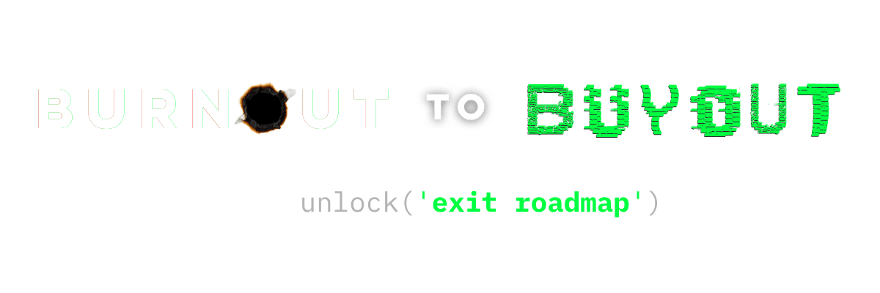
A 12-Month Framework to Scale, Systemize, and Sell
Jason Gilbert • hello@burnouttobuyout.com

INTRODUCTION
You Don't Need More Hustle. You Need Structure.
Most founders are trapped inside their own businesses. They are the product, the salesperson, the decision-maker, and the bottleneck — all at once. This roadmap is the way out.

THE 12-MONTH ROADMAP
PHASE 01  STABILIZE  Months 1 – 3 | - Audit where your time actually goes  - Identify bottlenecks — especially you  - Document the 3 things only you can do  - Stop taking on work that belongs to someone else

PHASE 02  BUILD SYSTEMS  Months 4 – 6 | - Write SOPs for your 10 most-repeated processes  - Standardize client delivery and onboarding  - Create a quality-control layer without you in it  - Introduce basic KPIs the team owns

PHASE 03  BUILD TEAM  Months 7 – 9 | - Hire or promote for the roles you are filling  - Delegate responsibilities — not just tasks  - Build a leadership layer that runs weekly ops  - Test: can the business function without you for 30 days?

PHASE 04  PREPARE FOR EXIT  Months 10 – 12 | - Improve EBITDA and clean up the P&L  - Document value drivers a buyer will care about  - Prepare a CIM-ready financial summary  - Run the business as if you are presenting it to a buyer

THE BURNOUT TO SCALE BLUEPRINT
5 Steps to Build a Business That Can Run — and Sell — Without You
STEP 1 STOP BEING THE BOTTLENECK
- Identify everything that only YOU do today
- Delegate or document every single one
- If everything flows through you, growth stops

STEP 2 PRODUCTIZE YOUR SERVICE
- Move from custom work to standardized offers
- Define exactly what you deliver, how, and at what price
- Predictability is the foundation of scale

STEP 3 BUILD RECURRING REVENUE
- Shift from projects to contracts, retainers, or subscriptions
- MRR / ARR directly increases business valuation
- Stability makes your business attractive to buyers

STEP 4 INSTALL AN OPERATING SYSTEM
- Implement EOS, OKRs, or a similar framework
- Weekly meetings with clear agendas and owners
- Accountability chart with defined roles
- Every team member knows what winning looks like
(EOS — Entrepreneurial Operating System — is a strong starting point)

STEP 5 THINK LIKE A BUYER
- Ask: Would YOU buy your business today?
- Would it feel like an asset — or a liability?
- Build for optionality, not just revenue

____________________________________________________
This is just the framework.
Burnout to Buyout gives you the tools, the playbook, and the community to actually execute it.
→ hello@burnouttobuyout.com

