**Scaley Addictions**

Snellville, GA 30039

678-787-5194

scaleyaddictions@gmail.com

ScaleyAddictions.org

***CRESTED GECKO***

**HOUSING**

Crested geckos thrive in a variety of housing options, making them an ideal introductory species to work with.

* Hatchling and juvenile geckos do best kept in a smaller environment, such as a 6 quart plastic shoebox style tub. If you prefer glass enclosures, an 8" cube is appropriate for geckos up to 10 grams in weight.
* At 10-15 grams, a gecko could be moved into a slightly larger enclosure - a 20 quart tub or a 12x12x18" glass enclosure would be suitable. You may also opt to move them to their permanent enclosures at this time.
* 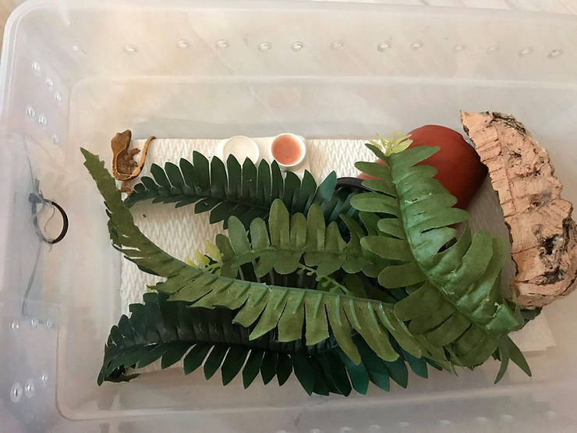Adults or geckos 20 grams and larger do best in larger enclosures. There are many options for this: plastic tubs 55 quarts or larger, or front opening enclosures like Exo Terra 18x18x24" or larger.

**HOUSING DECOR**

Crested Geckos are arboreal geckos who, in nature, spend their time several feet off the ground in the canopy of the forest. Their enclosure should be decorated with a healthy balance of branches and leaf cover. We opt for cork bark as it aids in shedding, is resistant to mold, and provides plenty of climbing surface for the animal. Pool noodles can be used in place of cork bark, if necessary. They will need to be removed and cleaned regularly due to their porosity. The enclosure should not be stuffed with decor but should have several spots covered by leafy plants for hiding and security.

This species does well with a variety of substrate options; we opt for paper towel for juvenile geckos up to 15 grams in weight and for the first 90 days of owning the animal regardless of size. This is suitable for the lifetime of the gecko, should that be your preference.

Alternatively, a bioactive soil mixture can be used BioBedding Tropical, sold through [www.JoshsFrogs.com](http://www.joshsfrogs.com/) and also other suppliers. This substrate drains well while slowly wicking moisture to the surface, allowing it to function without a drainage layer in most circumstances. It grows plants well and even does a decent job incubating crested gecko eggs! Springtails and isopods love it, and it comes seeded with beneficial fungi. A bioactive environment does require the inclusion of isopods and springtails to remove waste and other organic matter.

Female crested geckos over 20 grams in weight should be given constant access to either a [lay box](https://hayfox.wixsite.com/crestedcabana/post/crested-gecko-egg-laying) or several inches of soil, to allow for safe egg laying.

**TEMPERATURE & HUMIDITY**

One of the universal appeals of crested geckos is their temperature requirements, and that the species often does not require additional heat. During the warmer months, daytime temperatures of 75-79f are ideal and promote activity, appetite, and growth. Night time temperatures can dip as low as 65f.

During winter months, if temperatures dip below 70f during the day or lower than 65f at night, additional heat becomes necessary. This is best provided with a mini CHE (ceramic heat emitter) or DHP (deep heat projector) on a reliable thermostat. Both of these can be found at most retailers, both in store and online. Watch the wattage of these CHE and they must be on a thermostat or you will cook your gecko in its cage.

While these geckos are endemic to forest areas, they do require a dry out period. Their humidity levels should dry down (30-40%) and remain that way through the entirety of daylight hours, with a short spike of 80%+ at night time. This can be accomplished with a decent misting. Some climates only require misting the enclosure every other day, while others require daily misting. Ensure that your geckos have constant access to a bowl of clean drinking water.

**DIET & FEEDING**

Crested geckos are omnivores, requiring both a powdered diet and live insects. We feed and recommend the Pangea (but there are other brands such as repashy and zoo-med) prepared diets; powder that is mixed with water. This should be offered every 2-3 days.

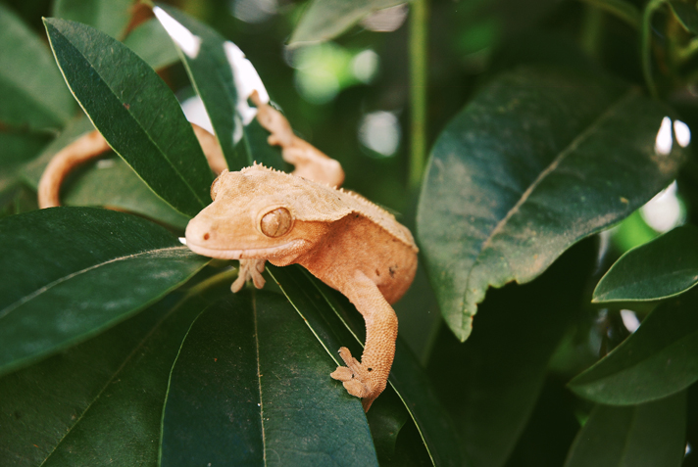Twice per week, live insects should be offered. These provide both nutrition and healthy proteins, but are also an excellent source of enrichment for your gecko as they are able to exercise their natural hunting instinct.

With both prepared diet and live food, variety is always best. There are many options of feeder insect that make excellent staple feeders:

* Crickets
* Mealworms
* Dubia and Discoid roaches
* Silkworms
* Superworms-small ones
* BSFL (Black soldier fly larvae)

Every live feed should be dusted. Most frequently with calcium with D3, alternating every few feeds to use a multivitamin instead.