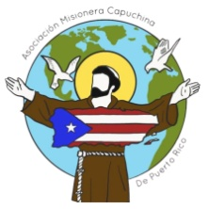
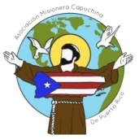
ASOCIACIÓN MISIONERA CAPUCHINA
CUSTODIA DE SAN JUAN BAUTISTA DE PUERTO RICO
787-764-6080 / 787-224-9700 / amcapuchinapr@gmail.com
Padre Pio Novena 2026
Membership number «EnvelopeNumber»
«FIRSTNAME» «LASTNAME»
«Address1»
«Address2»
«City», «State» «ZIPCode»

Peace and Good «FIRSTNAME»!

Many years ago, an elderly man frequently visited Saint Pio of Pietrelcina. One day he said to him sadly, “Father, I can no longer work as I used to, I can hardly leave the house, and I feel that I am of little use.” Saint Pio looked at him serenely and replied, “Who told you that? If you can pray, you can sustain the world.” That man understood that his hands might lost the strength for many tasks, but they still had the capacity to unite with God in prayer for those he loved most.
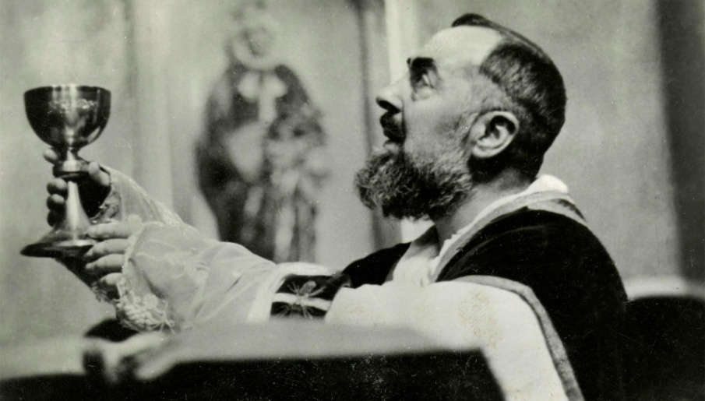
That is also our mission. Perhaps we can no longer solve all the problems of our children, grandchildren, or friends; perhaps we cannot take away their burdens. But we can do something that no one can prevent us from doing, placing their names in God's hands each day. Prayer does not replace love; it is its deepest expression, because it entrusts to the Lord what we can no longer achieve.



Fr. Gamalier, please include in your prayers the following intentions for the
Padre Pio Novena 2026

Name: «FIRSTNAME» «LASTNAME»_ «EnvelopeNumber» Phone: __«PreferredPhone»___

People and intentions included in your prayers.
____________________________________________________________________________________________________________________________________________________________________________________________________
______________________________________________________________________________________________________________________________________________________________________________________________________________________________________________________________________________________________________

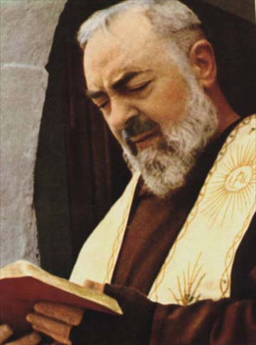
«FIRSTNAME», I invite you to experience this novena in Saint Pio with a heart full of trust. For nine days, let us present to the Lord all our intentions: our joys, our worries, the sick, our families, those who have strayed from the faith, and our own needs. Saint Pio often repeated: “Pray, hope, and don’t worry.” Let us make this invitation our own, convinced that no prayer offered in faith goes unheard by God.

With fraternal affection,



Friar Gamalier Martínez, OFM. Cap.
Director
Capuchin Missionary Association

Please accept my donation of: ______$40 _____$50 _____$60 _____$100 Another amount $ _____
The recurrence of my donation will be: ___ One time ___ Monthly
Please complete your personal information:
Name: _______________________________________________________________________
Phone: ______________________________________________________________________
Email: ______________________________________________________________
Address: ______________________________________________________________________
Please complete this section only if your donation is by credit or debit card:
Credit card number: ______________________________________________________
Expiration date: Month _______ Year _______ Security code: ______ Signature: ____________________________

