**These are some ways you can support our mission of saving hundreds of kitty lives every year! Please share with friends & family! More donations means more lives are saved!**

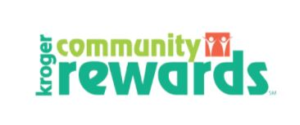

**(It only takes a few minutes to sign up and no cost to you)**

**Go to**[**Kroger.com**](https://r20.rs6.net/tn.jsp?f=001fpT1Q5xQtIUDpE0c5M4wXxVw6LKp0_C4IF2OzQ5qb5nRjvnVjT1kmyzXa-e2rI9_JKbGC7JGJjyD04y0tjuYKS8sODDUjP_qH1-XgRJEOh8NVzols9Jyb7haV6g5Du4o8npQeRlXZf1FUF_IPTsZsoGW7zKJQOVn6O66BUAR4xjedIRqZL0CypreScAa2mbcGmlGH6a7d23VxODtdlYA6Q==&c=rlQCq-lBQdhNj4kVAwNPq2vfyxpk9h13Ydz_aLL4Xhv_6S5HuFNjJA==&ch=XnNnTmy2qbw4vlZcLUzF4OAla_XpJ_I5Fncynp5_veGNmuuxvG60NQ==)**(sign in or create an account) or open your Kroger app,**

**Click on the Menu (bars at top left screen… on app)**

**Click on Rewards, then View Community Rewards**

**Click on Change Organization or Add an Organization**

**Search for Star’s Cat Connection & choose “enroll”**

 WISHLIST

**To donate from our wish list on Chewy.com, SCAN THE QR CODE**

**OR, from the Chewy home page, select “give back.” Select “donate to a rescue,” then type in “Star’s Cat Connection” in the search box.**

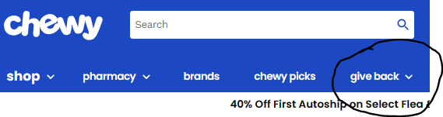



 **WISHLIST**

<https://www.amazon.com/hz/wishlist/ls/24QFM5DUFL1MU?ref_=wl_share>

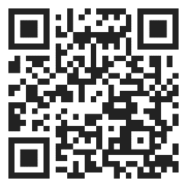

**CASH DONATIONS CAN BE MADE:** 

**through PAYPAL by sending to** [**starscatconnection@gmail.com**](mailto:starscatconnection@gmail.com)

**through VENMO to Starlene Kinser @Starlene-Kinser-1**

**OR BY MAIL TO: P.O. Box 2346 Heath, Ohio 43056**

**VOLUNTEERS ARE ALWAYS NEEDED**

**Please text your name to 740-334-9921 with what type of volunteering you may be interested in and someone will get back with you as soon as possible. We have openings for fosters, transport, and store care of adoptable cats (food, water, care, and socialization once to three times weekly for about an hour).**