**PET ADOPTION COMMITMENT**

**please send updates after your new cat adoption**

**We love to hear from our cat adopters with updates & photos within a few days of adoption, and intermittently thereafter. Updates on how your new cat is adjusting in his/her new home are encouraged. Updates may be sent**

**by e-mail or text. This contact information may be found at the end of this document.**

**Please contact us immediately if you cannot keep your adopted cat FOR ANY REASON or if your cat gets outside & becomes lost. Please don’t delay reporting the issue. We can help!**

ADOPTION, HEALTH & SAFETY

Adoption is a long-term commitment that should be seriously considered prior to the adoption. Current lifestyle and future plans should be considered in the decision to adopt any new pet. The average life expectancy of an indoor cat is approximately 15 to 18 years.

Renters should have landlord approval prior to bringing a pet into the home because an additional deposit and/or monthly fee may be required. Cats are commonly abandoned due to owners moving to places where they are not allowed to take pets, people having or developing allergies, and when a new baby is welcomed into the home.

We highly recommend that a pet cat is never let outside because there are too many dangers & potential disease exposures. The average survival of an outdoor free-roaming cat is only 3 years (VetInfo, 2018) due to outdoor dangers. We want the best outcome for both the adopter and the adopted pet and strive to prevent pet re-homing, neglect/abuse, and abandonment.

# **picking out your new cat**

Cats have a wide variety of personalities. While appearance may be important, it is more important that the cat you choose have a personality that your family can adapt to and vice versa. If you have children, other cats, or dogs, it is important to find a cat who will do well with them.

If you have no other pets, you might consider giving a good home to a shy cat who would otherwise spend years in a shelter and possibly never find a home. Personalities range from cats who desire constant attention, to others who will only tolerate being picked up, and others who may only let you pet them occasionally but never hold them. Some cats get along great with children, other cats, and dogs while some cats don’t get along with any other pet including other cats.

# **taking your new cat home**

**Re-homing is stressful to most cats. We generally recommend that anyone taking a cat to a new home keep them confined to one room of the home until they get used to their new owners before allowing them to explore the entire home.** This will help prevent or reduce the incidence of hiding. If a cat has a naturally shy personality or if they are just experiencing an adjustment to moving, they may hide even in one room. If this happens, try sitting down on the floor and coaxing them with treats until they come out to you. Once the cat understands that you are not a threat and they are used to the new area, they will be back to their usual self and ready to relax and explore. This process may only take a day or two for some very relaxed cats and weeks for others who are more fearful of new places.

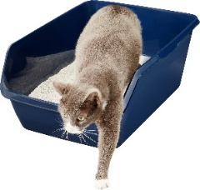Always show your new cat where the litterbox, food and water are located and these should be in the room where they will stay initially while adjusting to new owners and a new home.

# **HEALTH & safety**

Your new cat should have received routine vaccines and appear healthy and act appropriately upon adoption. As a rescue, we treat our pets for any health conditions and assure that they are up to date on vaccines prior to adoption. Once you get to know your new pet, if you notice any unusual behavior, it should prompt you to seek advice from a veterinarian because cats are very good at hiding illness.

In regards to safety, there are a number of things to watch for when bringing a new cat home.

**The following is a list of some common things to be cautious of:**

**Serious injuries:** Because children and kittens love to run and play, we have to be careful that kittens don’t get stepped on and hurt when they are both running and playing in the same area. Opening and closing doors are also a hazard as many cats and kittens love to run through doorways when they are being opened so it’s important to watch as you are opening and closing any door.

**Choking hazards:** Some cats and most kittens love to chew on or eat strings or any similar objects which can lodge in and become trapped in their stomach leading to blockage and a medical emergency requiring surgery to save their lives. Very small objects such as tiny children’s toys should be kept off the floor and out of reach of cats and kittens.

**Suffocation hazards:** Grocery bags and any type of plastic bag large enough for a cat or kitten to get their head into is a serious suffocation hazard as they love to play with bags but can actually cause a vacuum of air which prevents them from getting the plastic off of their face.

**Be alert to changes in your cat’s behaviors & activities as this can be a sign of an underlying illness that may not be obvious.** Cats tend to hide illness very well, even serious illness. Sometimes the only sign of a complete urinary tract blockage in a cat is that they go in and out of the litterbox many times without urinating or they may lay in the litterbox. This is an extremely urgent medical problem that can be deadly in a matter of a day!

**We always recommend that your cat is not let outside.** There are too many dangers including predators and exposures to deadly diseases. While the indoor cat has an average life expectancy of 15 to 18 years, the average survival of an outdoor free-roaming cat is only 3 years (VetInfo, 2018).

There are many more pet safety hazards in addition to the ones listed above, so it’s important to watch out for our new pets, use common sense, & keep them safe.

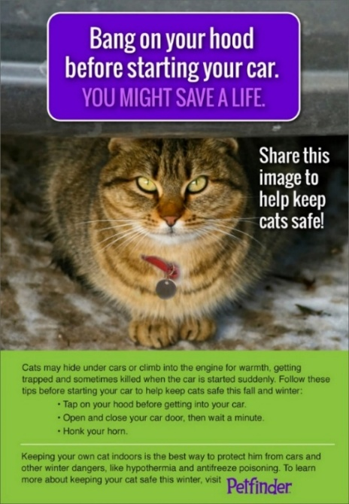

# **THE LOST CAT**

**When an indoor cat gets outside, whether accidentally or intentionally, most are very fearful and will hide for days or weeks, only coming out at night when things are quiet. If you have searched during the day with no luck, be sure to check all doors of your home periodically throughout the night every night until your cat is back inside. It’s best to check the doors at least every couple of hours during the night as a lost cat may come to the door at any time of the night and wait a short time for their owner to open the door. They will retreat back to their hiding place if they are unable to get back into their home. A cat may do this for several weeks.**

**Utilizing a door camera (ring camera) can help alert you in real time when the cat returns to the door. If available, you might set up a trail camera or similar camera near your property or where you suspect the cat may have disappeared to. This may have to be checked after the fact, but at least you will know if the cat has been in the area.**

**Using a flashlight at night to look under porches, decks, buildings, etc. can also help locate a lost cat. Going outside and sitting down in the yard and calling your cat very late in the evening or very, very early in the morning may work as well but it must be done when things have quieted down and there are less people and less traffic around. We have been successful at getting several cats back into their homes through these methods.**

We wish to thank everyone who has supported us in the past and to all those who will support us in future endeavors to help homeless cats find happy, healthy new forever homes!

Star’s Cat Connection

P.O. Box 2346

Heath, OH 43056

**Text:** 740-334-9921

**E-Mail:** [**starscatconnection@gmail.com**](mailto:starscatconnection@gmail.com)

**Website:** [**www.starscatconnection.com**](http://www.starscatconnection.com)

**Facebook:** [**www.facebook.com/starscatconnection**](http://www.facebook.com/starscatconnection)

**PetFinder:** [**Pets for Adoption at Star's Cat Connection, in Heath, OH | Petfinder**](https://www.petfinder.com/member/us/oh/heath/stars-cat-connection-oh1000/)

[**https://bmvonline.dps.ohio.gov/bmvonline/oplates/specializedplates/1**](https://bmvonline.dps.ohio.gov/bmvonline/oplates/specializedplates/1)

|  |
| --- |
|  |

**Support our mission to help homeless cats find a loving family!**

**Donate through our web page at www.starscatconnection.com.**

**Or scan the QR code**

**Register your Kroger Rewards Card listing our organization as your nonprofit choice at** [**www.krogercommunityrewards.com**](http://www.krogercommunityrewards.com) **or by using the Kroger app!**