Calling all K-5th grade kids! Join the award-winning Aliso Niguel Dance Team for the 2025 Diva Dance Camp! The Aliso Niguel Dance Team members will be teaching dances to the campers. No experience necessary!
CAMP DATES:
Friday, December 5th | 4:00 – 7:00 pm | Camp, Dinner & Fun | ANHS Food Court*
Friday, December 12th | 7:00 pm | Winter Concert | ANHS Theater*
Directed by Ann-Marie Desiano the Dance Team Advisor

*Address: 28000 Wolverine Way, Aliso Viejo

COST: $65 per camper (or sign up with a buddy – two for $99)!!!
All campers will receive a Diva Dance Camp t-shirt & bow, dinner & dance class, access to Shutterfly photos after 12/12, show rehearsal….and some unforgettable memories!

REGISTRATION: Due by November 30th
PAYMENT: Venmo, PayPal, or check payable to ANHS Dance Team Boosters

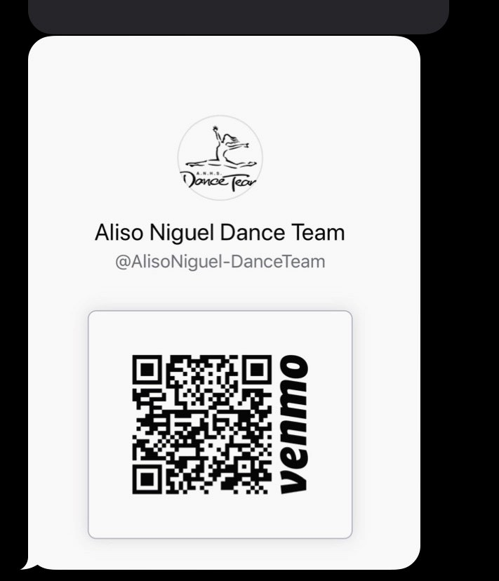

**If paying by Paypal or Venmo please include Diva’s name and indicate payment is for
Diva Dance Camp!

THIS IS A FUNDRAISER FOR THE ANHS DANCE TEAM – THANK YOU FOR YOUR SUPPORT! WE CAN’T WAIT TO MEET YOU!
Follow us on Instagram @alisodanceteam or visit www.anhsdanceteam.com
The Winter Concert starts at 7:00pm.
Costume for the performance: black leggings, their Diva Dance T-shirt, and dance/tennis shoes!

Please fill out ALL information below and email to karensmcdonnell12@gmail.com or turn into Mrs. Desiano at ANHS by November 5th!
Cost is $65 a camper (or sign up with a buddy (2) for $99.00)

Signing up with a buddy? Name of buddy: _____________________

Camper #1 Full Name | Grade Level | T-Shirt Size
Small Medium Large

Please circle one: CHILD or ADULT size

Print Parent Name | Parent Signature** | Phone Number
Parent Email | Non-Parent Emergency Contact | Phone Number
Insurance Company Name | Policy Number

Camper #2 Full Name | Grade Level | T-Shirt Size
Small Medium Large

Please circle one: CHILD or ADULT size

Print Parent Name | Parent Signature** | Phone Number
Parent Email | Non-Parent Emergency Contact | Phone Number
Insurance Company Name | Policy Number

How did you hear about Diva Dance Camp?

Does your child/children have any allergies? If yes, please describe:

Consent to take and use photos on flyers and ANHS dance team social media?
YES____ NO_____

Any comments or additional information we should know about?

