September 2024

We are excited to be members of Aliso Niguel High School’s nationally ranked Dance Team. Our group is comprised of many talented and dedicated dancers who also hold strong academic records and achievements. The Dance Team has been under the constant direction of Ann-Marie Desiano since its establishment in 1991. We are also privileged to have placed for twenty-two consecutive years at the national level, including two First Place Awards in 2024.

In addition to a very full competition schedule, our team performs at pep rallies, football and basketball games and in several showcase performances, including our spectacular Winter Concert. Each year we also participate in various community service activities such as recycling for Earth Day and assembling food boxes for the homeless.
Our team receives limited funding from the school district and needs to raise funds for expected costs of over $45,000 for the 2024-2025 school year. Each member is asked to donate $2,350 to help cover the cost of costumes, coaching, choreography and competition entry fees.

We are seeking your sponsorship to help us reach our goal! All donations are tax-deductible through the ANHS Dance Team Booster Club, a 501 (c) (3) organization. All sponsorships include recognition opportunities outlined in the details section on page two of this package.

There are several ways to make a sponsorship donation:
- Cash or check payable to ANHS Dance Team Boosters (please send to address at the top of this page)
- Venmo: @AlisoNiguel-DanceTeam
- PayPal: Alisodanceteam@gmail.com
  - Please note for PayPal transactions, a fee of 2.2% is incurred for debit or credit card transactions. If the fee is not added to the donation, it will be deducted from the sponsorship amount.
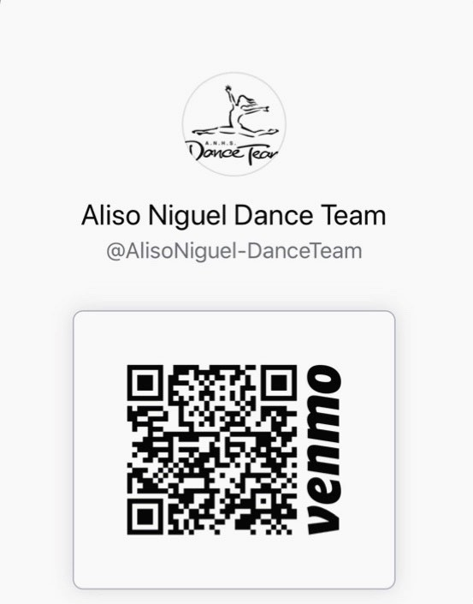


Please contact alisodanceteam@gmail.com with any questions. Thank you so much for helping to make our year a success! We appreciate your partnership and support!

With Gratitude,

20234-2025 Aliso Niguel Dance Team

2023-2024 Sponsorship Opportunities
LEVEL | AMOUNT | BENEFITS
Champion Sponsor | $5,000 | - Recognition on Dance Team Instagram Bio  - Name on back of Dance Team tee shirt (worn all year!)  - 3’x5’ Banner displayed at Wolverine Stadium  - Logo & Website link on our sponsor recognition webpage  - Front inside cover ad (8.5”x11”) in the Winter Concert program  - Sponsorship plaque
Premier Sponsor | $2,000 | - Business card ad/logo on the Sponsorship page on the Dance Team website  - 3’x5’ Banner displayed at Wolverine Stadium  - Full page ad (8.5”x11”) in the Winter Concert program  - Name on Dance Team tee shirt (worn all year!)  - Sponsorship plaque
Elite Sponsor | $1,000 | - Business card ad/logo on the Sponsorship page on the Dance Team website  - 3’x5’ Banner displayed at Wolverine Stadium  - Half page ad (8.5”x5.5”) in the Winter Concert program  - Sponsorship plaque
Signature Sponsor | $500 | - Business card ad/logo on Sponsorship page on Dance Team website  - Quarter page ad (2.75”x4.25”) in the Winter Concert program  - Sponsorship card
Banner Sponsor | $250 | - 3’x5’ Banner displayed at Wolverine Stadium  - Business card ad/logo on Sponsorship page on Dance Team website
Partner Sponsor | $100 | - Name on Sponsorship page on Dance Team website

All artwork must be at least 300 dpi and in .jpg or .pdf format. Please send artwork to alisodanceteam@gmail.com

Name of Organization: _____________________________________________________________
Contact: ________________________________________________________________________
How would you like to be listed on the website? _________________________________________
Address: _______________________________________________________________________
Phone: ______________________________ Email: _____________________________________
Amount Donated: ___________________ (Any amount is graciously accepted)

Payment Method: □ Cash □ Check □ PayPal □ Venmo

Please send completed form to:
ALISO NIGUEL HIGH SCHOOL DANCE TEAM BOOSTER CLUB
PO Box 6231 – Laguna Niguel, CA 92607-6231

THANK YOU FOR YOUR SUPPORT!

