A priceless investment
BECOME A FRIEND OF THE HSFM MUSEUM
2018 MEMBERSHIP
I would like to:
___ NEW ___RENEW ___UPGRADE

Check appropriate box:
- Lanier Annual Individual ……...… $15
- Flood LIFETIME Individual………$250
- Hancock Annual HOUSEHOLD… $25
(Members of one family at residence)
- Tillis LIFETIME HOUSEHOLD…. $300
- Whidden Annual Small Bus……..$100
- Lewis Annual Corporate..………..$500
- Varn LIFETIME Corporate.….….$5000
- Memorial/Honorary Brick………....$50
Contact Museum to order.

TOTAL AMOUNT ENCLOSED: $ ____

MEMBERSHIP BENEFITS on back.

PLEASE PRINT name to appear on
Friends of the HSFM Membership Card

MEMBERSHIP NAME _________________
Contact Person if different from above:
_____________________________
Mailing Address ______________________
City, State, Zip _______________________
Phone (_____) _______________
*Email: ___________________________
_*Prefer to receive Newsletter via Email.
Return this form with your check made out to HSFM Mail to: P O Box 1021
Ft Meade, FL 33841

Annual Society Events
3rd Tuesday/Monthly
History Night

January
Annual Membership Drive

February 17, 2018
Museum BBQ

March 29, 2018
90-year old Luncheon
& Easter Baskets
For Fort Meade Pioneers

April
Calendar Sale

May 1, 2018 (Tuesday)
May Pole Dance

November 16-17, 2018
History Trolley
Ride-Along
Friday Night 6-8 pm Saturday Afternoon 4-6 pm

FRIENDS OF THE HSFM MUSEUM
Membership Form
SEE BACK PANEL TO JOIN/RENEW

HSFM, Inc. is a Non-Profit, 501(c) 3 Organization

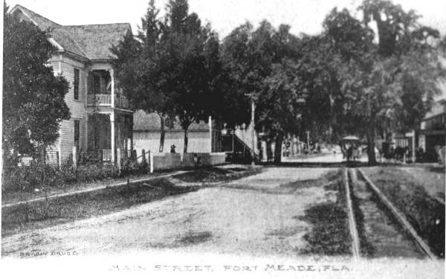
HSFM
Historical Society of Fort Meade
1 Tecumseh Avenue
863/285-7474

Hours 10 a.m. – 2 p.m.
Tues.*, Wed., Thur., Sat.
* 2nd Tuesday Museum closes at noon.

MISSION STATEMENT
Preserve Our History with Dignity.
Honor Our Future with Vision.

Keep up with what’s happening:
Facebook:
Fort Meade FL Historical Society & Museum
Email: museumfm@gmail.com

HISTORICAL SOCIETY OF FORT MEADE
FRIENDS OF THE MUSEUM – HOUSEHOLD AND CORPORATE PARTNERSHIP OPPORTUNITIES
 | BENEFIT LEVELS | LANIER  ANNUAL  INDIVIDUAL  $15 | FLOOD  LIFETIME  INDIVIDUAL  $250 | HANCOCK  ANNUAL  HOUSEHOLD  $25 | TILLIS  LIFETIME  HOUSEHOLD  $300 | WHIDDEN  ANNUAL  SMALL BUSINESS  $100 | LEWIS  ANNUAL  CORPORATE  $500 | VARN  LIFETIME  CORPORATE  $5000 | Lewis Lanier  A pioneer settler of Fort Meade,  cattle rancher, merchant and  founding father of Fort Meade.  Luke B. Flood  Irish immigrant to Fort Meade  and founding member of  Christ Church, (Episcopal).  Jordan Hancock  Seminole War and Confederate  veteran is the patriarch of the  Hancock Family in Fort Meade.  Willoughby Tillis  Pioneer and wounded veteran of the Seminole War and Civil War Battle of Bowlegs Creek.  James Whidden  The first wilderness settler in Fort Meade in what would  become Polk County.  W. Henry Lewis  Early town alderman and  successful cattleman and  citrus  grower.  Frederick N. Varn  Frederick Newton Varn was  patriarch of prestigious lineage  in the citrus industry.
Subscription to
* MUSEUM NEWSLETTER
Notification of
Special Events via Email
 | Membership Card
Complimentary attendance to
Non-Fundraising Events w/Membership Card
 | 10% Off Facility Rental
One Annual
Free Facility Use

 | Ad In Museum Calendar
 | Name on Lifetime Member Panel
* Museum Newsletter – mailed or emailed to all Friends of the Museum REWARDS: Joining the Fort Meade Historical Society ensures the preservation and presentation of local history for present and future generations. The chart above describes the benefits you will enjoy at each membership level. Support Today!

