Historical Society of Fort Meade:
Preserve our history with dignity. Honor our future with vision.
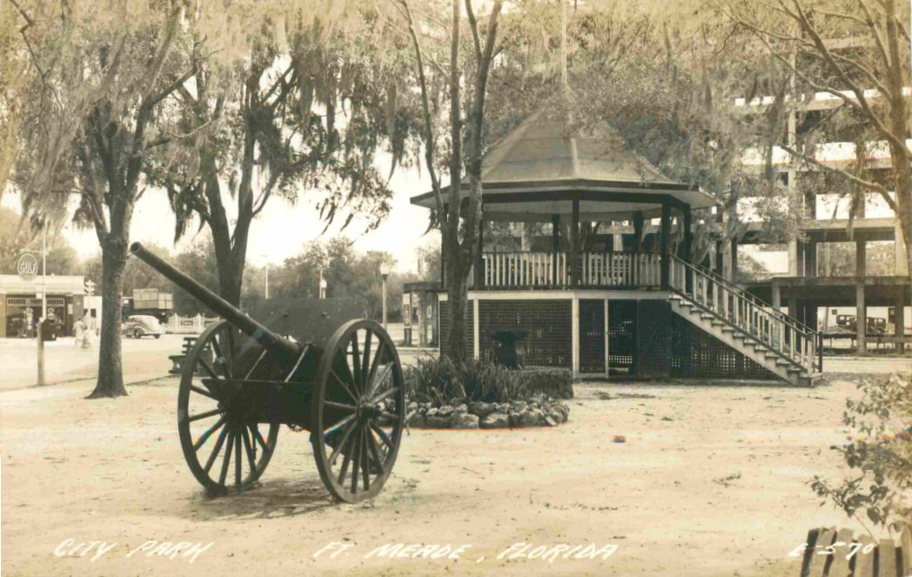

Triangle Park. Fort Meade Terrace Hotel is seen in the background at intersection of US 17/98.

Take a ride through Polk County’s Oldest settlement.
Fort Meade - where you can canoe Peace River, live the quiet life, enjoy your family surrounded by good neighbors, cheer for the Miners, enjoy hometown activities, volunteer to build, teach, guide, help.
Once it was the “wild, wild south!” Now Fort Meade is a growing and proud community respecting those who cleared the palmettos, planted the crops, built their homes, and stood up every time they fell down so we could live in this amazing place we call home.
December 13, 1849 .. 2nd Lt. George G. Meade selected this place to build a fort during the 2nd Seminole Wars. That was the beginning.
Now enjoy your drive through the rest of the story!
Special appreciation to Dr. Canter Brown, Jr., and Robert M. White for their research and publications, which can be purchased at the Museum. Also, check out HSFM’s web page: fortmeadeflmuseum.com and Florida’s archives at www.myflorida.com (click Floridian, then Fort Meade.)

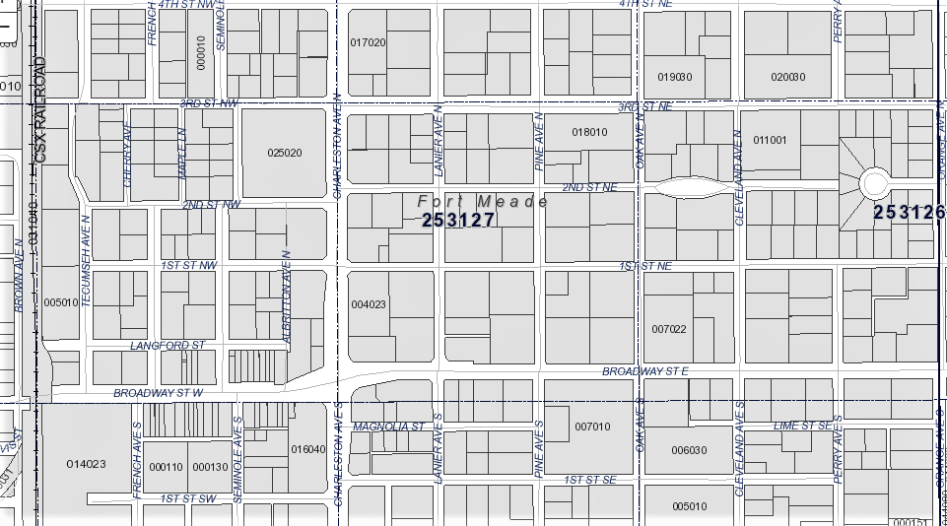
HISTORIC SITES IN FORT MEADE ….

6
4
6
3
3
5
1
2
6
1

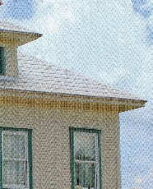
START: Park and read …. 1. The Museum (1885) continues to be the Treasure Box of Fort Meade. The Academy was donated to the City by the Ragon Barnett, Jr. family in 1984. The original site was located on the corner of SE Oak Ave. and 1st St. across from the Lewis Elementary campus; then moved to the corner of Magnolia and S. Lanier. The structure has served as a school, even the first High School, a community center, a boarding house, and a private residence. The City-owned property is also the location of the Train Museum on its own track, which is available to rent for meetings and special occasions. The gazebo was built by local Historical Society volunteers in honor of the one once found at Triangle Park at the intersection of Charleston and Broadway. The Society hosts an annual traditional May Pole Event for children and their families.

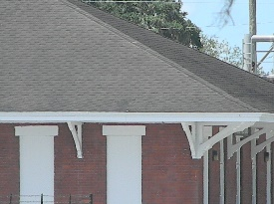
2. Second Train Station (1891) is located at Peace River Packing across from the Museum on Broadway. The original train station was simpler in its structure and located several blocks south. The 1914 station conjures up the image of a once crowded street. Broadway would have been filled with excited folks waiting for friends and family to arrive or depart for some rail venture on the train, as well as shipments of merchandise and goods. This building is owned by Peace River Packing Company and is not open to

the public. But the red brick and “Fort Meade” sign remain as a reminder of why “New Town” was constructed. Peace River Packing is family owned and operated and was founded 1928. Turn LEFT onto W. Broadway into town.

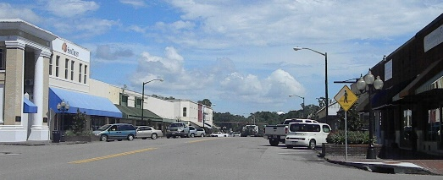
3. Downtown “New Town” Fort Meade was built to be close to the Railroad and after the disastrous fires of 1890-94 in “Old Town,” businesses moved. City Hall was built circa 1920s, and is still the center of the municipality, 8 W. Broadway St. Traveling east on Broadway gives a picturesque view of the Historic Downtown District, known once for the widest main street around. On the north side of the street is the former site of The First State Bank, which has retained its basic historic structure. Across the street on the corner of French and Broadway is Southern Posh, which was once the location of New Town’s Post Office.
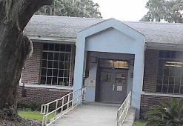
4. While at the Charleston/Broadway intersection look to your left and you’ll see the Veterans Memorial at City Hall, where the Population Center of Florida marker is found, as well. Now take a little detour to the south (TURN RIGHT onto Charleston) and then turn east (LEFT) onto 2nd Street SE. Turn LEFT again onto Oak Street SE to find the campus of Lewis Elementary #11, named in honor of its benefactor and education champion Dr. O.B. Lewis. With its huge oaks and original main building intact, the school was the academic genesis for many Fort Meade children. At the NW corner of 1st St and S Oak Ave, once called Francis Street (named for the trolley rail car owner William Henry Francis), you see the Queen Anne/Victorian Style home once owned by Florida State Congressman William O. Williams. Then later owned by Mayor Rupert Charles McClellan, grandson of George E. McClellan, a delegate of the Florida Constitutional Convention in 1838, leading the territory of Florida into statehood in 1845. Turn LEFT onto 1st St. E.

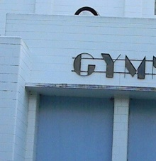
5. Art Deco Gym At the stop sign at Pine Ave., on the southwest corner, you’ll see the White House, which is a duplication in construction of a few more homes throughout the city. Turn RIGHT. Once Fort Meade High School’s gym is now Lewis Elementary’s cafeteria. You’ll be traveling alongside what was once the entrance to the gym. This architecture and lettering depict the only Art Deco found in Fort Meade. Continue north to East Broadway. While still in an historic mood, turn RIGHT and travel east. (You’ll pick up all the Northeast section on the way back.)

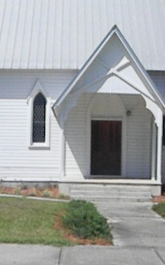
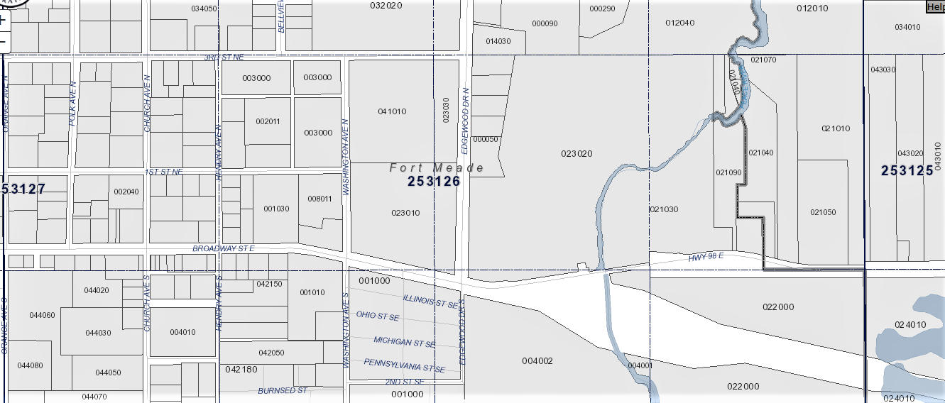
6. Immediately, on your north is the First United Methodist Church, whose congregation was the first to construct a church in Fort Meade. East Broadway’s hammock of large Oak trees provides a peaceful drive toward the river and is the site for the Presbyterian Covenant House, First Baptist Church of Fort Meade, and Christ, Episcopal Church (photo), which is on the National Register of Historic Places, built in 1889 with its familiar traditional architecture and founded by Luke and Alicia Flood. Across the corner is the Claude Reid Home, 1914, from where the carriage step in front of the museum came. “Old Town” stores were located between Orange and Church Aves.
7
8
8
9
10
8
7

.

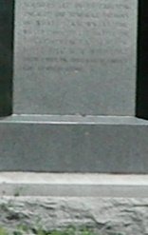
7. Monument Park Turn RIGHT onto S. Church to encircle Monument Park between S. Church and S. Hendry at 2nd . The Park memorializes the Battle of Peace River (1856) and is the Burial Site of Alderman Carlton, Lott Whidden, William Parker, Robert F. Prine and George Howell, who lost their lives when the Willoughby Tillis homestead was attacked by Seminoles. Turn RIGHT onto E. Broadway (US 98 E).

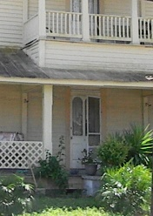
8. On the left is the Keller Home, circa 1900, and on the right Dr. Reagan Home, across from each other with balconies. These are original structures built when “Old Town” was located near Peace River prior to relocating west to benefit from the railroad. At N. Washington is the F.M. Yearwood Home, 1910. The large oak was the “end of the line” for mules pulling the trolley for the Fort Meade Street Railroad. Continue on to Bridge.

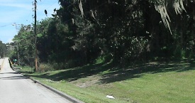
9. Continue toward “Peas” (Peace) River and as you prepare to cross the bridge take note that this area is where 2nd Lt. George Meade crossed the river (1849) … noted to be the most narrow and shallow part of the river. This was also the site of the First Fort and was the practice shooting range for Federal troops during the Second Seminole War. Archeologists Tom Dankowski and Dwight Dovel found various items from this site, as well as the Second Fort on 3rd Street NE. A number of the items unearthed from the area by Dwight Dovel are on display at the Museum.

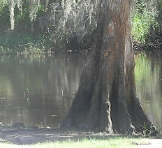
10. After crossing bridge, prepare to turn RIGHT at the curve into Fort Meade Outdoor Recreational Area. This location is currently Fort Meade Recreation Area, more than 200 acres proposed to become the Old Fort Meade Outpost. The park road is a loop you might enjoy taking, as well as the road to the river landing, where folks enjoy fishing and picnics on the banks. The park now has a river walking trail and has been designated as a Blue Way Community for canoe and kayak enthusiasts. There are several Native American archeological finds along Peace River registered with the State of Florida. Oh, if these cypress trees could talk!
Along this river for thousands of years the Original Tribes of Florida rendezvoused to trade skins and news. Return to entrance and exit LEFT back across bridge and immediately turn RIGHT onto Edgewood Dr.
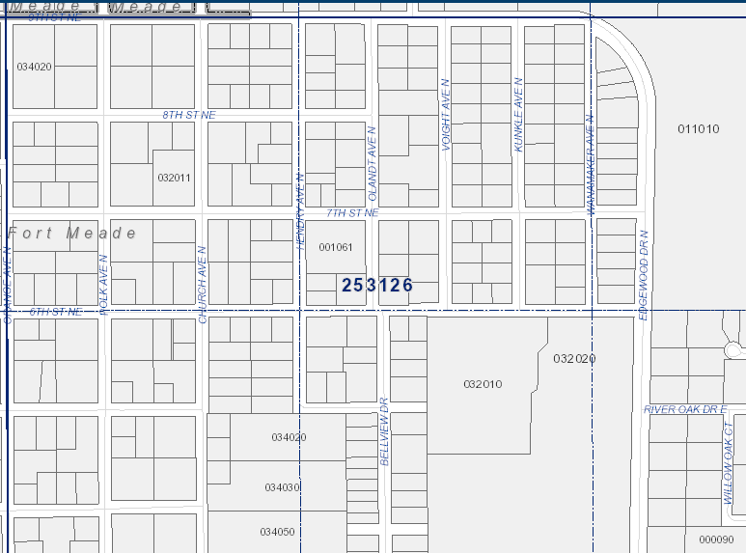
11
12
13
Orange Ave.
12
11

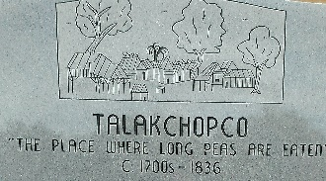
11. Continue north to the Performing Arts Auditorium which is on the right before the Fort Meade Middle Senior High School. At the Auditorium entrance is a monument recognizing one of Florida’s most historic sites: Talakchopco … “The Place Where Long Peas Are Eaten.” On Edgewood Drive, turn RIGHT and follow around curve where road melds into 9th Street NE.

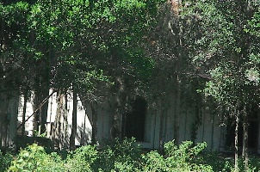
12. Continue west to Polk Avenue and SLOW DOWN to look to your right to find Fort Meade’s oldest structure in a clutch of trees in the middle of the pasture. Known as Magnolia House, the Luke B. Flood home is the oldest remaining structure in Fort Meade. Turn LEFT onto Orange Ave.

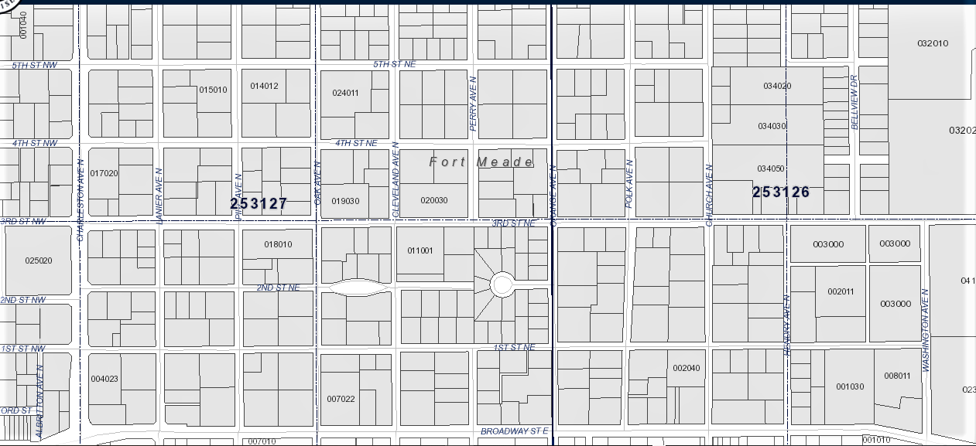
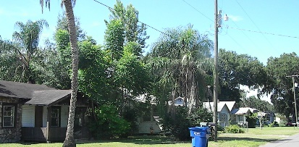
13. Travel south to 6th Street NE. Turn LEFT onto 6th St. to Bellview Dr. Turn RIGHT onto Bellview where you’ll find a row of quaint homes built in the first half of the 1900’s known as “Yankee Town” and were get-away vacation homes for folks from up North. In this area to the east, was a rack track. The English brought horse racing to Fort Meade and the track included property that is now owned by Evergreen Cemetery and the Polk County School Board behind FMMHS’s Agriculture Building.
14 2Plaque depicting information is located at Performing Arts Auditorium, as well.
2
133
15 2Plaque depicting information is located at Performing Arts Auditorium, as well.
2
16 2Plaque depicting information is located at Performing Arts Auditorium, as well.
2
17

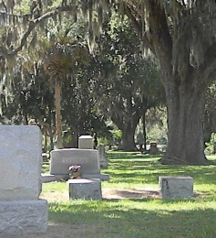
14) At the end of Bellview Dr., turn LEFT onto 3rd Street NE. Turn RIGHT onto Washington Ave. N. and drive through Evergreen Cemetery. The oldest area will be on your left where many of Fort Meade’s pioneers are buried. “Of all the readable markers in cemeteries in and around Fort Meade, the one which dates earliest is the marker of John J. Hooker. He died January 2, 1862, and is buried in Evergreen Cemetery, Fort Meade. He was born September 22, 1822, in Clinch County, Georgia.” (History of Fort Meade, Florida 1849-1960 / Robert M. White) Also, are found markers “The Dead For” with no details marking the graves of soldiers killed during Seminole battles and of victims of smallpox in the 1800s.

Leaving Evergreen Cemetery, turn RIGHT on E. Broadway to Church Ave. Continue to 1st St. NE. Turn LEFT on 1st St. NE On the right, north corner, you’ll pass the oldest residence still occupied in the city, built circa 1891. Continue on 1st NE to NE Orange Ave. Turn LEFT on 3rd Street NE.
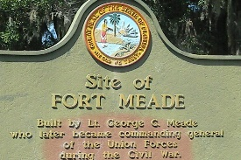
15) Heritage Park will be on your right on NE 3rd St. Take time to read the plaque and enjoy the shade. This is the location of the “Second Fort” relocated from Peace River after the malaria outbreak circa 1850.
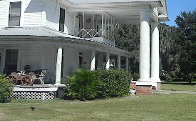
16) At the corner of 3rd St. and Oak Ave. is another lovely home on the left, built in 1956, and once owned by Dr. David Hugh Varn, a character in his own right and well-loved physician.

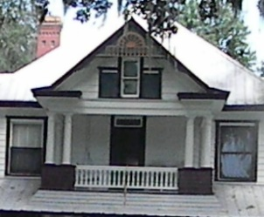
17) Turn RIGHT on Oak Ave. The street has many lovely homes of yesteryear including The William Henry Lewis Home in the 500 block listed on the National Registry of Historic Places, built 1901.

To return to E. Broadway (US 98) and to Charleston Ave. (US 17/98) follow Oak Ave. NE to 9th St. NE and turn RIGHT for one block to Polk Ave. NE. Turn RIGHT onto Polk Ave and follow south back to E. Broadway St. Turn RIGHT to get back onto Charleston (US 17/98 N). Turning LEFT will take you east toward Frostproof.

Hope you enjoyed your tour … but there’s more! Patterson Park is on N. Charleston and very inviting with a wonderful half-mile walk through the park. And there’s good fishing there, as well!
And if you still want to see beautiful country, head east on Broadway to Orange Ave. South. Turn RIGHT off Broadway onto Orange Ave., which will meld into Mt. Pisgah Road. This two-mile stretch crosses Peace River and then Bowlegs Creek near the site of the Battle of Bowlegs Creek, 1864.
Streamsong Resort is 10 miles west of Fort Meade and is a stellar winter golf course destination. The resort is a beautiful reclamation success story of phosphate-mined land by The Mosaic Company.
Fort Meade has been designated as a Main Street Project by the State of Florida. Come watch us grow as Main Street Fort Meade revitalizes the historic downtown district.

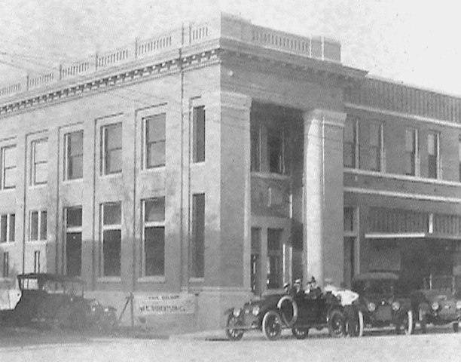
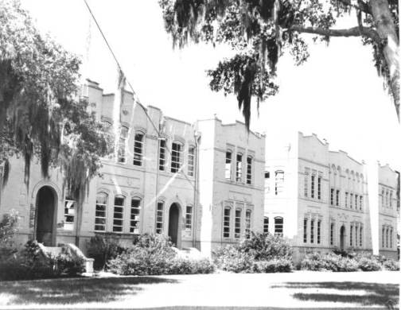
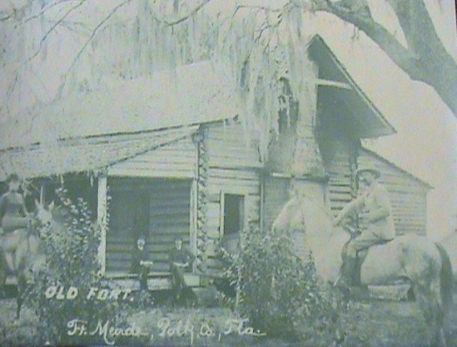
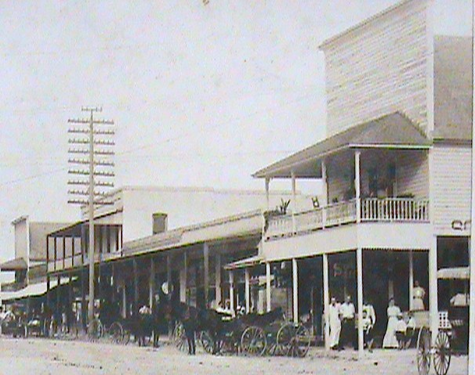
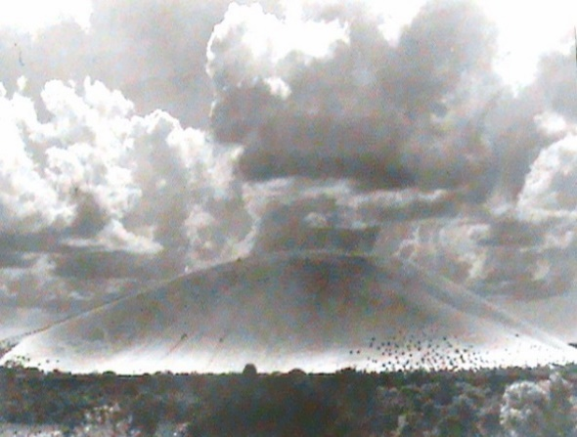
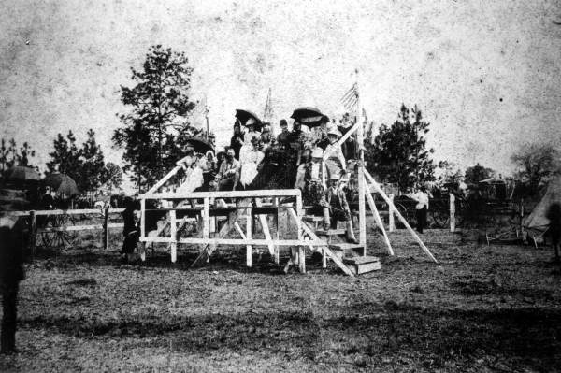
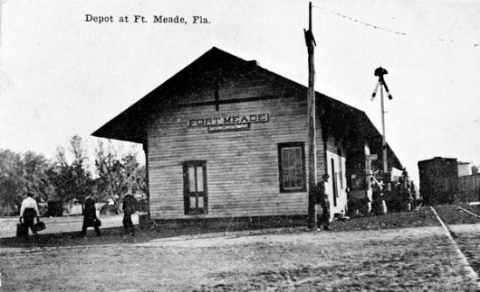
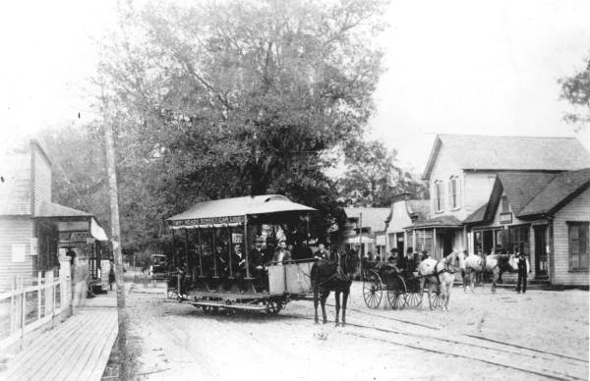
You will want to obtain books by Dr. Cantor Brown, Jr. and Robert M. White. Their research and insight are expressive and accurate for those interested in the history of Fort Meade. Locations to purchase books: Fort Meade Library and Fort Meade Historical Society. Also, check out www.myflorida.com. Click Floridian.
Fort Meade High School
First State Bank
2nd Fort Meade (Heritage Park)
Triangle Park at Charleston and Broadway
Early 1900’s downtown Fort Meade
The Trolley ran from Old Town to New Town
Enjoying the races on Bellview.
SAND MOUNTAIN !
SKELETON HOTEL
Original train depot south of town.

