Historical Society of Fort Meade:
Preserve our history with dignity. Honor our future with vision.
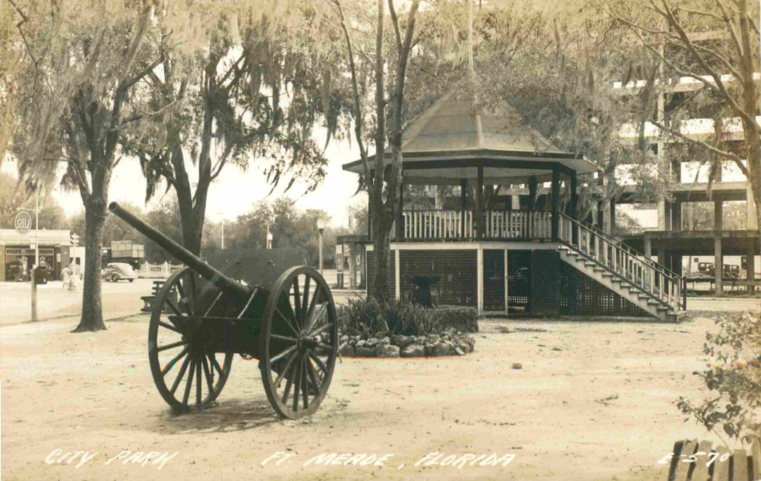

Triangle Park. Fort Meade Terrace Hotel is seen in the background at intersection of US 17/98.

Take a ride through Polk County’s Oldest settlement.
Fort Meade - where you can canoe Peace River, live the quiet life, enjoy your family surrounded by good neighbors, cheer for the Miners, enjoy hometown activities, volunteer to build, teach, guide, help.
Once it was the “wild, wild south!” Now Fort Meade is a growing and proud community respecting those who cleared the palmettos, planted the crops, built their homes, and stood up every time they fell down so we could live in this amazing place we call home.
December 13, 1849 .. 2nd Lt. George G. Meade selected this place to build a fort during the 2nd Seminole Wars. That was the beginning.
Now enjoy your drive through the rest of the story!
Special appreciation to Dr. Canter Brown, Jr., and Robert M. White for their research and publications, which can be purchased at the Museum. Also, check out HSFM’s web page: fortmeadeflmuseum.com and Florida’s archives at www.myflorida.com (click Floridian, then Fort Meade.)
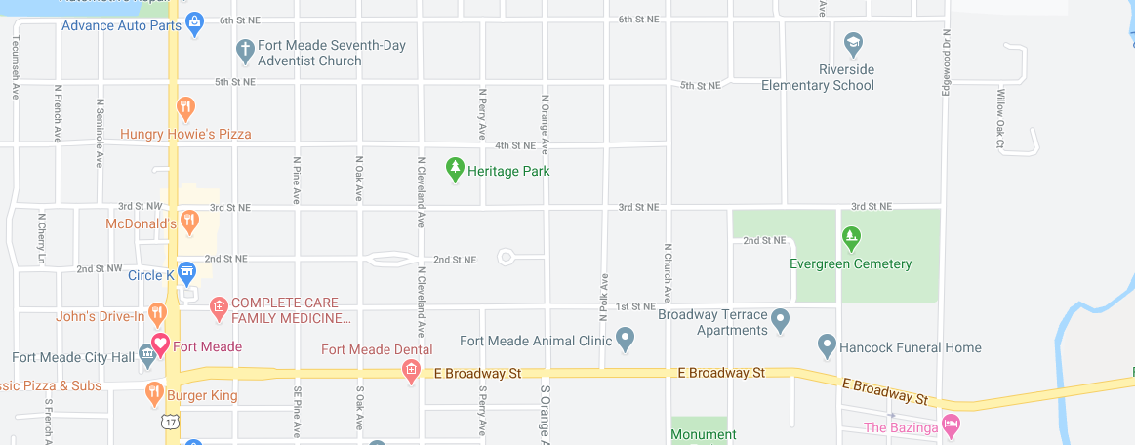
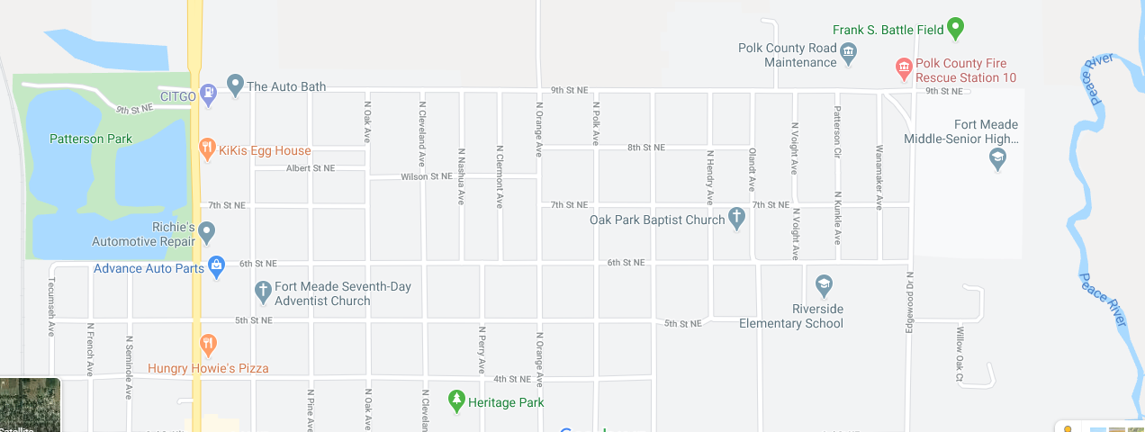
7
6
15
14
16
13
8
4
1
9
11
5
1000
3
2
12

HISTORIC SITES IN FORT MEADE ….

15

14

16

13

12

1
9
8
5
4
3

1. Historical Society of Fort Meade, Fort Meade Academy 1885
2. Second Train Station 1891
3. Downtown New Fort Meade was built to be close to the Railroad and after disastrous fires of 1890-94 in Old Town, businesses moved.
4. Christ Church, Episcopal 1886 On National Historic Registry
5. Reid House
Circa 1900s
6. Monument Park
Battle of Peace River 1886 Casualties of Seminole attack on Willoughby Tillis homestead.
7. / 8. Last two standing structures of Old Town on “Wire Street”
9. Yearwood Home
Circa 1910
10. a) Near place where 2nd Lt. George M. Meade crossed “Peas River” b)Location of First Fort, 1849
11. Talakchopko, along this river for thousands of years the Original Tribes met to trade deer skins and news.
12. Oldest residence still occupied. Property purchased in 1891.
13. Lewis/Marsh Home Circa 1900 National Historic Registry
14. Heritage Park, Site of Second Fort, 1850
15. Magnolia House, Luke B. Flood home, oldest remaining structure
16. Yankee Town, these small homes were built as vacation homes by northern visitors.

SELF-GUIDED TOUR OF HISTORIC FORT MEADE
BEGIN at the Fort Meade Historical Society

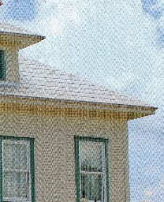
1) The Museum continues to be the Treasure Box of Fort Meade. Donated to the City of Fort Meade by the Ragon Barnett Jr. family, the original site was on the first block of South Lanier and was a school, a hotel, and a residence prior to its move to the present location. Museum Park is home to the Train Museum on its own track, which is available for meetings and special occasions. The gazebo was built by local volunteers in honor of Triangle Park that once graced the intersection of Charleston and Broadway. The Society hosts a traditional May Pole Event presented by Lewis Anna Woodbury and Child Development Center students. The Society’s annual Country Fair is held the 3rd Saturday of November. Hours are 10 a.m. – Noon, Tuesday, Wednesday, Thursday, and Saturday. Admission is free.

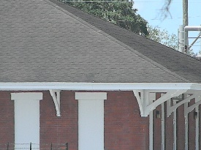
2) The original train station was simpler in its structure and located several blocks south. The 1914 station found across from the Museum conjures up the image of a once crowded street. Broadway would have been filled with excited folks waiting for friends and family to arrive or depart for some rail venture on the train, as well as shipments of merchandise and goods. This building is owned by Peace River Packing Company and is not open to the public. But the red brick and “Fort Meade” sign remain as a reminder of why “New Town” was constructed.

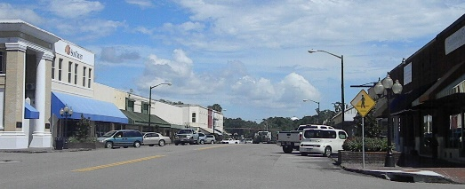
3) Traveling east on Broadway gives a picturesque view of the Historic Downtown District, known once for the widest main street around. On the north side of the street is the former site of The First State Bank, which has retained its basic historic structure. Across the street on the corner of French and Broadway is Southern Posh, which was once the location of New Town’s Post Office.

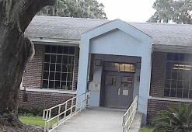
4) While at the Charleston/Broadway intersection look to your left and you’ll see the Veterans Memorial, which is also the location of the Population Center of Florida marker. Now take a little detour to the south (TURN RIGHT) and then turn east (LEFT) onto 2nd Street SE. Turn LEFT onto Oak Street SE to find the campus of Lewis Elementary #11, named in honor of its benefactor and champion Dr. O.B. Lewis. With its huge oaks and original main building intact, the school was the educational genesis for many Fort Meade children. At the corner of Oak and 1st is the home in front of the school was known as Francis Street (named for the trolley rail car owner William Henry Francis). the Queen Anne/Victorian Style home was once owned by Florida State Congressman William O. Williams. Then later owned by Mayor Rupert Charles McClellan, grandson of George E. McClellan, a delegate of the Florida Constitutional Convention in 1838, leading the territory of Florida into statehood in 1845.

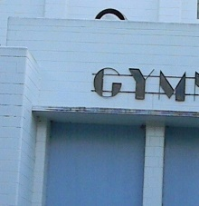
5) At the corner of S Oak Ave. and 1st St. SE, turn LEFT. You’ll be traveling alongside Lewis Campus’s cafeteria on the right. At the stop sign at the end of the block (1st St. SE and Pine Ave.) on the southwest corner, you’ll see the White House, which is duplication in construction to Jeanette Lewis’s home a few blocks away. Now turn RIGHT and look at the side of the building which was once the entrance into the old Fort Meade High School gym. This architecture and lettering depict the only Art Deco found in Fort Meade.

Continue north to East Broadway. While still in an historic mood, turn RIGHT and travel east. (You’ll pick up all the Northeast section on the way back.)
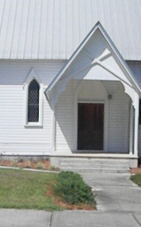
6) Immediately, on your north is the First United Methodist Church, whose congregation was the first to construct a church in Fort Meade. East Broadway’s hammock of large Oak trees provides a peaceful drive toward the river and is the site for the Presbyterian Covenant House, and the First Baptist Church of Fort Meade. Christ, Episcopal Church (photo) with its familiar traditional architecture is located east of the Baptist Church and is on the National Register of Historic Places, built 1889.

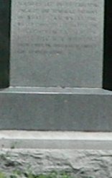
7) Continue on E. Broadway (US 98 E) and at Church Avenue, turn right to travel to city-owned Monument ( Alderman Carlton, Lott Whidden, William Parker, Robert F. Prine and George Howell) who lost their lives when the Willoughby Tillis homestead was attacked by Seminoles. This is a very solemn ground.

Continue to circle Monument Park until traveling north on Hendry Avenue and returning to E. Broadway.
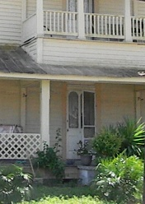
8) As you turn RIGHT on E. Broadway you’ll see two older homes .. one on your right and one on your left. These are original structures built in “Old Town” Fort Meade when it was located near Peace River prior to relocating west to benefit from the railroad. Can’t you imagine sitting on those balconies enjoying the cool breeze at night? Oh, “Old Town” was located between Orange Avenue and Washington Avenue.

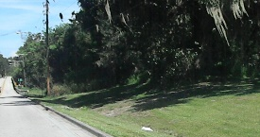
9) Continue toward “Peas” (Peace) River and as you prepare to cross the bridge take note that the area is Lt. George Meade crossed the river … noted to be the most narrow and shallow part of the river, this was also the site of the practice shooting range for the Federal troops of the Second Seminole War. Tom Dankowski and Dwight Dovel found various items from this site, as well as the Second Fort on Second Street NE. A number of the items unearthed by Dwight Dovel are on display at the Museum.
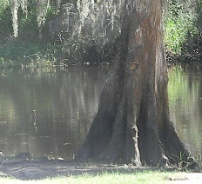
10) Cross the bridge and continue around the curve. Turn RIGHT at the Fort Meade Outdoor Recreation Area, site of the proposed Old Fort Meade Outpost. Travel to the road that takes you to the landing where folks enjoy fishing from and picnics on the banks. There are several Native American archeological finds along Peace River registered with the State of Florida. This area was the site of an annual rendezvous held for thousands of years by tribes as they migrated across the land. Oh, if these
cypress trees could talk!

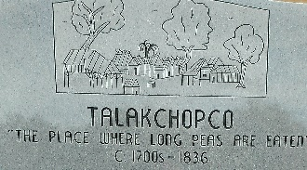
11) Return to US 98 E and at the Park exit turn LEFT, cross back over the bridge and then turn RIGHT on N. Edgewood Drive. Continue north to the Performing Arts Auditorium which is on the right before the Fort Meade Middle Senior High School. At the Auditorium entrance is a monument recognizing one of Florida’s most historic sites: Talakchopco … “The Place Where Long Peas Are Eaten.”

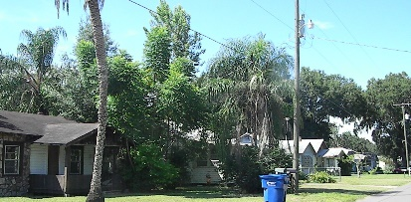
12) When leaving the school property, turn LEFT on N. Edgewood and immediately turn RIGHT onto 6th Street NE. Then travel to Bellview Dr. and turn LEFT. Here you’ll find a row of quaint homes built in the first half of the 1900’s known as “Yankee Town” since they were the get-away vacation homes of folks from up North. The English brought horse racing to Fort Meade and the track was Bellview and included property that is now owned by Evergreen Cemetery and the Polk County School Board behind the Ag Building.

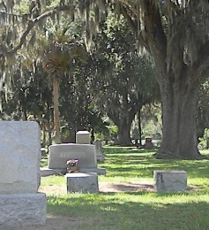
13) At the end of Bellview Dr., turn LEFT onto 3rd Street NE. Turn RIGHT onto Washington Ave. N. and follow Evergreen Cemetery. The oldest area will be on your right. “Of all the readable markers in cemeteries in and around Fort Meade, the one which dates earliest is the marker of John J. Hooker. He died January 2, 1862, and is buried in Evergreen Cemetery, Fort Meade. He was born September 22, 1822, in Clinch County, Georgia.” (History of Fort Meade, Florida 1849-1960 / Robert M. White)

The BEST WAY to enjoy Fort Meade’s eclectic Historic Northeast Residential District with its cracker homes moved from mining communities, Yankee summer retreats, late-1800/early-1900 gentry homes, and even today’s attractive residences, is to take the north / south route. (Of course, if you want to turn east / west, do it!) As you travel along these thoroughfares, you’ll see many homes worthy to slow down a little and take in their personality and beauty. These are but a few: From Washington Avenue travel to 1st Street NE. Notice the three-story home at the corner of 1st Street and Hendry Ave. Continue on Washington Avenue to E. Broadway.

Turn RIGHT on E. Broadway to Hendry Ave. and continue to 3rd Street. On 3rd Street turn LEFT and go to Church Ave. Turn RIGHT
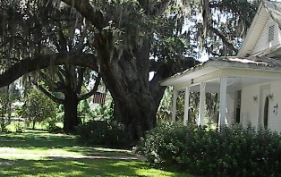
14) Follow Church Ave. to 6th Street. Turn LEFT and go to Polk Ave. Follow Polk Ave. back to 1st St. On Polk you’ll want to take notice of the home of on the corner of Polk and 3rd St. The home itself is beautiful and the property is the location where school children had their classes in good weather. Somewhere on this knoll is an oak that Lt. Thomas “Stonewall” Jackson retreated to write and meditate. One could understand why he could find solace under the shade and protection of such commanding trees.

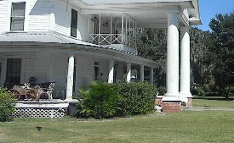
15) At the corner of 1st St. and Polk Ave. is another lovely home built in 1956 and once owned by Dr. Hugh Varn, a character in his own right and well-loved physician.

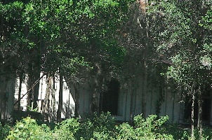
16) At 1st St. turn RIGHT and follow 1st to Orange Ave. Again turn RIGHT and follow Orange Ave. to 9th St. this time. Across 9th St., is a pasture and a thatch or two of trees. Look very, very hard and you’ll see the structure of one of Fort Meade’s oldest homes built by the Flood family who immigrated from Ireland. At the time it was built, this area was considered to be in the “country.”
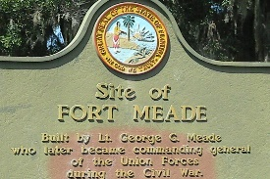
17) Now turn LEFT onto 9th St. and then turn LEFT at Perry Ave. Perry will dead-end and Heritage Park will be on 3rd St. Take time to read the plaque and enjoy the shade. This is the location of the “Second Fort” relocated from Peace River after the malaria outbreak.

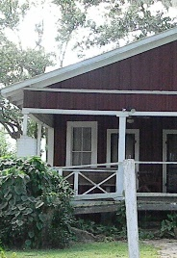
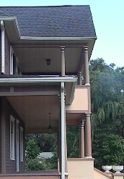
18) At the end of Perry turn LEFT onto 3rd St. and take a LEFT at Cleveland. Notice the pretty yellow home at the corner of 1st St. Continue on Cleveland Ave. and you’ll pass the Brown House built in 1904 by the mayor of Fort Meade. It is owned by Christ, Episcopal Church now. Continue to E. Broadway and notice the Reid House on the left.

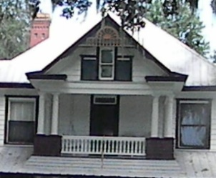
19) Turn RIGHT on E. Broadway and go to Oak Ave. where you’ll turn right. The street has many lovely homes of yesteryear including the one found in the 500 block that is listed on the National Registry of Historic Places, built 1901.

Continue on Oak Ave. to 6th Street and turn LEFT. Then go to Pine Ave. and turn LEFT following Pine to 1st St. and turn RIGHT. Then on Lanier Ave. turn RIGHT. Follow Lanier to 9th St. and turn LEFT to get back onto Charleston (US 17/98 N). Turning LEFT will take you back to Fort Meade but Patterson Park on the west is very inviting. Good fishing, as well. And if you still want to see beautiful country … turn east at Broadway, continuing to Orange Ave. turn RIGHT which turns into Mt. Pisgah Road. The two mile stretch is awesome as you cross Peace River and then Bowlegs Creek near the site of the Battle of Bowlegs Creek, 1864.

