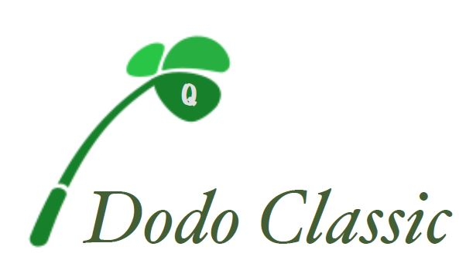

Friday, October 11th, 2019

Auction/Raffle Item Donation Form

DONOR: _________________________________________________

ADDRESS: _________________________________________________

__________________________________________________________

CONTACT NAME: ___________________________________________

PHONE NUMBER: ___________________email:____________________

AUCTION ITEM: ___________________________________________

____________________________________________

ITEM VALUE: $ ______________________

PLEASE RETURN THIS FORM TO:
Brian Nee
54 Cedar Grove Street, Dorchester MA 02124
For questions or further information: 617-905-2886

Tax ID # EIN# 82-1585335

