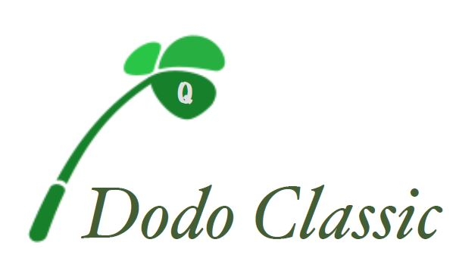

Friday, October 11th, 2019

Hole Sponsorship Form

Business Name: ________________________________________________

Contact Name: _________________________________________________

Address: ______________________________________________________

City, State, Zip __________________________________________________

Phone #:________________________email:__________________________

- $250 Hole Sponsor
- ______ Other Amount

Sponsorship name as you would like it to appear on hole:

____________________________________________________________

Information must be received by 10/01/19 to be included in print material

PLEASE RETURN THIS FORM TO:
Brian Nee
54 Cedar Grove St
Dorchester Ma 02124

