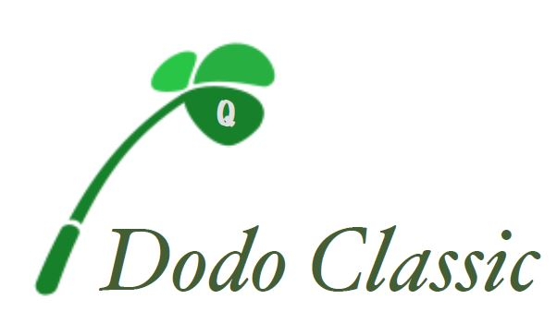 | THIRD ANNUAL  DODO CLASSIC GOLF TOURNAMENT  HOSTED BY JOSEPH DODO NEE FOUNDATION  FRIDAY OCTOBER 11th, 2019

REGISTRATION FORM
Individual Name/Company
Contact Person
Address
Phone email address/fax
PARTICIPATION OPPORTUNITIES
-Player names and jacket size (XXL, XL, L or M):
1. (Captain) Email/Phone#
2. Email/Phone#
3. Email/Phone#
4. Email/Phone#
Individual player form:
☐ Players spot ($150) - Golf, Continental Breakfast, Gift Package, Buffet Lunch at Florian Hall
Player’s name
Address
phone# email address/fax

Golf courses are: George Wright Golf Course & William J. Devine(Franklin Park) Golf Course

To secure a spot please mail this registration form with your check to the address below. Once you have registered you will be notified of your assigned course.

For golf teams please make all checks payable to “Joseph (Dodo) Nee Foundation, Inc.” and mail to: 54 Cedar Grove St Dorchester, MA02124 For additional information or questions regarding golf please contact joedodoneefoundation@gmail.com

