Private Chef and Catering | 
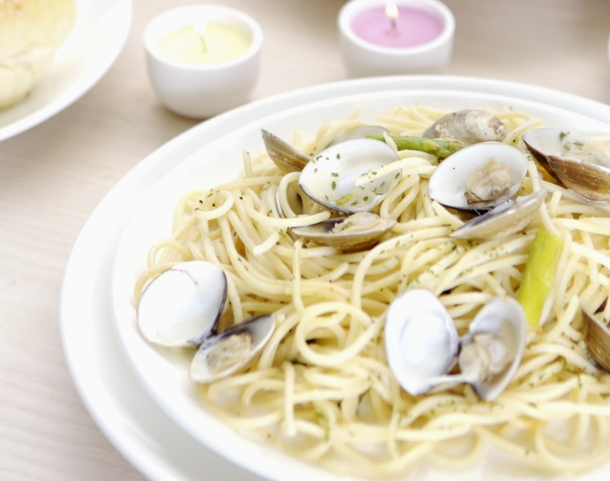 | 

  - I come to your home
My daily rate is $350. Whether I cook for 4 or 10 people, it stays the same. Typical rates in Atlanta are a minimum of $55 per hour-my rate is superb!
It takes a total of 10 hours to prep and serve an event. Your only additional expense is the cost of the food and beverage.
Text me at 770 776-8354 to discuss dates and menus
Or email: Jkauffman16@gmail.com

