Shoalhaven Avicultural Society Inc.
The benefits of becoming a member of this bird club!
Our Meetings:
Our monthly meetings are a great place to meet people who share your hobby of keeping and breeding birds. There is often a guest speaker to give an informative talk on a range of different avian species. Our members are all extremely knowledgeable and always happy to share any tips and tricks of the trade. We always have a lucky door prize and a raffle on the night where sometimes even a pair of birds will be kindly donated by our members!
After the meeting, enjoy a complimentary supper and you’ll have the opportunity for a friendly chat with the members.
Newsletter:
A monthly newsletter is sent to members with up-to-date information about birds, their care, hints, and tips. A “For Sale” section is included.
Excursions:
Excursions are organised through the year to visit aviaries or organized venues.
Fee:
New members joining fee is $50 total. This includes a once off registration fee of $20.00 to cover the cost of your badge and member’s card.
Annual Membership of $30.00 for single or $40.00 for a family.
Junior members are free until 15 years of age – includes free cap and badge.
Meetings are held: 7:15pm on the 2nd Tuesday of each month, at the North Nowra Community Centre. 7 Hood Close, North Nowra.
MEMBERSHIP APPLICATION FORM
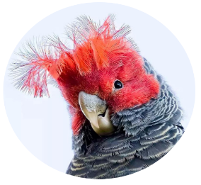
Single Membership = $30.00

Family Membership = $40.00

NEW membership = $50.00

(Badge and members card included in $50)
Total: $…………….….
Membership Details
Name (s) ……………………………………………………………………………………………………………
Address: ……………………………………………………………………………………………………………
………………………………………………………………Post Code…………………………………………..
Phone: Mobile: ………………………….………………. Home: ……………………..…………………
Email Address: ………………………………………………………………………………………………….
Signature: ……..……………………………………………………Date:…………………………………….
Newsletter is emailed out – Please advise if you are unable to receive emails.
Type of birds kept (optional)
…………………………………………………………………………………………………………………………
CLUB CONTACTS:
OFFICE USE ONLY
YEAR:
RCD $:
DATE:
METHOD:
RECEIPT #:
Member #:
President: Keiran Egan
Vice President: Robert Fish
Treasurer: Shelby Robertson
Mail: 93 Sophia Road,Worrigee, NSW 2540
Forms can be emailed to sasbirdclub@gmail.com
Direct transfer payments Greater Bank:
BSB 637 000 ACC 7224 89799

