ManorGate Community Updates
Do you like living in ManorGate? Then please consider giving just a little bit of your time to serve on a committee to keep the neighborhood looking good, financially stable, and a great place to live.
Have some financial background? Join the finance committee and help keep an eye on the budget and expenses.
Just want to give an hour or two of your time? Sign up to drive around the neighborhood for Neighborhood Watch on a few nights.
Want to shape the way the neighborhood looks? Join the Architectural Review Committee and give a little bit of time to reviewing proposals.
Your time and input help keep ManorGate a wonderful place to live. Contact Cory Blackston with Gates Hudson if you are interested in joining any of these committees.
New locations for dog waste stations – Two of the dog waste stations have been moved in the Skylemar Trail/Autumn Circle area. The new locations are in better lit areas that will be more convenient for dog owners to use. One station has been relocated to the corner of Skylemar Trail and Autumn Circle and the other one is now just before the Skylemar Trail loop.
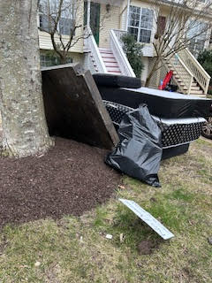
NO DUMPING - This is what dumping looks like.
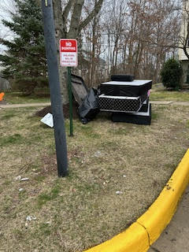
It’s a horrible eyesore and shows a lack of respect for neighbors and the community at large. Also, it’s an expense the entire neighborhood has to share when the garbage company has to come pick up the pile of trash. If you see someone dumping items, please report them to management!
Storm water pond work project has begun – The storm water pond project has started -fencing is up and construction work is beginning. The project should last about three months. The county plans to use the existing entrance from Creek Run Drive side for construction vehicle access. The playground down the hill from Rock Canyon Drive will remain open. The trail between Rock Canyon Drive and Creek Run Drive will remain open to pedestrians except during construction of inflow culvert (below the playground), however, there is planking over the asphalt so please be careful when using the trail path. The community will be notified when the trail closure timing is confirmed. If you want to see the scope of the work, please visit the ManorGate website and click on the Storm Water Pond Improvement/Rehabilitation PowerPoint.
Spring neighborhood inspection starting – Gates Hudson management will be conducting the annual home inspection starting in March and continuing through April. Please take time to inspect your home for areas of concern, such as those listed below. Please note that violations can be reported year-round by neighbors and ARC committee members, not just after the spring management inspection.
Storing trash cans, lawn supplies/materials, flowerpots, etc. on driveways and in front yards
Rotting wood trim, garage doors, arches
Peeling paint or rotting soffits, eaves, rake, fascia boards
Worn/peeling, fading-deck and fence stains
Algae buildup on vinyl siding and fence boards
Black stained driveways, steps, stoops, and lead walks
Unkempt yards-overgrown grass, trees, bushes, weeds
Dead trees and bushes
Storing items in common areas
Plan to have those things repaired before the inspection in order to avoid receiving a violation letter. After violation letters are mailed, due process hearings are held. Please make sure to correct any ARC violations if you receive a letter in order to avoid participating in a due process hearing. The ARC regulations are in place to help keep our neighborhood looking great and to ensure home values don’t decline.
Reminder on yard waste pick-up – Patriot Disposal does not pick up yard waste again until April 6. Please put any yard waste into trash bins or hold it until yard waste pick-up resumes in the spring.
ManorGate book club –The next book club meeting is March 12 at 7pm at the clubhouse. We will discuss Horse by Geraldine Brooks. The meetings are every other month, so there’s plenty of time to read the book for discussion. Future titles are listed on the website, so plan to read the book and come join in the discussion!
The next HOA meeting is Wednesday, March 27, 2024 at 7pm and will be virtual. Watch for sign-in information to come from the community manager at Gates Hudson Management.

