N

Visit: <https://usfsmallsatwebmaster.wixsite.com/usf-small-satellite>

Contact: [USFsmallsatpresident@gmail.com](mailto:USFsmallsatpresident@gmail.com)

Initial Release: June 16, 2023

Botany In Orbit Satellite

Mission Design Document: BIOSat

|  |  |  |  |
| --- | --- | --- | --- |
| This document owned and controlled by the University of South Florida | | | |
| REV | Date | Reason | Personnel |
| ----- | 6/16/23 | Initial Release | Bianca Seufert, Kat-Kim Phan, Ryan Beland, Nida Khattak |
| 1 | 7/19/23 | Post SCR & SRR Revision – Specifically address previous testing completed, ISS comparison, and update MOs & MSCs. | Bianca Seufert, Kat-Kim Phan, Ryan Beland, Nida Khattak |

**Document Distribution**

Table of Contents

**1. Mission Overview** 1

**1.1 Mission Relevance** 1

**1.2 Technology Readiness Level (TRL)** 2

**Table 1: Mission Objectives** 2

**Table 2: Mission Success Criteria** 2

**Table 3: Plant Requirements** 3

**2. Experiment Plan** 4

**2.1 Experimental Setup** 5

**Task 1.** 6

**Task 2.** 7

**Task 3.** 8

**2.2 Bill of Materials (BOM)** 10

**3. Concept of Operations (CONOPS)** 11

**3.1 Mission Life** 11

**3.2 Mission Modes** 12

**3.3. Orbit Path** 12

**Appendix A: References** 14

# **1. Mission Overview**

Astronaut freeze-dried foods lose a significant amount of their nutritional vitamin/mineral value within the first 6 months of storage. Therefore, producing food in space in the form of edible crops for space exploration (e.g., Moon, Mars and beyond) is a necessity. However, the spaceflight environment (e.g., radiation and reduced/partial gravity) is stressful for humans and plants alike. Furthermore, the International Space Station (ISS) while in Low Earth Orbit (~250 miles up from Earth), is conducting several growth experiments to observe this phenomenon in an attempt to meet this growing need. However, conducting these experiments is incredibly expensive, time consuming, and requires daily human interaction. For instance, the maintenance needed to nurture plants and the contribution humans make of turning O2 to CO2. Furthermore, the need for autonomous growth chambers for the study of plant growth in LEO would greatly contribute to this research area.

The proposed CubeSat mission will autonomously grow the candidate plant Red Romaine Lettuce and expose it to the stressors in LEO such as microgravity and radiation. As the driving requirements are derived by the respective candidate plant, as seen in Table 3, it is imperative to monitor all aspects of the growth chamber. Therefore, a series of sensors such as temperature/ humidity sensors along with hyperspectral and optical cameras will be used to capture the impact the stressors impart on the plant and communicate it back to Earth. The resulting data can then be compared to previously collected control data from earth and the ISS.

While the concept of sending plant life to space is not inconceivable, developing a satellite with a growth chamber large enough to support such a large produce plant is quite a challenge. Previous designs have centered around microgreens but are still limited in study. The uniqueness of this problem results in custom builds and even pricier customized components. Furthermore, our team is embarking on the groundbreaking mission to develop the small satellite, BIOSat (Botany In Orbit Satellite).

***Mission Statement*:** Investigate autonomous plant development in the LEO microgravity environment to enhance our knowledge of space agriculture and contribute to the long-term sustainability of human habitation beyond Earth.

## **1.1 Mission Relevance**

Currently, food within space is limited to freeze-dried food which can lose nutritional value over time. The ISS is growing nutritional plants however this requires human tasking such as watering and cleaning. Along with human interaction, space and time is involved, leading to high expenses. BIOSat’s mission is to autonomously grow red romaine lettuce for NASA to further investigate candidate plants for nutritional diversity. This closed loop system will allow for optimal tunability to develop a healthy growing plant while exposing it to microgravity in the LEO environment. The results will expand NASA’s understanding of plant stressors in space and further nutritional variety for astronauts in deep space exploration while minimizing overall cost and size/space requirements.

## **1.2 Technology Readiness Level (TRL)**

As the project currently stands the overall project remains at a TRL 3. For the latest model see Figure 1. The working theories can be found in section 2, Experimental Plan, while calculations can be found in the Budget Summary.

## **Table 1: Mission Objectives**

|  |  |
| --- | --- |
| Mission Objectives | Description |
| MO-1 | Germinate a Red Romaine Lettuce seed within 30-days using an autonomous system. |
| MO-2 | Monitor and record nutrient dissemination, emissions release, and photosynthetic activity within the microgravity enviro  ent and its radiation exposure. |
| MO-3 | Collect and transmit data (both experimental and vehicle) back to Earth via downlinking to a ground station for comprehensive analysis and dissemination to the scientific community. |
| MO-4 | Model the impacts of microgravity and radiation on plant morphology, emissions, and overall plant health from the data collected by the roots and leaves. |
| MO-5 | Compare any discrepancies in the foliage growth, gaseous emissions, and vegetable production in the microgravity environment and its radiation exposure with control samples grown under normal Earth gravity conditions tested before launch. |

## **Table 2: Mission Success Criteria**

|  |  |  |  |
| --- | --- | --- | --- |
| **Criteria Identifier** | **Description** | **Minimum Success Criteria** | **Full Success Criteria** |
|
| **MSC-1** | Red Romaine Lettuce seed shall germinate and mature past root and leaf growth | Red Romaine Lettuce seed germinates within a 30-day experiment including roots | Red Romaine Lettuce seed germinates and matures to a head of lettuce with a diameter of 5 cm (TBR) including root and leaf growth, within a 30-day experiment |
|
|
| **MSC-2** | Payload sensor array data shall be transmitted on orbit during the experimental execution phase | Payload sensor array working specifically humidity, temperature, and CO2 sensor data is transmitted from the satellite on orbit during the experimental execution phase for at least a 30-day mission | All of the payload sensor array data is transmitted from the satellite on orbit during the experimental execution phase for at least a 30-day mission |
|
|
|
| **MSC-3** | Optical cameras shall capture and transmit images of the plant’s leaves and root systems to be used for modeling and comparison to on ground experiments | Capture and transmit 30 images within a 30-day experiment. (1 image of the sprout zone and 1 image of the root zone captured every day) | Capture and transmit 60 images within a 30-day experiment. (1 image of the sprout zone and 1 image of the root zone captured every day) |
|
|
|
| **MSC-4** | Hyperspectral camera shall capture and transmit images for bacterial growth and radiation analysis to model and compare to on ground experiments | Capture and transmit 15 images within a 30-day experiment (1 image of the leaf zone every day) | Capture and transmit 30 images within a 30-day experiment (1 image of the leaf zone every day) |
|
|
|

## **Table 3: Plant Requirements**

|  |  |  |
| --- | --- | --- |
| ID | Requirement | Rationale |
| MIS_REQ_01 | LED Grow Light | The red romaine lettuce needs light intensity of 200-250 nm with a light wavelength of 400-700 nm for 16-18 hours a day. |
| MIS_REQ_02 | Compressed Air tank | The red romaine lettuce needs .3-.5 m/s of air velocity. |
| MIS_REQ_03 | Heater | The red romaine lettuce needs to have a day temperature of 22-25 C and a night temperature of 18-20 C. |
| MIS_REQ_04 | Sensor Array | Humidity, pH, alcohol, temperature, CO2, and O2 need to be measured. |
| MIS_REQ_05 | Water tank | The red romaine lettuce needs sufficient reverse osmosis water, supplied by water wicking method, with a specific nutrient level. |
| MIS_REQ_06 | Compressed CO2 tank | The red romaine lettuce needs a CO2 concentration of 1000-1500 uM. |

# **2. Experiment Plan**

To address the objectives of the project, three main tasks are planned for our study:

1. To design and implement the sensor system for studying the critical parameters representing the plant’s health status.

2. To design and test an irrigation system for microgravity conditions.

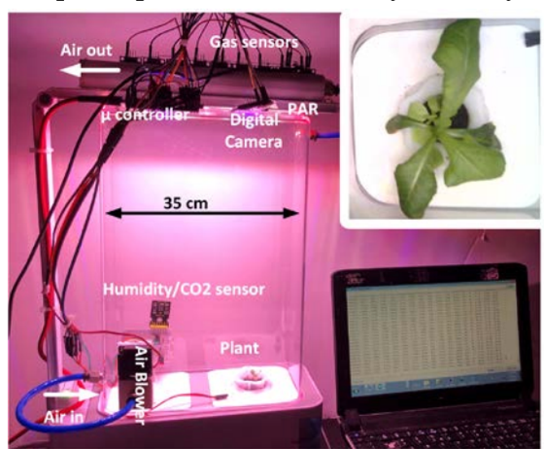3. To analyze the plant growth data to study the effect of stressors on the growth of a plant.

These three tasks investigate the plant’s growth in a closed-loop ecological system completely isolated from the surrounding environment. This study will analyze the effect of limited supplies and isolation have on the health status of the plant. The amount of oxygen, CO2, air, and water in the chamber will be derived by the needs of the specific candidate plant under study while the heater, fan, and insulation will maintain the minimum necessities of plant life. This is the mission of BIOSat, which requires further on-Earth testing to compare to the in-space testing environment.

Our preliminary studies were focused on red romaine lettuce as one of the recommended plants for growing plants in space by NASA [1]. We understand that in addition to lettuce, there are a few other plants such as Chinese cabbage, banana pepper, and cherry tomatoes that are identified by NASA as candidate plants for space missions [1,2]. We have collected preliminary data regarding simple needs and requirements to grow lettuce, as seen in Figure 1. Furthermore, we intend to test growing lettuce in a 3U area, displayed in Figure 2, however since our proposed plant health monitoring system (PHMS) can be used for any plant, we plan to test other candidate plants in the future.

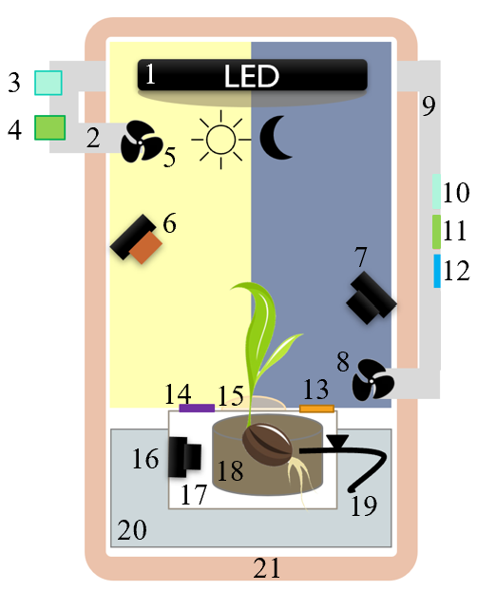

1. LED
2. Intake outlet
3. CO2 Gas Valve
4. Compressed Air Gas Valve
5. Input fan
6. Hyperspectral Camera
7. Optical Camera 1
8. Output Fan
9. Outtake outlet
10. CO2 sensor
11. O2 sensor
12. Alcohol sensor
13. Temp & Humidity sensor
14. pH sensor
15. Beeswax seal
16. Optical Camera 2
17. Isolation Box
18. Cocopeat
19. Nylon wick
20. Water reservoir
21. Heated insulation

Figure 2: Plant growth chamber diagram

*Figure 1: The setup that was made for collecting the preliminary results for growing green lettuce in a chamber. An image of the plant taken by the camera in the chamber is shown.*

## **2.1 Experimental Setup**

Learning from our earlier experiments, a similar setup as shown in Figure 2 will be designed for this task. Specifically using opaque acrylic materials for isolating the plant from externals factors such as sunlight. The chamber will be designed and made with the dimensions of a 3U allowing for external resources such as CO2 and air to be attached externally. An outlet will be designed at the right of the chamber for half of the sensor array: CO2, alcohol, and O2 sensors. The isolation box will contain the rest of the sensor array including the temperature and humidity sensors. The left side of the chamber will be equipped with the feeding tube of air and CO2. Using a fan, constantly, fresh air will be inserted into the chamber from an inlet near the top left and purged through the outtake outlet where the concentration of the gases can be measured and recorded from the sensor array on the right.

An LED-based strip consisting of Chanzon LED chips will be installed at the top to shine a light on the plant during the “day” hours. This light supply will maintain blue and red wavelengths considering the blue wavelength is best for germination of the seed and red wavelengths for the vegetation process. It takes about 7-10 days for a lettuce seed to germinate on Earth and then about 20 days after the initial days of germination to vegetate. With taking about 30 days to grow a whole head of lettuce on Earth, the microgravity environment in low earth orbit can change the growth process entirely. This led to the assumption that it would take our lettuce seed 30 days to vegetate half a head of lettuce. The germination is a huge focus which required the certain light spectrum of blue wavelengths from 400-500 nm to ensure germination will occur [3]. Once the seed has germinated, assumed to take 15 days in the microgravity environment, the LED light will be designed to change to a red wavelength of 600-700 nm for the rest of the growth process. If the seed was to germinate quicker than the expected 15 days, there would be no harm to the plant if blue wavelengths were exposed for a longer period considering these wavelengths are primarily focused to promote germination and stomatal opening which facilitates the transfer of CO2 within the leaves. The red-light wavelength is used primarily for the growth of stems, leaves, and overall vegetation [3]. This lighting will ensure the growth past germination to speed up the process and overall growth.

To image the germination and vegetation of the red romaine lettuce, the hyperspectral camera will take top-view imaging of the plant. This spectral camera will detect if the plant has been exposed to radiation, bacterial growth, water absorption, and further discrepancies in the vegetation indices (Vis) to determine whether the plant is edible for astronauts [4]. It is required to have pictures of the plant from different angles to have an accurate estimation of leaf surface area at different growth stages. For that reason, two OV5640 optical cameras will be used as to collect high quality imaging at the roots and the leaves. One optical camera will be placed in the isolation box to the left to see how the roots grow around the coco peat. Another will be placed on the right side above the isolation box at a higher angle but near the sprouting area to see which direction the seed will grow. This microgravity environment changes the ideal conditions of the plant which requires the two cameras near the initial growth area while a hyperspectral camera sits at a top view to monitor the health status as well.

Vertically under the LED strip is the clear isolation box containing the coco peat pellet encompassing the seed. This isolation box will have a small hole at the top for the plant to grow upwards. This hole will be covered by a single layer of antibacterial bees-wax thin film to avoid any leakage of water initially. Once the seed has germinated, the beeswax will be pressurized and stretch so that the stem can continue to grow upward. Eventually when large enough the plant will break through the barrier. This layer of beeswax will ensure there is no fungus at this point of growth [5].

******Task 1. To design and implement the sensor system for studying the critical parameters representing the plant’s health status.**

Figure 3: Variation in the total alcohol concentration being released when the plant started growing a brown leaf.

The photosynthetic process involves the consumption of CO2 and the release of oxygen through the green leaves of a plant. However, in the dark, a plant releases CO2. Different gases are released by plants when in bloom such as the release of ethylene and acetone [1]. Based on our preliminary studies, Figure 3 reflects the requirement of an alcohol sensor to measure any VOCs released by the plant. This L-com SRAQ-G005 sensor will monitor various gases to compare ideal plant gases for a health status indicator. Using off-the-shelf devices, an array of gas and VOC sensors will be employed to make a sensor array for sensing the released chemicals from a plant being grown in a chamber (objective 1). Additionally, an array of moisture sensors will be employed for measuring the moisture in the soil near the root. Realizing that the change in the generated voltage in a zinc-air battery (Figure 4) is proportional to the change in the oxygen level. Therefore, it is planned to use an array of zinc-air batteries as the Grove MIX8410oxygen sensor around the plant’s root. In the future, the research plan is to design fiber-shaped oxygen sensors that can be easily applied to the soil for root-zone oxygen measurement.

**Setup design for Task 1 and method of conducting experiments:** The effect of a closed ecological system will be studied by connecting the air and CO2 feeding pump into the chamber with the sensor array connected to the exhaust line, seen in figure #. The air pump will be regulated for the circulation of air in the chamber as it is recommended for the healthy growth of the plants however the CO2 pump will be on only during the first 16 hours of light and turned off for 8 hours of night. The flow rate of the fan will be set to a constant of .4 m/s considering red romaine lettuce needs a range of .3-.5 m/s of air velocity. Since the lettuce does not flower, there is no mechanism considered for the pollination. Utilizing the designated outlet sensor array will process the chamber’s simulated atmosphere. With each sensor response we will understand the plant’s consumption or release feedback. The humidity sensor will be in the isolation box with the coco peat while the final pH sensor will be inserted into the water chamber.

**Expected research outcomes from task 1:** Critical chemicals can be identified through the alcohol sensor to assess the health status of the plant. Analyzing the sensor data and implementing the machine learning model will give more accurate information about the rate of consuming and releasing of chemicals from the plant. The data collected from the humidity and pH sensor will reveal if there is enough water provided and if it is receiving enough nutrients for growth. At the end of the experiment, the roots of the plant will be studied and compared to grown on-Earth plant roots via images for comparison.

**Task 2. To design and test an irrigation system for microgravity conditions.**

Since surface tension is larger than gravitational force in space, watering a plant in space is challenging. Due to this problem, conventional hydroponic irrigation is not practical for growing plants in space. Currently the International Space Station (ISS) has a vegetable production system consisting of a garden with various flowers and vegetables. The watering technique is detailed as requiring personnel tasked with an individual plant in the garden. The seeds are placed into plant pillows that contain soil consisting of a pillow garden. The tasking requires each “pillow” to be injected with water and sanitized every so often [6].  However, it is possible for soil particles to easily become viral under microgravity conditions therefore we will place a coco peat pellet in an isolation box and adapt the water-wicking system for the autonomous CubeSat.

**Setup design for Task 2 and method of conducting experiments:**Considering that roots grow differently in space due to the lack of gravity, the root zone of the plant needs an isolated area. For our design, the coco peat will be placed in a clear isolation box held by a tunnel big enough for the coco peat to absorb the water and expand. The seed will be tied to the coco peat pellet using a nylon thread which will ensure the seed does not dislodge during detumbling. In this method, the system can deliver water by a simple nylon thread drawing the nutritional water directly to the coco peat and then nutrition to the seed. This nylon thread provides another protective layer of antibacterial properties to avoid any possibility of degradation to the plant [7]. This design idea includes a reservoir for water storage with a connected sealed nylon thread to guide the nutritional water to the coco peat. The system is designed to fit in the bottom portion of the CubeSat which will provide enough water for the 30-day mission by this slow wicking method and absorption of water in coco peat. This experimentation will lead to further applications for growth of various plants with small adjustments to design specifications such as reservoir size and substrates.

**Expected outcomes from task 2:** With this distinct water system, the top view and side view angles will be able to provide enough images if the water provided was too little, adequate, or in excess. Also, the AnyLeaf module pH sensor will relay data concerning the hydrogen ions within the water. In general, the pH sensor should indicate the water for irrigation is between the pH levels of 5 and 7 [8]. The pH sensor used will also measure temperature which should remain around 68-72 degrees F for sufficient growth of roots and maintaining dissolved oxygen. Dissolved oxygen increases the growth of the plant which reflects in the water quality. It has been correlated that the higher the water temperature, the less dissolved oxygen the water is able to hold which is why the range of 68-72 degrees is preferred. This data collection also studies the growth of pathogenic organisms, which are prevalent if not enough dissolved oxygen in the water is present [9]. The requirement of dissolved oxygen leads to using reverse osmosis water considering that dissolved oxygen can be removed during some purification methods. Using reverse osmosis water will ensure the plant retrieves the best water. The reverse osmosis process removes any harmful contaminants such as chlorine or heavy metals [10]. To ensure the water quality for successful growth, measurements from the pH sensor will provide experimental data that will benefit our current water aeration understanding.

**Task 3. To analyze the plant growth data to study the effect of stressors on the growth of a plant.**

It is obvious that growing plants out of Earth requires a closed ecological system. Such a system can be designed in the form of a greenhouse or small chambers in which temperature and various other conditions are controlled to grow plants. However, a critical difference between growing plants in a closed system in and out of the earth’s atmosphere is gravity. The research on the effect of gravity on agricultural crops is still an ongoing study with NASA being the pioneer in the field [11]. While solutions are offered for operational irrigation in microgravity, the effect of gravity on absorbing water and nutrients via the root system and the photosynthetic process can be different across plants species. The most notable difference is the capillary force the root system uses, for water uptake and other chemicals, which acts against gravity for plants grown on earth. At a lower gravity, the rate of transferring materials from roots to the leaves can be faster if the vascular structure in the root and stem are the same. Hence, the question is if plants grow faster at a lower gravity or if their vascular structure changes to adapt to the lower gravity. The answer can be different for different plants. This effect will be monitored via the cameras and sensors to truly understand the difference.

**Setup design for Task 3 and method of conducting experiments:** For this task, the developed chamber in task 1 equipped with sensors and cameras will be used to analyze plants. The signals related to the health status of the plant, including the concentration of the verified VOCs and gases released from the plant, and humidity and pH levels will be monitored constantly as the plant grows. The growth rate and the structure of the plants will be constantly monitored through the pictures from the cameras installed. One camera will be placed vertically above the plant providing images from the leaf view. In the microgravity environment, the tumbling of the satellite may affect the distribution of oxygen and water in the root zone. The data from the sensors and images from the hyperspectral camera will be analyzed together to find the effect of the position on the growth of the plant. This data can be compared to an on-Earth growth process and even further by analyzing the correlation between the rotations and the photosynthetic activities of the plant by the measuring its biological signals and the satellite’ gyroscope data. Furthermore, the structure of the leaves, stems, and roots will be considered to fully assess the effect of gravity on the growth of the plants by the sensor array and imaging.

**Expected outcomes from task 3:** The results from the PHMS are expected to show the effect of gravity and air circulation on the health status of plants being grown at different angles and rotations. The images from the roots (at the end of the growth cycle) will reveal if the gravity direction changes the direction of the root’s development and its structure. The images from the leaves and stems of the plants will be used to find if the rate of growth is a function of the gravity direction and speed of the air being circulated. With the vast amount of data collected, MATLAB will be used to analyze the variation in the sensor array output that will be plotted and compared with the results from the dark and light cycles. In addition to using the image processing tool in MATLAB and machine learning (ML) algorithms, the images from the plants will be processed to find the different colors of the plant’s leaves in each chamber and correlate the sensor array data from the sensors with the size of the plant. A free hyperspectral data analysis software from the camera’s company, Resonon, is provided which has hyperspectral VIs to estimate biophysical and biochemical traits in plants. These VIs can measure the structure, biochemistry, and plant physiology/stress which is required to analyze the plant in microgravity [4].

## **2.2 Bill of Materials (BOM)**

|  |  |  |  |  |  |
| --- | --- | --- | --- | --- | --- |
| **Component** | **Size** | **Weight** | **Power** | **Price** | **Purchase Link** |
| Heater | 25.4x25.4x1.54 mm | 1.54 g | 5W at 24V | $94 | [Product Link Here](https://www.minco.com/catalog/?catalogpage=product&cid=3_6-all-polyimide-thermofoil-heaters&id=HAP6735&unit=metric) |
| Humidity, temp, and CO2 sensor | 35x23x7 mm | 3.4 g | 95mW at 5V | $64.40 | [Product Link Here](https://www.sensirion.com/products/catalog/SCD30/) |
| LED Grow Light | 16.99x13x.99 cm | 9.98 g | 3W at 3V | $25 | [Product Link Here](https://www.amazon.com/Chanzon-Power-Spectrum-Plant-Light/dp/B01DBZIR4G?th=1) |
| O2 Sensor | 37x27x24.5 mm | 37 g | 0.25W at 5V | $39.99 | [Product Link Here](https://www.seeedstudio.com/Grove-Oxygen-Sensor-MIX8410-p-4697.html) |
| Alcohol Sensor | 35x22x17 mm | 4.6 g | 0.75W at 5V | $15.49 | [Product Link Here](https://www.l-com.com/acohol-sensor-moldulemq3-sraq-g005?gclid=CjwKCAjw1YCkBhAOEiwA5aN4AWYjFd8ux9QmjBBDyrfxRSxHkr8JpHgg5-bztt0OsPqs6RWwuIqrnhoCSWMQAvD_BwE) |
| pH sensor | Probe:155x12 Module: 50x25x17 mm | 38g | 6.875mW at 5V | $70.00 | [Product Link Here](https://www.anyleaf.org/ph-module) |
| Hyperspectral Imaging Camera | 115x104x66 mm | 0.64 kg | 3.4W via USB | TBD | [Product Link Here](https://resonon.com/content/files/Resonon---Camera-Data-Sheets-Pika-L-02-27-2023.pdf) |
| Optical Camera | 8.5x8.5x6 mm | TBD | 392mW at 2.8V | $49.99 | [Product Link Here](https://www.digikey.com/en/products/detail/digilent-inc/410-358/8111762) |
| ADCS | 50x96x91 mm | 715 g | 1.4W | TBD | [Product Link Here](https://satsearch.co/products/arcsec-arcus-adcs) |
| SLink-PHY | 50x55x94 mm | 275 g | TX:0.5W, RX:4.5W | TBD | [Product Link Here](https://www.iq-spacecom.com/products/slink-phy) |
| Antenna | 70x70x3.4 mm | 49 g | Need to request | TBD | [Product Link Here](https://www.iq-spacecom.com/products/antenna-s-band) |
| Solenoid | 14.1x11.8x4.5 cm | 159 g | 0.8W at 12V | TBD | [Product Link Here](https://www.amazon.com/Clscea-Inline-Solenoid-Temperature-Aquarium/dp/B0B15J1BNL/ref=sr_1_5?keywords=co2%2Bsolenoid%2Bvalve&qid=1686759070&sr=8-5&th=1) |
| Coco Peat Seeds | 1-1/2"x1-5/8" | 45 g | N/A | $8.99 for 6 | [Product Link Here](https://www.amazon.com/Jiffy-Windowsill-Greenhouse-Plant-Starter/dp/B000BX4QW4/ref=sr_1_24?crid=GY6S21NKS1ZI&keywords=jiffy+pellets&qid=1686156726&s=lawn-garden&sprefix=jiffy+pe%2Clawngarden%2C557&sr=1-24) |
| Battery | 18.5 x 65.3 mm | 47.5 g | 3.5 Ah | $8 | [Product Link Here](https://www.imrbatteries.com/content/panasonic_ncr18650b-2.pdf) |

# **3. Concept of Operations (CONOPS)**

## **3.1 Mission Life**

The goal of this mission was to launch a CubeSat in LEO and bring a seed to plant within a 30-day period. The following diagram provides a rough estimation of the mission life over a 35-day period with 30 days being the designated experiment time and an additional 5 days for a buffer, seen in Figure 4.

Figure 5 is a relative concept of operations regarding the modes BIOSat will need to transition through to successfully conduct the experiment.

Figure : Mission Life Diagram

Figure : Relative Concept of Operations Diagram

The diagram in Figure 5, demonstrates the relative CONOPS of the BIOSat mission process. The modes are described in the next section to elaborate upon the subsystems used. The initial launch of the satellite will be in safe mode until after about an hour from launch it will transition to detumble mode. After stabilizing and communications with the satellite has been established the intended 30-day experiment will commence. The resulting typical day in the life (DiTL) of the satellite will be 16 hours of daylight with one 90-minute data collection period per day. Once the 16 hours of daylight is over the satellite simulates nighttime for 8 hours. After 8 hours of night the next DiTL cycle is initiate. Once the satellite mission is over and all data has been downlinked the satellite will deorbit.

## **3.2 Mission Modes**

*Safe Mode*

This mode is specifically for when launching the satellite. Consequently, all subsystems will be off.

*Detumble Mode*

This mode requires the use of the ADCS for positioning to downlink original data.

*Experiment Mode*

Experiment mode will be the key mode as our satellite will be in experiment mode for 30 days. The various subsystems will be in use at a time most notable the payloads life support and sensor array. For a complete overview of the subsystems in use, see the Budget Summary Power Draw page.

## **3.3. Orbit Path**

The designated orbit path has been determined that in a worst-case scenario a polar orbit with an inclination of 96° and an altitude of 402 km would suffice for this satellite. For reference Figure 6, derived utilizing the ANSYS SDK software, demonstrates the worst-case scenario path for the BIOSat in green and best-case scenario in pink. The ISS path has been provided for reference as well. Figure 7 demonstrates the designated orbit path in comparison to the ISS and the intended grounding station which has been defined as the commercial Kongsberg Satellite Services (KSAT) Svalbard Satellite Station in Norway.

Figure 6: Potential satellite orbit path for the BIOSat in relation to the ISS. Best case scenario in pink and worst-case scenario in green.

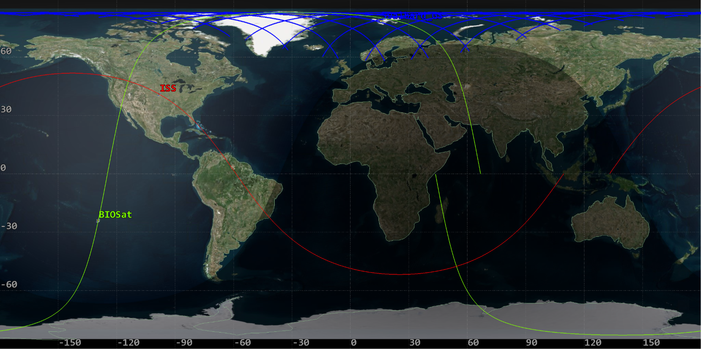

Figure 7: The green represents the orbit path of the BioSat and red represent the orbital path of the ISS. Blue represents the commercial Kongsberg Satellite Services (KSAT) Svalbard Satlite Station overlap with the BioSat.

Due to this identified orbit path the power generated budget and data budget have been directly impacted by the following constraints derived from this path utilizing the ANSYS SDK software, see Figure 8.

Worst-Case Scenario:

Orbit Duration: 90 minutes

Ground Station Passes: 10

Average Pass Duration: 5 minutes

Percentage of Sunlight/orbit: 64%

Figure 8: Derived ground station access times.

# **Appendix A: References**

[1] Seedhouse, E.: ‘Life Support Systems for Humans in Space’ (Springer, 2020) is 14 in the paper

[2] Stutte, G.W., Monje, O., and Wheeler, R.M.: ‘A Researchers Guide to International Space Station Plant Science’, NASA ISS Program Science Office,2015

[3] Divilife, “Grow light spectrum explained: Ideal led spectrum for plants,” The Ideal LED Grow Light Spectrum for Plants, <https://bioslighting.com/grow-light-spectrum-led-plants/grow-lighting/>.

[4] P. S. Thenkabail, R. B. Smith, and E. D. Pauw, *Hyperspectral Vegetation Indices for Determining Agricultural Crop Characteristics*. New Haven, CT: Yale University, Center for Earth Observation, 1999.

[5] J. Szulc *et al.*, “Beeswax-modified textiles: Method of preparation and assessment of antimicrobial properties,” *National Library of Medicine*, vol. 12, no. 2, 2020. doi:10.3390/polym12020344

[6] Stutte, G.W., Monje, O., and Wheeler, R.M.: ‘A Researchers Guide to International Space Station Plant Science’, NASA ISS Program Science Office, 2015

[7] K. M. F. Hasan *et al.*, “Colorful and antibacterial nylon fabric via in-situ biosynthesis of chitosan mediated nanosilver,” *Journal of Materials Research and Technology*, vol. 9, no. 6, Dec. 2020. doi: 10.1016/j.jmrt.2020.11.056

[8] D. Cox, “Water quality: Ph and alkalinity,” Center for Agriculture, Food, and the Environment, https://ag.umass.edu/greenhouse-floriculture/fact-sheets/water-quality-ph-alkalinity#:~:text=Alkalinity%20and%20pH%20are%20two,b%20etween%205.0%20and%207.0.

[9] L.G.Lyzit, What’s the correct water temperature when watering plants?, <https://www.maximumyield.com/whats-the-correct-water-temperature-when-watering-my-plants/7/17748#:~:text=The%20ideal%20water%20temperature%20for,important%20to%20understand%20dissolved%20oxygen>.

[10] C. Guru, “Is reverse osmosis water good for plants? the pros and cons,” Water Treatment, <https://purewaterblog.com/is-reverse-osmosis-water-good-for-plants-the-pros-and-cons>.

[11] Russomano, T., and Rehnberg, L.: ‘Into Space: A Journey of How Humans Adapt and Live in Microgravity’ (BoD–Books on Demand, 2018)