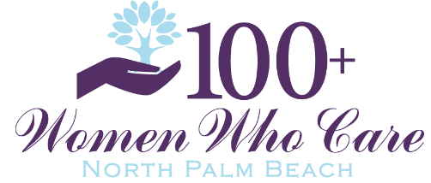
Charity Submission Process
In order to be considered, local charities must be a member of our Chapter or be sponsored by a member in good standing (i.e. current with donations). Member or sponsored nonprofits will have the opportunity to raise funds to support their mission.
Charity Eligibility Requirements:
- Must be a public (not private) 501(c)(3) organization
- Must have been in existence and in good standing for at least one year.
- NEW! Must have an operating budget under $1 million (effective 2/1/2026). Note: Charities that submitted a Charity Fact Sheet any time prior to February 1, 2026 will remain eligible regardless of their operating budget through the remainder of 2026.

How It Works:
1. Qualify to Submit a Charity:
✅ Be a member in good standing.
✅ Members can nominate or sponsor a charity of their choice (one active charity per member)
2. Member or Charity Representative Submits a Charity Fact Sheet:
🔹 Complete the form--HERE IS THIS LINK: https://100womenwhocaresouthflorida.org/charity-fact-sheet
Note: We suggest you email mhart@100womenwhocaresouthflorida.org once you have submitted your Charity Fact Sheet as they sometimes end up in Spam.
🔹 We will review your submission and notify you of approval.
🔹 Deadline for Submission: typically 2 weeks prior to a meeting; date will be specified via email sent to members
🔹 If you've already submitted a fact sheet, we should have it on file. You need only send an email to mhart@100womenwhocaresouthflorida.org to notify Mary Hart that you wish to be considered for the current quarter. If Charity Fact sheet is more than two years old, you may be asked to submit a new form.
3. RSVP & Confirm Presentation Interest:
📩 Email mhart@100womenwhocaresouthflorida.org to let us know you’d like to participate and who will be presenting for your charity if selected. Be sure at least that person registers to attend the event.
📩 We will confirm that we have a current fact sheet for your charity.
4. Selection Process for Presentations:
🎟️ A drawing will be held at the meeting to select three charities to present.
🗳️ Members only will vote to determine the grant recipient.
5. Presentation Guidelines:
🕐 Presentations are 5 minutes max.
🗣️ Can be given by either:
- A member sponsoring the charity.
- A representative from the charity (must be sponsored by a member).
6. Voting Process:
✅ After presentations, members vote by ballot.
✅ The winning charity is announced.
7. Donations & Matching Grants:
💰 100% of funds raised will be donated via Grapevine.org.
Additional Information:
- If your charity won previously, it is eligible to present again after two years. (Need to check? Email us!)
- The North Palm Beach Chapter typically donates $10,000 - $15,000 per quarter.
We appreciate your participation and look forward to supporting amazing local organizations together!
Warmly,
100+ WomenWhoCare North Palm Beach County Chapter

