# Franklin Regional Elementary T-Shirt Order Form

The FR Elementary campus would like to order class T-shirts for students to wear during the 2024-2025 academic year for school events such as field trips, field day and spirit days.

We are asking for a donation of **$5.00 per student** towards the cost of the T-shirt.

The FR Elementary Campus PTO will supplement these donations to cover printing costs and provide a shirt to any student who may not be able to purchase one at this time.

**Please complete & return this form with your donation (please send cash only) to your homeroom teacher by Thursday September 26, 2024**

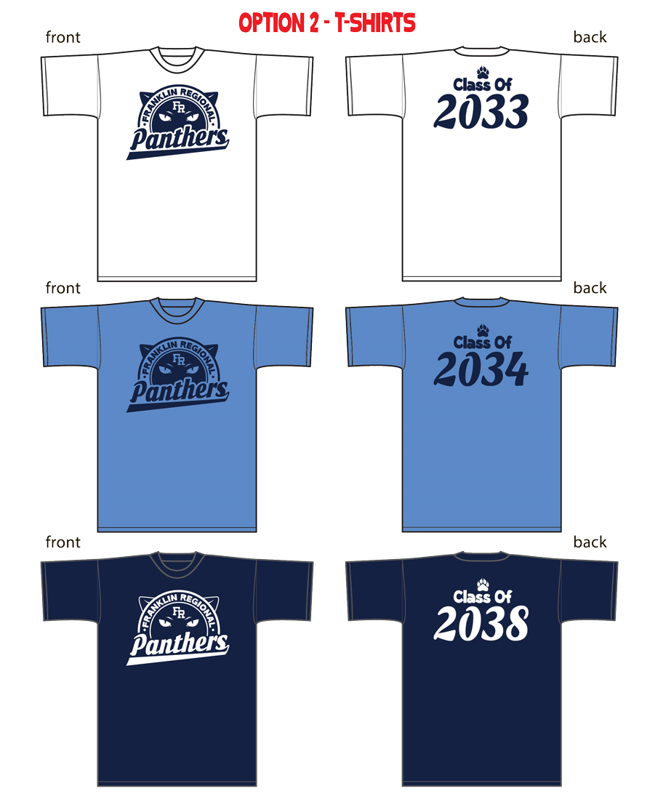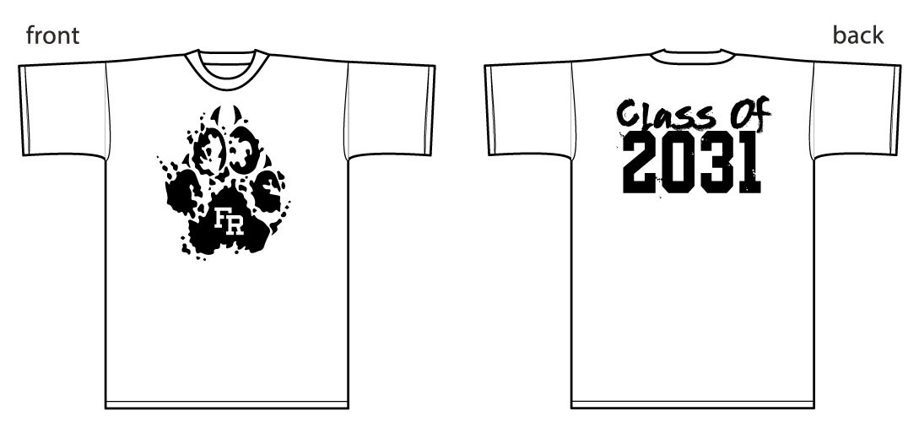

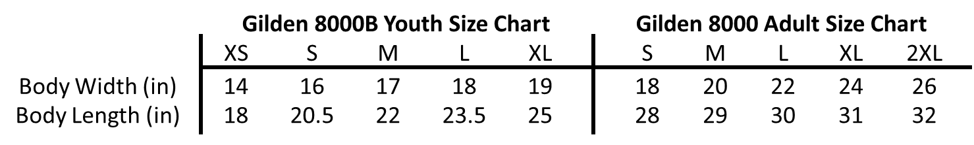

***(50/50 Cotton/Poly Shrink Resistant)***

*\*Shirt color and class year will vary based on homeroom teacher.*

## Student Name

**Grade Homeroom Teacher**

**Size Selection:**

Please select **ONE** size with consideration the student will wear for the full academic year.

**CHILD SIZES (circle one)**: Extra Small Small Medium Large Extra Large

**ADULT SIZES (circle one)**: Small Medium Large Extra Large 2XL

## Parent/Guardian Name

## 

## Parent/Guardian Phone Number

## Please check box: $5 Donation Enclosed Assistance Requested

**Reorder Information:** A reorder date will be offered in Spring 2025. Reorder shirts will be sold at cost at that time.