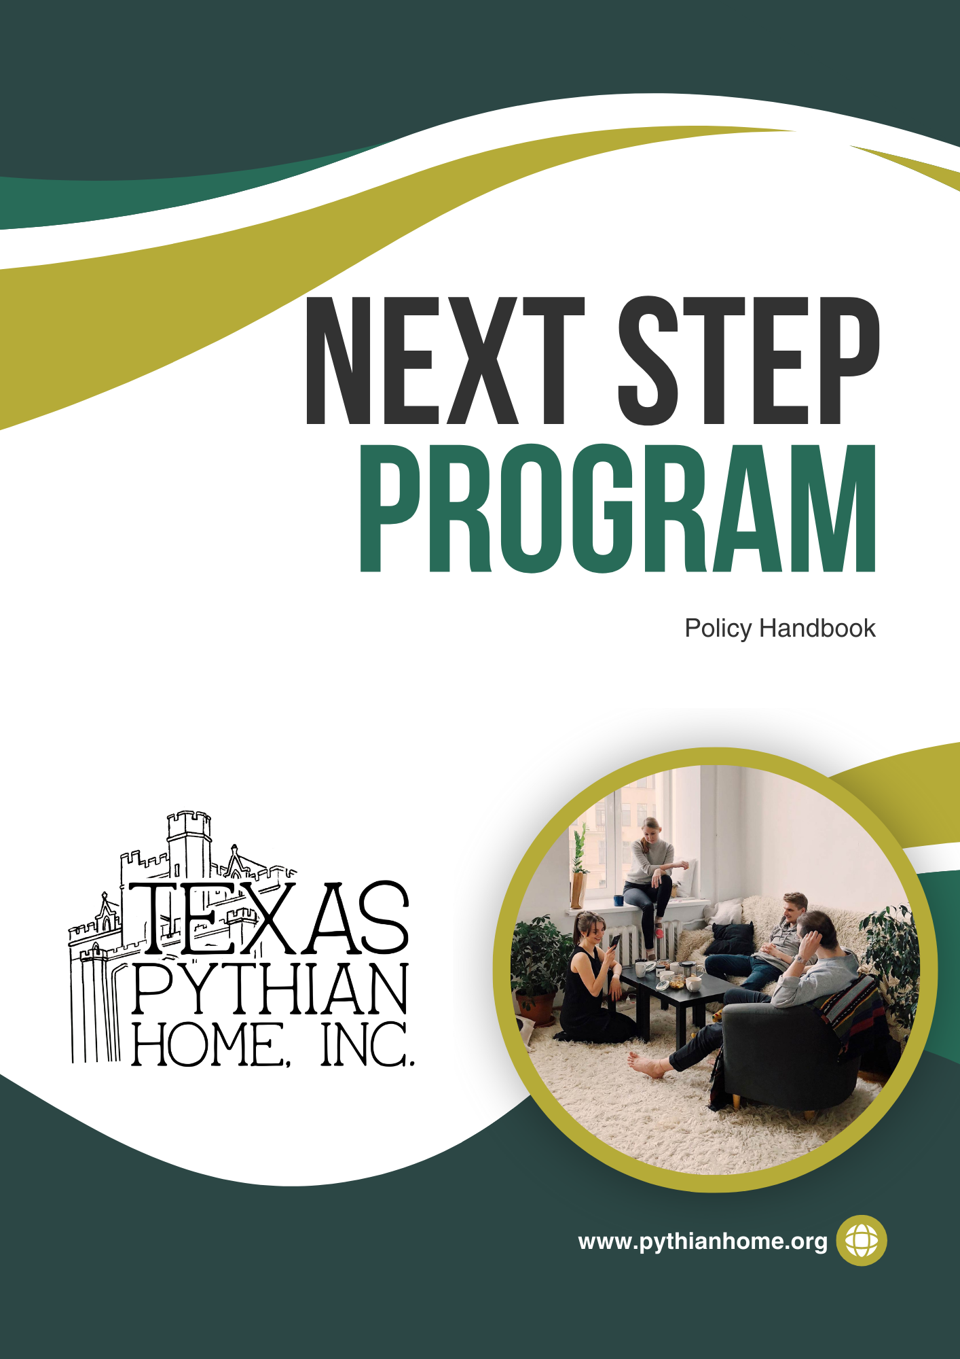

As a handbook cannot anticipate every circumstance or question regarding policy, Texas Pythian Home, Inc. reserves the right to revise, supplement or discontinue any policies or portion of the handbook from time to time, in its sole discretion.
The Next Step Program is open to all applicants age 18-24; Texas Pythian Home, Inc. High School Seniors will have priority in admittance to the Next Step Program. Second Priority will be those who wish to attend college/or trade school or are already attending college/or trade school, and those who wish to enter the workforce right out of high school.
Mission:
The Texas Pythian Home, Inc. provides a safe, stable environment
for children and adults to grow physically, socially, emotionally and spiritually to become responsible, independent adults.
Purpose:
The Next Step Program will provide the greatest assurance that each person after high school shall be prepared for his or her future course in life. The Program and its staff will provide appropriate information, encouragement, and counsel to assist each person in making the best possible decisions affecting his or her future.

Table of Contents
Contact information Page 4
Next Step Program Guidelines Page 5
Program House Rules and Guidelines Page 9
Next Step Program Application Page 13
Agreement Summary Page 15

Contact information

Next Step Program Advisor
Name: Emily Witherspoon
Office Number: 682-717-1714
Email: ewitherspoon@pythianhome.org

Assistant Executive Director
Name: Holly Boyer
Office Number: 817-594-4465 Ext. 103
Email: hboyer@pythianhome.org

Program Director
Name: Kristin Stansell
Office Number: 817-594-4465 Ext. 105
Email: kstansell@pythianhome.org

Next Step Program Guidelines
Definition:
Next Step Committee: Will recommend policy, evaluate individual cases and recommend dispositions and plans for assisting the Next Step participant emotionally and physically. The Next Step Committee will consist of the Executive Director, Assistant Executive Director, Program Director and Program Advisor. An individual planning to be a part of the Next Step Program will be required to fill out a Next Step Program application. The applicant will then have a meeting scheduled with the Program Advisor.
Employment:
- While attending college or trade school, residents will be expected to work to assist in meeting college expenses. It is expected that while taking classes you do not work more than twenty hours per week. During Holidays and school breaks we expect the student to work as many hours as they can.
- If college is not for you, then it is expected that residents will work full time (40 hours or more per week).
Insurance:
- Health Insurance is an important part of being an adult. It is often very confusing so speak with your program advisor if you have questions or need assistance.
- Visit www.healthcare.gov , to select the policy that works best for you.
- We recommend policies that include:
  - Basic Healthcare Coverage
  - Dental Coverage
  - Vision Coverage (If needed)
- When the resident deems a policy appropriate, contact the Program Advisor to discuss whether the plan is appropriate and affordable.
Vehicles:
- To bring a vehicle or purchase a vehicle while in the Next Step Program, you must have a valid driver’s license and valid insurance. A copy of the insurance policy must be given to the Program Advisor.
- You are responsible for keeping track of when car insurance is due.
- You must keep track of your vehicle’s maintenance continuously. This includes vehicle registration and oil changes.
Taxes:
- Individuals are responsible for filing their taxes every year as soon as your W2 Form is received. W2 Forms are usually mailed at the end of January. Your Program Advisor will assist you in filing your taxes, but they will not do it for you.

Grades (If attending School):
- Residents are required to send final semester grades to the Program Advisor at the end of every semester.
- A minimum of a 2.0 GPA is required of the student to remain eligible for the Next Step Program, unless there is an action plan put in place to improve educational standings.
Financial Aid:
- Each student’s FAFSA must be filled out or renewed each year. Renewals should be completed as early as allowed by FAFSA (October). The FAFSA website is https://fafsa.ed.gov/ . You can ask the Program Advisor for assistance.
- A copy of the student’s financial award letter must be provided to the Program Advisor.
Dress Code:
- When attending Pythian Home or Next Step events we expect that you will dress modestly. If you have any questions, please ask your Program Advisor.
- Clothing with wording or messages that are negative or display illegal activities or promote illegal activities will not be allowed on campus.

Drug and Alcohol Use:
- We have a ZERO Tolerance Policy on:
  - Drinking on Campus
  - Using Illegal Drugs
  - Misusing your Prescription Drugs
  - Using Prescription Drugs NOT Prescribed to You
  - Underage use of Tobacco Products and Alcohol
- Before entering the Next Step Program, you will be required to pass a drug test.
- Periodic Drug screenings will be performed.
- Smoking and Vaping are only permitted in designated areas. If you are caught smoking or vaping inside any building or home owned vehicle you will jeopardize your placement at Next Step.
- Alcoholic beverages and drugs are strictly prohibited on campus.
  - If you are under the age of 21 and appear intoxicated on campus you are jeopardizing your placement in the Next Step Program.
  - If you are of age to drink alcohol (21 years or older) and use alcohol off campus, you are expected to be responsible and NOT drive.
    - Once back at Next Step you are required to behave respectfully, or you will jeopardize your placement in the Next Step Program.

Program House Rules and Guidelines
- The Program House is fully furnished. Each room has a Full Size bed, mattress, pillows, bed sheets and comforters. Dressers or Chest of Drawers will also be provided.
- You are permitted to bring your own furniture (if it fits in the bedroom). You may decorate your room to your style; the Program Advisor must approve it.
- 3M strips and 3M Hooks are the ONLY hardware you can use to attach items to the wall.
- The bathrooms will be furnished with towels, a shower curtain and rugs. You are permitted to bring your own if you wish.
- Do not remove anything from bedroom or bathroom until approved by Program Advisor and the items are inventoried.
- The kitchen is equipped with dishes, glasses, silverware, utensils, pots and pans, cookie sheets and other cookware for all residents to use.
- The TV in the common room is Wi-Fi enabled and has basic cable.
- The computer in the common area is for everyone.
- The Heating and cooling unit is to be maintained at reasonable settings of no lower than 70° for the air conditioning and no higher than 75° for the heating.
- The clothes dryer has a lint filter trap that MUST be cleaned after each load to avoid creating a fire hazard.
- Any maintenance issues need to be reported as soon as possible to the Program Advisor.
- Trash should be emptied daily, the bags should be placed in the trash house (behind the pool house).
- All cleaning supplies are provided and should be requested through the Program Advisor.
- Meals are available when the dining room is open. The only food furnished by the Pythian Home is meals in the dining room and food requested through the Program Advisor on the weekly food order.
- A program agreement will be signed before moving in and a list of the Resident Rules must be read and signed. An inventory check will be made each time a resident moves in or out.

Program Fees:
- Each resident will have a Pythian Home account that money is deposited into.
- A $100.00 deposit will be required for each individual in the Next Step Program. (This deposit is refundable at exit of program if there is no damage to fix)
- You are required to deposit a monthly program fee of $50.00 due the 1st of each month in your Pythian Home account.
- You are required to deposit 10% of EACH paycheck into your Pythian Home account.
- If you cannot afford these expenses at move in, a plan will be put in place.
- Upon leaving the Next Step Program the Pythian Home has up to 30 days to provide you with your account balance.
- To help with budgeting, a monthly bank and or financial statement will be printed and provided to your Program Advisor for discussion.
Housekeeping:
- Each resident is responsible for always keeping his/her area clean and neat. Each room is subject to inspection or viewing at any time. Residents are not allowed in any of the Family Care or Residential buildings at any time.
  - Housekeeping General Guidelines:
- Beds must be made daily
- Trash must be emptied daily
- Bathrooms must be left clean daily
- Rooms must be vacuumed as needed or at least once a week
- No clothing in piles or stacks
- Anything with an actual flame is not permitted including candles and incense
- No space heaters are allowed in bedrooms
- Residents are not allowed to have pets. Fish are the ONLY exception.
Cooking and Dining:
- Food must be stored in the Pantry (no food in bedrooms)
- The main dining room is open for lunch at 11:30am Monday - Friday. Residents may eat in the dining room when meals are being served. If a resident would like to make a plate “to go” ask the kitchen staff if that would be acceptable.
- Residents are not allowed to take food from the dining room except during mealtimes.
- Residents are never to go into the main building without permission.
Miscellaneous:
- If a woman becomes pregnant while in the Next Step Program she will be able to stay in the program until the baby is born. Once the baby is born the Mother and Child will exit Next Step and have the choice to leave or transition to Grogan Family Program.
- If repairs or assistance is needed, the resident should speak to the Program Advisor. Residents are never to go to an employee for assistance before speaking with the Program Advisor.
- Residents are required to park in the designated area on the side of the Next Step Program.
- Residents should never park in the staff parking areas.
- The Program Advisor will receive the mail and bring it to the Next Step Program.
- Each person in the Next Step Program will be required to write Thank You Letters when contributions are made to the Program.
- All residents must tell the Program Advisor if they will not be staying on campus. This requirement is imperative as administration needs to know who is in the building in case of emergency.
- In order to have your weekends off campus, you MUST be meeting your work and/or school commitments.
- Curfew is 10pm Sunday-Thursday and Midnight Friday and Saturday.
- Visitors are allowed and must leave before Curfew.
- Texas Pythian Home, Inc. is home to many programs, and we do have children of all ages on the campus. We expect you to respect the policies and guidelines.



Next Step Program Application
Applicant Name ______________________________
Date of Birth _____________________________
Social Security Number ________________________________
Driver’s License or State ID Number ___________________________
*Must Bring Both (Social Security and DL or ID) for interview
High School Graduation Date ___________________________
Phone Number __________________________
College or University you plan to attend ___________________________
Address of College or University ___________________________________
If going to school:
What do you plan to study in college? __________________________________________________________________________________________________________________________________
What do you plan to do with your degree? ___________________________________________________________________________________________________________________________________________________________________________________________________
Honors and Accomplishments: ___________________________________________________________________________________________________________________________________________________________________________________________________
Extracurricular activities: ___________________________________________________________________________________________________________________________________________________________________________________________________
Employment: ____________________________________________
Have you ever been arrested? Yes____ No_____
If yes, what for? __________________________________________________________________________________________________________________________________
Have you ever been convicted of a felony? Yes_____ No _____
If you answered yes, you are not eligible to enter our program. We will run a background check before admission to the program.
List of Current Medications:
__________________________________________________________________________________________________________________________________
Have you ever struggled with substance abuse? Yes_____ No_____
If yes, how long have you been sober? ___________________________________________________________________________________________________________________________________________________________________________________________________
Have you ever had a Psych Evaluation? Yes____ No_____
If yes, please provide a copy with your application.

I affirm that to the best of my knowledge all the information I provided in this form is true and accurate.

______________________ ________________
Signature Date
Agreement Summary

I ____________________, agree to abide by the foregoing guidelines and policy while in the Texas Pythian Home, Inc Next Step Program.

______________________ ________________
Signature Date

