Rainbow Cookie Cake
November 10, 2020|Cakes, Daily Recipe, Desserts, Semi-Homemade, Shortcut Cooking
This cake is a nod to the popular rainbow cookies found in an Italian bakery. I use a boxed cake mix and almond extract to replicate their almondy goodness. Gel food coloring is used to create the red and green layers before the cake is topped with a rich chocolate ganache. While traditional rainbow cookies feature raspberry jam in between the cookie layers, being a complete choco-holic, I decided to use chocolate frosting as the filling for my cake. (If you really want to take a shortcut, substitute a can of prepared chocolate frosting) After glazing the outside of the cake with the ganache, chocolate sprinkles are added to the sides to complete the rainbow cookie effect.
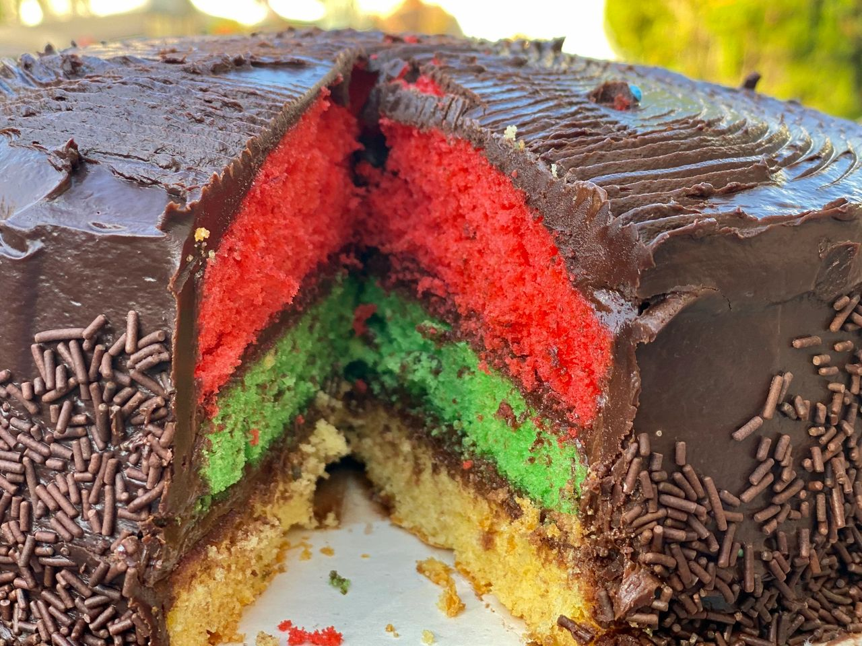Rainbow Cookie Cake
Ingredients
1 box yellow cake mix , prepared as per instructions
1 tsp almond extract
Red and green gel food coloring
Chocolate Frosting (recipe below) or Raspberry Jam as filling
Chocolate Ganache (recipe below)
Chocolate Sprinkles

Preheat the oven to 350 F. Grease three 8 inch round cake pans and line with a lightly greased parchment round cut to fit. Prepare the batter as per the instructions on the box. Add the almond extract and stir. Separate equal amounts of batter into three bowls. Add red coloring to one bowl and stir until the desired color is achieved. Repeat with the green coloring. Leave one third uncovered. Add each batter to a prepared cake pan and bake for approximately 20 minutes or until a tester inserted into the middle of the cake comes out clean. Cool for 10 minutes before loosening and unmolding onto a rack until completely cooled. Refrigerate the layers while you make the icing and ganache. Add frosting to the top of each layer. Add the ganache to the top and the sides, using an offset spatula to smooth. Using a fork, drag it lightly across the top of the cake to create a decorative pattern.
Sprinkles on the side

Using sprinkles cupped in your hand, add them to the sides of the cake.

Chocolate Frosting
1/2 cup butter, softened
1/2 cup cocoa powder, sifted
2 1/2 cups powdered sugar
1/2 tsp vanilla
2-3 Tbsp milk
Using an electric mixer, beat the butter and cocoa on medium until smooth in large bowl. Mix in the vanilla and powdered sugar. Slowly stream in milk while mixing and whip until light, fluffy and smooth, approximately 1-2 minutes.

Chocolate Ganache
8 oz. semi-sweet chocolate chips
2/3 cup heavy cream
Pinch of salt
Add the chocolate chips to a medium bowl. Bring the cream and salt to a boil in a small saucepan, then pour over the chocolate. Let stand for 1 minute then, using a small rubber spatula, slowly stir the chocolate and cream until it forms a shiny, smooth ganache. Cover the ganache with plastic wrap and let stand in a cool place in your kitchen until it is thick like pudding, but still pourable and spreadable, about 1 1/2 to 2 hours.

