Matthew Boutot

ECO 4421

5/2/2023

Project #5

**Introduction:**

This analysis evaluates various time series models to forecast the unemployment rate (UEMP) and the consumer price index (CPI) of Ireland on a monthly basis from January 2000 to December 2019. The monthly data for the unemployment rate is in percent and is seasonally adjusted for the period January 2000 to December 2019. The unemployment rate is of the harmonized kind meaning to be classified as unemployed they must be of working age and take specific steps to find a job.

The monthly data for CPI is indexed to 100 and is not seasonally adjusted between the aforementioned time period.

The time series is split from a sample period to estimate the model from the period January 2000 to December 2017 and a twenty-four-month evaluation period from January 2018 to December 2019 in order to better get an understanding of the out of sample forecasting performance of the models.

The data is truncated at December 2019 to avoid the period of covid from 2020 onward in order to better simplify the data.

To better model the levels of variables UEMP and CPI, graphs 1a and 1b are used as visual representations for the levels of the variables. In looking at the graphs for both variables, there does not appear to be any signs of stationarity. In examining the first differences of both variables in graphs 2a and 2b, there seems to be signs of stationarity with a relatively constant mean.

**Modelling UEMP:**

The first model considered deterministic trends and because the data has already been seasonally adjusted, there is no need for any use of seasonal dummies. The model with the lowest AIC is the cubic trend model as seen in output 1. All the coefficients in the deterministic trend model are statistically different from 0 giving validity to the model being used as an option for UEMP.

In examining the second output there is an ARMA (4,4) with the coefficients being statistically significant. When observing the correlogram, there is a clear difference between the displacements for the autocorrelations and partial autocorrelations. Residuals 1 through 10,14,15, and 21 from the autocorrelation function fall outside the confidence intervals, which points to statistical significance. This could point to a high seasonal component still remaining in the series for unemployment. When observing the partial autocorrelation, most residual values fall within the confidence bands with the exception of values 1,2, and 7, which can point to a factor specific to the given sample period. When observing the Q statistic, it can be noted that it is less than 0.05, which leads to a rejection of the null hypothesis of white noise residuals.

When considering the unit root test, output 3 performs augmented Dickey-Fuller tests under three alternative hypotheses, which in all instances fail to reject the null hypothesis of a series being nonstationary at a 5% significance level. The results confirm what was seen in graphs 1a and 1b.

The results of the unit root test imply a need to model and an ARIMA process using first differences. Output 4 shows an ARIMA(6,1,5) with a lag order decided by the lowest AIC. When examining the correlogram most values for auto and partial autocorrelation remain within the confidence bands with the exception of lag 12 on the partial correlogram. A possible explanation could be some error in sampling. Interestingly there is a rejection of the null hypothesis because of a high q statistic, there is white noise in the ARIMA model. The contrast of results between what is shown in the correlogram and what is seen in the Q stat could be attributed to a sampling error. Given the results of the correlogram, I am inclined to point to ARIMA being an acceptable forecasting model.

Based on the forecast results indicators of the RMSE and Theil’s U stat ARMA looks like the best model to forecast (seen in output 5), which contrasts the results from the Box Jenkins-differencing table that indicates that 1 difference is the correct specification.

**Modelling CPI:**

The first model examined is one with deterministic trends that has not been seasonally adjusted and as such must make use of seasonal dummy variables. Output 6 shows such results for the cubic model which was chosen because of the low AIC. The model may not be a valid way to represent CPI because the coefficients of February, March, April, July, November, and December are statistically significant.

Output 7 shows an ARMA (8,5) process selected using the lowest AIC results and has most residuals being within the confidence bands making them not statistically significant. The Q stat rejects the null of WN residuals.

Output 8 notes the unit root tests for CPI, which all fail to reject the null hypothesis of a unit root and show that an ARMA process with one difference is most acceptable.

Output 9 shows an ARIMA (6,1,5), which shows residuals that are outside of the bands in some instances, but this has a Q statistic that rejects the null hypothesis of WN residuals. Output 10 shows the forecast performances, and once again the ARMA model has the best indicators with the lowest RMSE and Theil’s U stat of the given models.

**Modelling VAR:**

There is now an estimation of the VAR model with the lag order being determined by the lowest AIC. Outputs 11a and 11b show the regression results with most coefficients not being statistically significant with p values higher than the 5% significance level. With that being the case, the model seems invalid for forecasting purposes if the majority of coefficients are not statistically significant.

**Out of sample Forecast Performance:**

The recursive estimates for this forecast are from January 2018 to December 2019. Using this recursive estimation period, two statistics for out of sample forecasting are calculated with those being the Root Mean Square Error and Thiel’s U stat. Both of those aim for a lower number with a lower number indicating a better out of sample forecasting performance of the model.

Graphs 3a and 3b show the forecast for UEMP and CPI respectively. Each graph pairs the forecasting results with historical realizations for an out of sample period.

Visually except for the trend model, the forecasts seem pretty good. The trend model seems to be very far below the other forecasts for UEMP. Output 10 has a summary of the recursive estimates from the out of sample process. The models for UEMP are generally bad with a U-stat above 1 for every model and high RMSE. For the variable UEMP, the ARMA model had the lowest RMSE and U stat with the ARIMA model being a distant second. Overall, I chose the ARMA model over the ARIMA model. The reason for this being that despite proof of a unit root, the disparity in U stat and RMSE was so drastic that the ARIMA model could not be considered valid.

In deciding the best forecasting model for CPI, I chose the ARIMA model. This is despite the VAR model having a Thiel’s U below 1 and a low RMSE. However, the difference between ARIMA and VAR is not as drastic and there was evidence of a unit root. This combined with the fact that the VAR model had coefficients that were not statistically significant, made me choose the ARIMA model.

**Question 10:**

See output 13 at the bottom of the document.

**Conclusion:**

For unemployment the best forecasting model is the ARMA model of those considered. The forecasting performance is not the greatest, but it is demonstrably better than the other models measured. For CPI the best forecasting model is the ARIMA model with a decent forecasting performance but a high likelihood of seasonal factors remaining in the series.

**Graph 1a:**



**Graph 1b:**

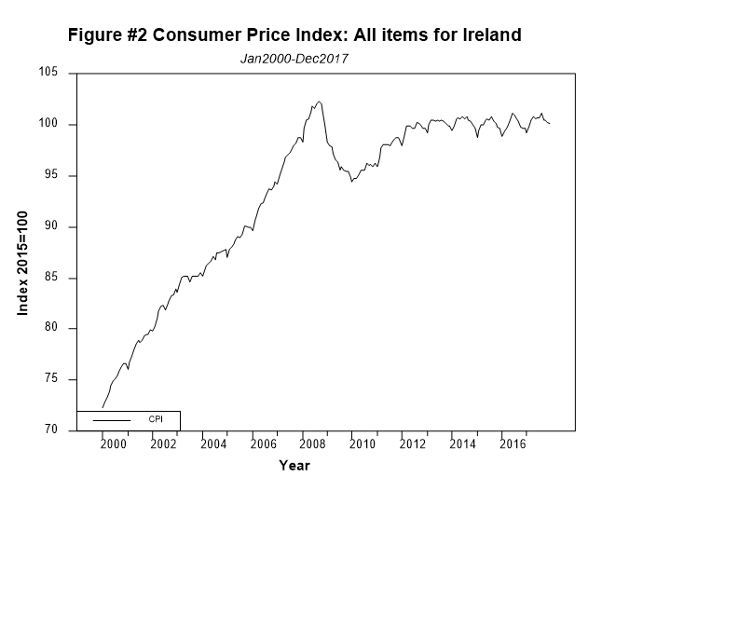

**Graph 2a:**



**Graph 2b:**

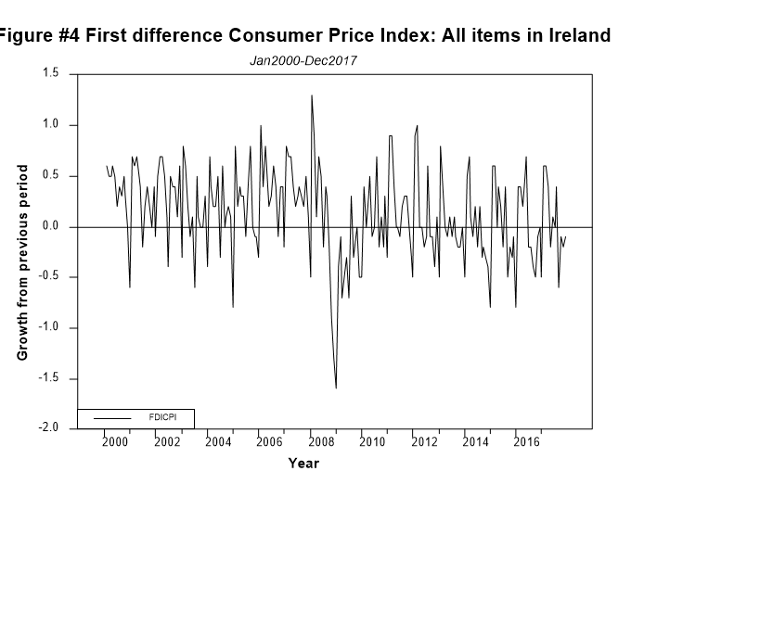

**Output 1: Deterministic Trend Model UEMP**

Linear Regression - Estimation by Least Squares

Dependent Variable UEMP

Monthly Data From 2000:01 To 2016:12

Usable Observations 204

Degrees of Freedom 200

Centered R^2 0.8622918

R-Bar^2 0.8602261

Uncentered R^2 0.9721549

Mean of Dependent Variable 8.6004901961

Std Error of Dependent Variable 4.3404898313

Standard Error of Estimate 1.6227504155

Sum of Squared Residuals 526.66378223

Regression F(3,200) 417.4486

Significance Level of F 0.0000000

Log Likelihood -386.2046

Durbin-Watson Statistic 0.0181

Variable Coeff Std Error T-Stat Signif

************************************************************************************

1. Constant 7.313454539 0.462944737 15.79768 0.00000000

2. TREND -0.250074816 0.019509402 -12.81817 0.00000000

3. TRENDSQ 0.004145299 0.000220852 18.76961 0.00000000

4. TRENDCB -0.000014467 0.000000708 -20.42628 0.00000000

Information Criteria

AIC 3.835

SBC 3.917

Hannan-Quinn 3.868

(log) FPE 3.835

**Output 2: ARMA (4,4) UEMP**

Box-Jenkins - Estimation by LS Gauss-Newton

Convergence in 14 Iterations. Final criterion was 0.0000037 <= 0.0000100

Dependent Variable UEMP

Monthly Data From 2000:05 To 2017:12

Usable Observations 212

Degrees of Freedom 203

Centered R^2 0.9983824

R-Bar^2 0.9983187

Uncentered R^2 0.9996821

Mean of Dependent Variable 8.5683962264

Std Error of Dependent Variable 4.2480540595

Standard Error of Estimate 0.1741872278

Sum of Squared Residuals 6.1592616339

Log Likelihood 74.2797

Durbin-Watson Statistic 2.0006

Q(36-8) 67.9351

Significance Level of Q 0.0000360

Variable Coeff Std Error T-Stat Signif

************************************************************************************

1. CONSTANT 8.665441401 1.434744703 6.03971 0.00000001

2. AR{1} 0.936491147 0.288856479 3.24206 0.00138715

3. AR{2} 0.728410341 0.370178426 1.96773 0.05046116

4. AR{3} -0.313187588 0.369917647 -0.84664 0.39819201

5. AR{4} -0.354604383 0.279247913 -1.26986 0.20558995

6. MA{1} 0.600495261 0.277032458 2.16760 0.03135297

7. MA{2} -0.370200821 0.188612753 -1.96276 0.05104063

8. MA{3} -0.577970507 0.218611256 -2.64383 0.00883777

9. MA{4} -0.323214847 0.100522360 -3.21535 0.00151594



**Output 3: Augmented Dickey Fuller Unit Root tests: UEMP**

**Dickey-Fuller Unit Root Test, Series UEMP**

Regression Run From 2000:08 to 2017:12

Observations 210

With intercept

With 6 lags chosen from 6 by AIC

Null is unit root. Reject in left tail.

Sig Level Crit Value

1%(**) -3.46273

5%(*) -2.87533

10% -2.57405

T-Statistic -1.55401

**Dickey-Fuller Unit Root Test, Series UEMP**

Regression Run From 2000:08 to 2017:12

Observations 210

Without intercept or trend

With 6 lags chosen from 6 by AIC

Null is unit root. Reject in left tail.

Sig Level Crit Value

1%(**) -2.57536

5%(*) -1.94120

10% -1.61646

T-Statistic -0.53308

**Dickey-Fuller Unit Root Test, Series UEMP**

Regression Run From 2000:08 to 2017:12

Observations 210

With intercept and trend

With 6 lags chosen from 6 by AIC

Null is unit root. Reject in left tail.

Sig Level Crit Value

1%(**) -4.00465

5%(*) -3.43224

10% -3.13959

T-Statistic -0.98867

**BJDiff Table, Series UEMP**

Reg Diff Seas Diff Intercept Crit

0 0 No 0.276766

0 0 Yes -0.897153

0 1 No -1.624628

0 1 Yes -1.565513

1 0 No -3.336682*

1 0 Yes -3.311817

1 1 No -2.586717

1 1 Yes -2.560553

**Output 4: ARIMA(6,1,5) UEMP**

Box-Jenkins - Estimation by LS Gauss-Newton

NO CONVERGENCE IN 100 ITERATIONS

LAST CRITERION WAS 0.0002539

TRY INCREASING ITERS OPTION

Dependent Variable UEMP, differenced 1 times

Monthly Data From 2000:08 To 2017:12

Usable Observations 209

Degrees of Freedom 197

Centered R^2 0.9986850

R-Bar^2 0.9986115

Uncentered R^2 0.9997441

Mean of Dependent Variable 8.6267942584

Std Error of Dependent Variable 4.2501753087

Standard Error of Estimate 0.1583708286

Sum of Squared Residuals 4.9410199133

Log Likelihood 94.7695

Durbin-Watson Statistic 2.0478

Q(36-11) 27.6864

Significance Level of Q 0.3224885

Variable Coeff Std Error T-Stat Signif

************************************************************************************

1. CONSTANT 0.027687478 0.069334571 0.39933 0.69008153

2. AR{1} 0.675446152 0.156799000 4.30772 0.00002601

3. AR{2} 0.815727060 0.060865450 13.40214 0.00000000

4. AR{3} -1.199548768 0.154584151 -7.75984 0.00000000

5. AR{4} -0.151998114 0.149462861 -1.01696 0.31041863

6. AR{5} 0.932142717 0.089483127 10.41697 0.00000000

7. AR{6} -0.178223128 0.129494889 -1.37629 0.17029280

8. MA{1} -0.031970579 0.134309042 -0.23804 0.81209946

9. MA{2} -1.064428078 0.089726079 -11.86308 0.00000000

10. MA{3} 0.842021746 0.101375328 8.30598 0.00000000

11. MA{4} 0.681695912 0.064824253 10.51606 0.00000000

12. MA{5} -0.754953624 0.135657940 -5.56513 0.00000008



**Output 5: Forecasting performance for UEMP**

Forecast Performance for UEMP from trend model

From 2017:01 to 2017:12

Mean Error 3.40679702

Mean Absolute Error 3.40679702

Root Mean Square Error 3.61246395

Mean Square Error 13.049896

Theil's U 23.649128

Mean Pct Error 0.512112

Mean Abs Pct Error 0.512112

Root Mean Square Pct Error 0.549205

Theil's Relative U 24.604454

@uforeerrors(title = "Forecast Performance for UEMP from ARMA(p,q) model") UEMP UEMP_FARMA1 2017:01 2017:12

Forecast Performance for UEMP from ARMA(p,q) model

From 2017:01 to 2017:12

Mean Error -0.1461114

Mean Absolute Error 0.1584005

Root Mean Square Error 0.2033894

Mean Square Error 0.041367

Theil's U 1.331496

Mean Pct Error -0.021841

Mean Abs Pct Error 0.023686

Root Mean Square Pct Error 0.030533

Theil's Relative U 1.354563

@uforeerrors(title = "Forecast Performance for UEMP from ARIMA(p',1,q') model") UEMP UEMP_FARIMA 2018:01 2019:12

Forecast Performance for UEMP from ARIMA(p',1,q') model

From 2018:01 to 2019:12

Mean Error -0.6008047

Mean Absolute Error 0.6008047

Root Mean Square Error 0.6865653

Mean Square Error 0.471372

Theil's U 4.378864

Mean Pct Error -0.117537

Mean Abs Pct Error 0.117537

Root Mean Square Pct Error 0.137846

Theil's Relative U 4.755222

@uforeerrors(title = "Forecast Performance for UEMP from VAR model") UEMP VAR_FORE(2) 2017:01 2017:12

Forecast Performance for UEMP from VAR model

From 2017:01 to 2017:12

Mean Error -93.594421

Mean Absolute Error 93.594421

Root Mean Square Error 93.596180

Mean Square Error 8760.244931

Theil's U 612.730829

Mean Pct Error -13.883758

Mean Abs Pct Error 13.883758

Root Mean Square Pct Error 13.902855

Theil's Relative U 621.938289

**Output 6: CPI with dummy variables**

Linear Regression - Estimation by Least Squares

Dependent Variable CPI

Monthly Data From 2000:01 To 2017:12

Usable Observations 216

Degrees of Freedom 201

Centered R^2 0.9591542

R-Bar^2 0.9563092

Uncentered R^2 0.9996850

Mean of Dependent Variable 93.147271368

Std Error of Dependent Variable 8.231155456

Standard Error of Estimate 1.720504086

Sum of Squared Residuals 594.98699618

Regression F(14,201) 337.1390

Significance Level of F 0.0000000

Log Likelihood -415.9229

Durbin-Watson Statistic 0.0310

Variable Coeff Std Error T-Stat Signif

************************************************************************************

1. Constant 70.97595052 0.60408732 117.49287 0.00000000

2. TREND 0.38673507 0.01903887 20.31292 0.00000000

3. TRENDSQ -0.00171808 0.00020363 -8.43742 0.00000000

4. TRENDCB 0.00000246 0.00000062 3.98355 0.00009489

5. FEB 0.52031469 0.57351194 0.90724 0.36536469

6. MAR 0.90963051 0.57354341 1.58598 0.11431495

7. APR 1.05164399 0.57359549 1.83342 0.06821841

8. MAY 1.14015493 0.57366798 1.98748 0.04822665

9. JUN 1.20283637 0.57376078 2.09641 0.03729733

10. JUL 0.92957029 0.57387388 1.61982 0.10683959

11. AUG 1.17312596 0.57400738 2.04375 0.04228295

12. SEP 1.09177974 0.57416145 1.90152 0.05866419

13. OCT 0.96793236 0.57433639 1.68531 0.09348146

14. NOV 0.77941884 0.57453256 1.35661 0.17642565

15. DEC 0.63143805 0.57475044 1.09863 0.27324374

**Output 7: CPI ARMA(8,5)**

Box-Jenkins - Estimation by LS Gauss-Newton

NO CONVERGENCE IN 100 ITERATIONS

LAST CRITERION WAS 0.0001691

TRY INCREASING ITERS OPTION

Dependent Variable CPI

Monthly Data From 2000:09 To 2017:12

Usable Observations 208

Degrees of Freedom 194

Centered R^2 0.9983632

R-Bar^2 0.9982535

Uncentered R^2 0.9999898

Mean of Dependent Variable 93.881423834

Std Error of Dependent Variable 7.463332067

Standard Error of Estimate 0.311897844

Sum of Squared Residuals 18.872371453

Log Likelihood -45.5560

Durbin-Watson Statistic 2.0247

Q(36-13) 116.1550

Significance Level of Q 0.0000000

Variable Coeff Std Error T-Stat Signif

************************************************************************************

1. CONSTANT 103.2396454 4.6692907 22.11035 0.00000000

2. AR{1} 1.2148642 0.0760827 15.96767 0.00000000

3. AR{2} 0.1292535 0.1081683 1.19493 0.23357310

4. AR{3} -0.1841596 0.0593403 -3.10345 0.00219862

5. AR{4} -0.5356134 0.0545250 -9.82326 0.00000000

6. AR{5} -0.3794916 0.0567871 -6.68271 0.00000000

7. AR{6} 1.1875155 0.0600625 19.77131 0.00000000

8. AR{7} -0.6592279 0.1073671 -6.13994 0.00000000

9. AR{8} 0.2142168 0.0732981 2.92254 0.00388428

10. MA{1} 0.1531831 0.0406269 3.77049 0.00021621

11. MA{2} -0.3672875 0.0423827 -8.66597 0.00000000

12. MA{3} -0.3262109 0.0458332 -7.11734 0.00000000

13. MA{4} 0.4011702 0.0567872 7.06445 0.00000000

14. MA{5} 1.0580197 0.0457247 23.13892 0.00000000



**Output 8: Augmented Dickey Fuller Unit Root tests: CPI**

Dickey-Fuller Unit Root Test, Series CPI

Regression Run From 2000:08 to 2017:12

Observations 210

With intercept

With 6 lags chosen from 6 by AIC

Null is unit root. Reject in left tail.

Sig Level Crit Value

1%(**) -3.46273

5%(*) -2.87533

10% -2.57405

T-Statistic -2.27691

Dickey-Fuller Unit Root Test, Series CPI

Regression Run From 2000:08 to 2017:12

Observations 210

Without intercept or trend

With 6 lags chosen from 6 by AIC

Null is unit root. Reject in left tail.

Sig Level Crit Value

1%(**) -2.57536

5%(*) -1.94120

10% -1.61646

T-Statistic 1.21216

Dickey-Fuller Unit Root Test, Series CPI

Regression Run From 2000:08 to 2017:12

Observations 210

With intercept and trend

With 6 lags chosen from 6 by AIC

Null is unit root. Reject in left tail.

Sig Level Crit Value

1%(**) -4.00465

5%(*) -3.43224

10% -3.13959

T-Statistic -1.74766

BJDiff Table, Series CPI

Reg Diff Seas Diff Intercept Crit

0 0 No 5.440974

0 0 Yes 1.714536

0 1 No -0.785212

0 1 Yes -1.042383

1 0 No -1.683091

1 0 Yes -1.708207

1 1 No -2.006036*

1 1 Yes -1.980645

**Output 9: ARIMA(6,1,5) CPI**

Box-Jenkins - Estimation by LS Gauss-Newton

NO CONVERGENCE IN 100 ITERATIONS

LAST CRITERION WAS 0.0002443

TRY INCREASING ITERS OPTION

Dependent Variable CPI, differenced 1 times

Monthly Data From 2000:08 To 2017:12

Usable Observations 209

Degrees of Freedom 197

Centered R^2 0.9982151

R-Bar^2 0.9981155

Uncentered R^2 0.9999886

Mean of Dependent Variable 93.793734955

Std Error of Dependent Variable 7.552522934

Standard Error of Estimate 0.327863891

Sum of Squared Residuals 21.176461950

Log Likelihood -57.3113

Durbin-Watson Statistic 2.2336

Q(36-11) 80.4230

Significance Level of Q 0.0000001

Variable Coeff Std Error T-Stat Signif

************************************************************************************

1. CONSTANT 0.576286432 0.103161622 5.58625 0.00000008

2. AR{1} -0.142246716 0.051074500 -2.78508 0.00587369

3. AR{2} -0.158764991 0.054297240 -2.92400 0.00386050

4. AR{3} -0.135380029 0.047132675 -2.87232 0.00452104

5. AR{4} -0.142479219 0.051634149 -2.75940 0.00633681

6. AR{5} -0.201546219 0.055633652 -3.62274 0.00037087

7. AR{6} 0.825752064 0.047447055 17.40365 0.00000000

8. MA{1} 0.870006580 0.049149957 17.70106 0.00000000

9. MA{2} 0.911424207 0.046272074 19.69707 0.00000000

10. MA{3} 0.784820759 0.033307023 23.56322 0.00000000

11. MA{4} 0.905858472 0.044817395 20.21221 0.00000000

12. MA{5} 1.065039236 0.052044171 20.46414 0.00000000



**Output 10: Forecasting performance for CPI**

Forecast Performance for CPI from ARMA(p,q) model

From 2017:01 to 2017:12

Mean Error 0.68979541

Mean Absolute Error 0.72601557

Root Mean Square Error 0.85550040

Mean Square Error 0.731881

Theil's U 2.241113

Mean Pct Error 0.006852

Mean Abs Pct Error 0.007216

Root Mean Square Pct Error 0.008495

Theil's Relative U 2.230393

@uforeerrors(title = "Forecast Performance for CPI from ARIMA(p',1,q') model") CPI CPI_FARIMA 2018:01 2019:12

Forecast Performance for CPI from ARIMA(p',1,q') model

From 2018:01 to 2019:12

Mean Error -1.8279032

Mean Absolute Error 2.4690127

Root Mean Square Error 3.1500140

Mean Square Error 9.922588

Theil's U 6.979828

Mean Pct Error -0.017926

Mean Abs Pct Error 0.024276

Root Mean Square Pct Error 0.030911

Theil's Relative U 6.892244

@uforeerrors(title = "Forecast Performance for CPI from VAR model") CPI VAR_FORE(2) 2017:01 2017:12

Forecast Performance for CPI from VAR model

From 2017:01 to 2017:12

Mean Error -0.0038883

Mean Absolute Error 0.3537205

Root Mean Square Error 0.3968833

Mean Square Error 0.157516

Theil's U 1.039696

Mean Pct Error -0.000055

Mean Abs Pct Error 0.003527

Root Mean Square Pct Error 0.003960

Theil's Relative U 1.038157

**Output 11a: VAR for UEMP and CPI(UEMP dependent variable)**

VAR/System - Estimation by Least Squares

Monthly Data From 2000:01 To 2017:12

Usable Observations 210

Skipped/Missing (from 216) 6

Dependent Variable UEMP

Mean of Dependent Variable 8.6066666667

Std Error of Dependent Variable 4.2500158551

Standard Error of Estimate 0.1775186192

Sum of Squared Residuals 6.2080334491

Durbin-Watson Statistic 2.0663

Variable Coeff Std Error T-Stat Signif

************************************************************************************

1. UEMP{1} 1.558385520 0.069459051 22.43603 0.00000000

2. UEMP{2} -0.534039958 0.129699981 -4.11750 0.00005632

3. UEMP{3} -0.047187109 0.135161355 -0.34912 0.72737445

4. UEMP{4} -0.025999122 0.134782498 -0.19290 0.84723846

5. UEMP{5} 0.273031080 0.129434794 2.10941 0.03617213

6. UEMP{6} -0.230694226 0.069137981 -3.33672 0.00101328

7. CPI{1} -0.011019862 0.030231261 -0.36452 0.71586165

8. CPI{2} -0.042685161 0.046503489 -0.91789 0.35979803

9. CPI{3} 0.072705532 0.046657552 1.55828 0.12077190

10. CPI{4} -0.001841104 0.047050062 -0.03913 0.96882578

11. CPI{5} 0.007951978 0.047268707 0.16823 0.86657554

12. CPI{6} -0.023112889 0.030471422 -0.75851 0.44905203

13. Constant -0.127848925 0.178213236 -0.71739 0.47398142

F-Tests, Dependent Variable UEMP

Variable F-Statistic Signif

*******************************************************

UEMP 10989.8671 0.0000000

CPI 0.9951 0.4297697

**Output 11b VAR for UEMP and CPI(CPI dependent variable)**

Dependent Variable CPI

Mean of Dependent Variable 93.704982616

Std Error of Dependent Variable 7.643418504

Standard Error of Estimate 0.417774835

Sum of Squared Residuals 34.383555116

Durbin-Watson Statistic 1.9347

Variable Coeff Std Error T-Stat Signif

************************************************************************************

1. UEMP{1} -0.061973610 0.163465916 -0.37912 0.70500520

2. UEMP{2} -0.015007183 0.305237774 -0.04917 0.96083717

3. UEMP{3} 0.112884316 0.318090649 0.35488 0.72305840

4. UEMP{4} -0.295794888 0.317199041 -0.93252 0.35220861

5. UEMP{5} 0.291139210 0.304613679 0.95577 0.34036215

6. UEMP{6} -0.036318158 0.162710305 -0.22321 0.82360531

7. CPI{1} 1.174781141 0.071146679 16.51210 0.00000000

8. CPI{2} -0.138994683 0.109441970 -1.27003 0.20557166

9. CPI{3} -0.003775298 0.109804544 -0.03438 0.97260736

10. CPI{4} -0.060209149 0.110728282 -0.54376 0.58722433

11. CPI{5} -0.074611122 0.111242846 -0.67070 0.50319410

12. CPI{6} 0.092262959 0.071711876 1.28658 0.19975110

13. Constant 1.133605639 0.419409555 2.70286 0.00747498

F-Tests, Dependent Variable CPI

Variable F-Statistic Signif

*******************************************************

UEMP 0.8089 0.5640703

CPI 7019.0700 0.0000000

**Graph 3a:** 

**Graph 3b:**



**Output 12: Forecast evaluations of out of sample for UEMP and CPI**

Forecast Performance for UEMP from ARMA(p,q) model

From 2018:01 to 2019:12

Mean Error -0.2254330

Mean Absolute Error 0.2336111

Root Mean Square Error 0.2782829

Mean Square Error 0.077441

Theil's U 1.774869

Mean Pct Error -0.046593

Mean Abs Pct Error 0.048166

Root Mean Square Pct Error 0.057915

Theil's Relative U 1.993582

@uforeerrors(title = "Forecast Performance for UEMP from ARIMA(p',1,q') model") UEMP UEMP_FARIMA 2018:01 2019:12

Forecast Performance for UEMP from ARIMA(p',1,q') model

From 2018:01 to 2019:12

Mean Error -0.8124165

Mean Absolute Error 0.8124165

Root Mean Square Error 0.9352712

Mean Square Error 0.874732

Theil's U 5.965092

Mean Pct Error -0.159446

Mean Abs Pct Error 0.159446

Root Mean Square Pct Error 0.188555

Theil's Relative U 6.529653

@uforeerrors(title = "Forecast Performance for UEMP from VAR model") UEMP VAR_FORE(2) 2019:01 2019:12

Forecast Performance for UEMP from VAR model

From 2019:01 to 2019:12

Mean Error -96.797019

Mean Absolute Error 96.797019

Root Mean Square Error 96.798372

Mean Square Error 9369.924812

Theil's U 536.940759

Mean Pct Error -19.545313

Mean Abs Pct Error 19.545313

Root Mean Square Pct Error 19.557967

Theil's Relative U 566.858616

Forecast Performance for UEMP from trend model

From 2019:01 to 2019:12

Mean Error 1.19894319

Mean Absolute Error 1.38063339

Root Mean Square Error 1.78581224

Mean Square Error 3.189125

Theil's U 9.905904

Mean Pct Error 0.247181

Mean Abs Pct Error 0.283953

Root Mean Square Pct Error 0.371706

Theil's Relative U 10.870707

Forecast Performance for CPI from ARMA(p,q) model

From 2018:01 to 2019:12

Mean Error 0.41144286

Mean Absolute Error 0.58818049

Root Mean Square Error 0.63077897

Mean Square Error 0.397882

Theil's U 1.397685

Mean Pct Error 0.004014

Mean Abs Pct Error 0.005777

Root Mean Square Pct Error 0.006196

Theil's Relative U 1.381821

@uforeerrors(title = "Forecast Performance for CPI from ARIMA(p',1,q') model") CPI CPI_FARIMA 2018:01 2019:12

Forecast Performance for CPI from ARIMA(p',1,q') model

From 2018:01 to 2019:12

Mean Error -0.1415418

Mean Absolute Error 0.4432819

Root Mean Square Error 0.5651744

Mean Square Error 0.319422

Theil's U 1.252318

Mean Pct Error -0.001407

Mean Abs Pct Error 0.004383

Root Mean Square Pct Error 0.005598

Theil's Relative U 1.246054

@uforeerrors(title = "Forecast Performance for CPI from VAR model") CPI VAR_FORE(2) 2019:01 2019:12

Forecast Performance for CPI from VAR model

From 2019:01 to 2019:12

Mean Error 0.03051065

Mean Absolute Error 0.19055311

Root Mean Square Error 0.24410986

Mean Square Error 0.059590

Theil's U 0.542003

Mean Pct Error 0.000288

Mean Abs Pct Error 0.001874

Root Mean Square Pct Error 0.002401

Theil's Relative U 0.538456

**Output 13: Exponential smoothing for UEMP**

Exponential Smoothing for Series UEMP

Model Selection

TREND SEASONAL SumSquares SBC

Exponential None 7.50058341 -820.80

Exponential Additive 8.45340019 -786.61

Exponential Multiplicative 8.56649058 -783.43

Model with TREND=Exponential , SEASONAL=None

Alpha (level) 1.306860

Gamma (trend) 0.185401

Smooth Exercise with Alpha=0.5

From 2000:01 to 2019:12

Mean Error -0.0134111

Mean Absolute Error 0.1297025

Root Mean Square Error 0.1767836

Mean Square Error 0.031252

Theil's U 0.785360

Mean Pct Error -0.000628

Mean Abs Pct Error 0.017444

Root Mean Square Pct Error 0.023333

Theil's Relative U 0.808716